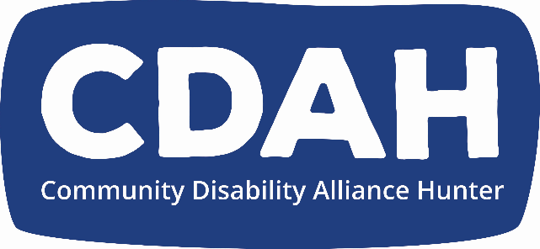
CDAH 7th Annual General Meeting (AGM) Minutes

Meeting Date: | 26 November 2020
Meeting Time: | 6.00pm
Meeting Venue: | Hunter Union’s Building  Level 3, 406-408 King St Newcastle west
Present: | In person: Joseph Popov, Lauren Hislop, Greg Bruce, Jen Cush, Andrew Vodic, Leigh Creighton, Raelene Bock, David Belcher, Bev Thoms, David Pearey, Kristy Trajcevski, Erin Forrester, Billie Mosman, Douglas Holmes, Justine Lorenz, Suzy Trindall, Owen Baird-Peddie, Julie Clifton, Geoff Locock, Mandy McCarthy(SW), Karen Lantry (interpreter), Jack Doran (SW), Jay Lawson (SW), Donna Mossman (SW), Justin King (SW), Kassandra Chan (SW)  On Zoom: Jess Watkins, Chris Morris, Stephen Hallinan, Kate Davies, Simon Swinson, Cedar Whelan, Jenna Watkins, Mel Sullivan, Alisha Cooper, Sarah Brook (interpreter)
Meeting Commenced: | 6.15pm
Establish Quorum: | Quorum established, with 18 voting members present
Acknowledgement of Country: | Owen Baird-Peddie gave an Acknowledgement of Country
Apologies: | Tania Lewis, Cath Mahony, Deb Hamilton, Sarah Simmonds, Arron Fitzpatrick, Emma Davies, Claire Bertholi  Motion: That the apologies are accepted  Moved: Lauren Hisplop  Seconded: Suzy Trindall  Carried
President’s Report: | Kristy Trajcevski (President) gave an overview of CDAH’s achievements over the last year and goals for the coming year, as per the Annual Report.  Motion: That the President’s Report be received.  Moved: Billie Mosman  Seconded: Erin Forrester  Carried
Minutes of 6th Annual General Meeting: | Motion: That the minutes of the 2019 AGM Meeting be confirmed.  Moved: David Belcher  Seconded: Leigh Creighton  Carried
2019/2020 Financial Report including Audit | Jess Watkins (ex-EO) gave an overview of the 2019/20 financial position and profit and loss statement & presented the audited finances  Motion: That the annual financial statement for 2019/20 be adopted.  Moved: Billie Mosman  Seconded: Kate Davies  Carried
Election of Board members: | The nominated members to the CDAH Board were elected:  Lauren Hislop  Kristy Trajcevski  David Pearey  Bev Thoms  The following members stay on the Board until the next AGM:  Billie Mosman  Kate Davies  Nominations from the floor:  Joseph Popov  Moved: David Belcher  Seconded: Raelene Bock  Carried  Thank-you to retiring board member for all their work  Sally Coddington  Moved: David Belcher  Seconded: Erin Forrester  Carried
Meeting closed | 6.40pm

