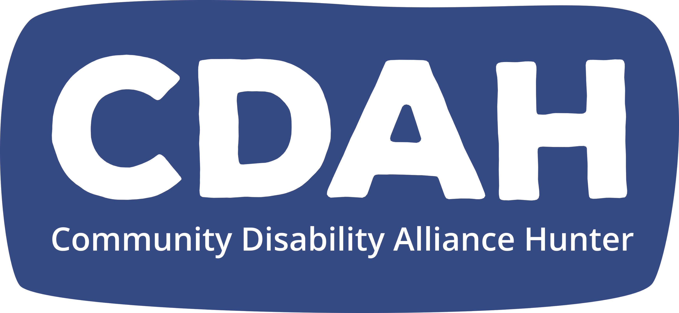
Community Disability Alliance Hunter Incorporated
406 - 408 King Street
Newcastle West NSW 2302
ABN: 32 394 152 929
Email: info@cdah.org.au
www.cdah.org.au

Community Disability Alliance Hunter Incorporated
(incorporated under the Association’s Incorporation Act 2009)
BOARD NOMINATION FORM 2021/2022

I wish to nominate to the Board of Community Disability Alliance Hunter Incorporated for the year 2021/2022.

Name:

Address:

Phone (Home):

Phone (Mobile):

Email:

Date of Birth:

Place of Birth:

(Information about date and place of birth is required by the Australian Charity and Not for Profit Commission)

Please mark one. Are you:
- a person with disability?
- a family member of a person with disability?

Please note: to be a member of the Board you need to hold a current WWCC.

Your signature:
Date:

Name of seconder (please print):

Signature of seconder:
Date:

