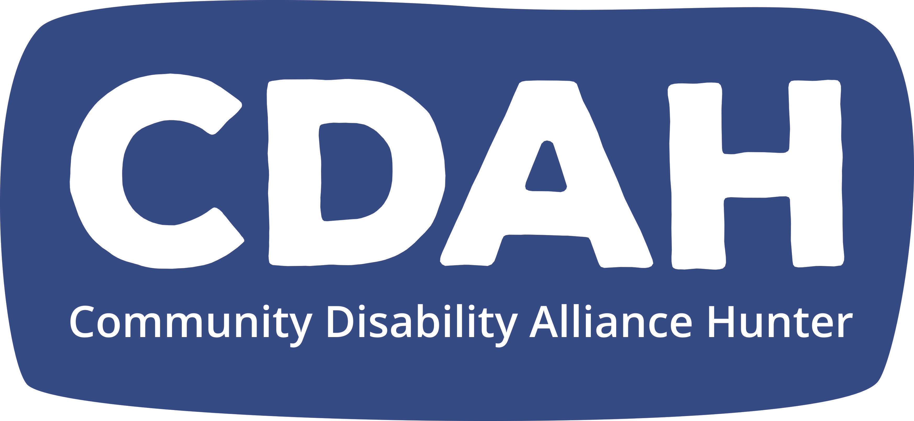
Guidelines for Mentors

About Peer Mentoring at CDAH
At CDAH, we believe in the power of Peer Support.

We believe that people who have shared experiences can offer invaluable support to others who are about to embark on a similar journey.

We want to grow a culture and community of people who support each other. This is part of our bigger movement to grow peer support as a viable option in the Hunter.

We want people to have the option to choose a peer mentor, rather than government or service providers, and for peer support to be recognised as an essential source of support for people with disability.

We want to build opportunities for people to help themselves and to help others.

Our peer mentoring relationships will be:
- founded on mutual respect and a connection between equals
- time-limited, one-to-one relationships that have a specific focus
- about sharing knowledge, ideas and experience to support, encourage and motivate another person
- non-judgemental, with a focus on an individual’s strengths not weaknesses, working towards people with disability living full and valued lives with real choice, voice and control.

Role of CDAH’s peer mentors
CDAH’s peer mentors have completed a training program and are now ready to provide one-to-one peer support to others. Our Peer Mentors have skills and qualities such as:
- being good at listening
- having empathy - able to see the world from someone else’s point of view
- curiosity - an interest in others
- understanding what helps other people to learn and grow
- being OK with being challenged and challenging others
- being good at asking questions
- having difficult conversations with others.

Peer mentoring relationships at CDAH are purposeful, specific and time limited.

A CDAH’s Peer Mentor’s role is to provide guidance and support to mentee’s who have a specific goal to get the most out the mentoring relationship so people can grow and develop in their own lives and communities.

"Mentoring is to support and encourage people to manage their own learning in order that they may maximise their potential, develop their skills, improve their performance and become the person they want to be."

Eric Parsloe, The Oxford School of Coaching & Mentoring

CDAH Peer Mentor Responsibilities
A CDAH Peer Mentor will:
- Assist the mentee to define learning goals in relation to mentoring
- Listen objectively, act as a sounding board to the mentee’s ideas, plans and issues
- Ask questions that encourage the mentee to explore issues from various perspectives
- Challenge the mentee’s traditional ways of thinking and act to try strategies that are outside their comfort zone
- Facilitate the mentee’s learning and development, and leadership potential
- Provide information, guidance, support, encouragement and constructive feedback
- Facilitate problem-solving and decision making in relation to the identified goals
- Ensure evaluation forms are completed for both the mentor and mentee.

Role of the mentee
Ultimately, each mentee takes responsibility for their own growth and success, but the mentor can aid in exploring the best ways to accomplish this. Ask your mentee to keep a list of questions as they arise. This can be a good way to begin mentoring conversations.

Mentee responsibilities
- Define their learning needs in relation to peer mentoring
- Make decisions and taking appropriate action
- Follow through on suggestions made by the mentor
- Keep commitments made with the mentor
- Participate in the evaluation

Purpose of mentoring
To support mentee’s to reflect, grow, change and become leaders in their own lives. You are there to help mentee’s think about their life. You are there to share your life experience and be able to help mentee’s with their reflecting and planning. You might give suggestions about how they might try something different, or reframe a particular thought pattern.

Timing of mentoring sessions
You will meet with each emerging leader you are mentoring between 3 - 5 times.
Each meeting will be between 0.5 – 1.5 hours long, allowing flexibility for communication needs.

If more than this amount of time is seen as necessary, the mentor can discuss this with the Executive Officer.

Locations of mentoring sessions
Meet in a public place. All CDAH Peer Mentoring sessions need to take place in a public space. Where you meet is up to you to negotiate with each other. You may wish to meet in a coffee shop, public library, community centre or public park.

It is always preferable to meet in person to undertake the mentoring sessions. After meeting up in person, you can undertake mentoring sessions by talking over the phone, or on internet, only if this is necessary.

COVID19 response
We expect that all mentors & mentees will discuss their comfort levels with public meetings during COVID-19 and follow instructions from NSW Health in regards to social distancing.

If you prefer to not to meet in person at this time, negotiate what is the best form of communication for you both.

Confidentiality
What is discussed between you is confidential, as is everything about your mentoring relationship with your mentor. CDAH Peer Mentors must not breach confidentiality.

However, there are some exceptions where it will be appropriate and necessary for mentors to share content of the mentoring sessions with the Executive Officer, such as:
- where they suspect on reasonable grounds that a child is at risk of significant harm, in line with mandatory reporting guidelines
- where there are concerns for the personal safety of the person you are mentoring due to abuse, self-harm or suicidal thoughts/ expressions.

Referral
Many people will not have had access to peer mentoring before so it is likely that additional issues may arise during sessions. For example, people may reveal past abuse, have an emotional issue they are dealing with or seek information on self-managing their funding.

It is important for mentors that when this happen you:
- acknowledge when this happens
- recognise if it falls outside the scope of mentoring
- reinforce the purpose of mentoring, and
- make appropriate referrals if necessary.
The mentor can seek advice from the Executive Officer, whilst still protecting the confidentiality of the person they are mentoring. The mentors should also refer the person to the CDAH Team for more information, support and referral to appropriate services and support.

Evaluation
Mentors will need to:

- complete a pre-evaluation form when beginning their role as a mentor at CDAH
- complete a post-evaluation form at the end of each mentoring relationship.
- Manage and support mentees to complete their pre and post evaluations as well. You may need to do this together if your mentee needs support to fill in the evaluation form.
This is a VERY IMPORTANT part of our project, to help us secure future funding. We NEED it to be done for every relationship.

Safety
What to do when I feel insecure, worried, uncomfortable about my safety…

Bring the session to a close. Leave. Get out.

Call us:

Executive Officer 0490 053 454

We will work out a solution for the problem with you.

Complaints process
CDAH takes all feedback & complaints seriously.
We encourage recommendations and requests for change at all times.

Please contact the EO in the first instance.
If you wish to pursue a formal complaint, there is a form you can fill out. We will send this to you, along with a copy of the policy.

Getting my first Mentee

Everybody who has their profile up on the CDAH website has the chance to be chosen as a Peer Mentor.

Now that your profile is ready to go – expect a call from us at any time!

Please let us know if your availability or details change, so we can keep your profile current

More information
For more information on any aspect of CDAH’s peer mentoring contact the CDAH office on

Mobile: 0490 053 454
Email: info@cdah.org.au

