Table of Contents
Introduction 5
What You Will Find in This Communication Book 5
What is Dual Sensory Impairment (DSI)? 5
How DSI Can Affect Communication? 5
Terms Used in This Communication Book 6
About This Communication Book 6
Touch, Consent and Personal Boundaries 8
Good Communication Environment 9
Why does it matter? 9
How to create a good communication environment? 9
Communication in Different Settings 11
Communication in Everyday Life 11
Before communicating 11
Creating a communication-friendly environment 11
Developing shared communication strategies 12
Supporting choice and participation 12
Learning together 12
Communication in Healthcare Setting 12
Before you begin 13
When meeting a person with DSI in healthcare setting 13
What is Health Haptics? 14
Communication in Emergency Situation 20
Communicating during an emergency 20
Emergency Haptices 20
Have a backup communication method 20
Contacting emergency services 20
Communication Strategies 21
Personalised Signs Used with Family and at Home 21
Introduction 21
When to use it? 22
How to use it? 22
Name Signs or Body Names 22
Introduction 22
When to use it? 22
How to use it? 22
Examples of Name Signs 23
Objects of Reference 25
Introduction 25
When to use it? 26
How to use it? 26
Print on Palm (POP) 27
Introduction 27
When to use it? 27
How to use it? 27
Social-Haptic Communication 28
Introduction 28
When to use it? 28
How to use it? 28
Personal Touch Messages 30
Deafblind Manual Alphabet/ Tactile Alphabet/ Fingerspelling 30
Introduction 30
When to use it? 30
How to use it? 31
Tactile Auslan (Hands-on-hands) 34
Introduction 34
When to use it? 34
How to use it? 34
Australian Sign Language (Auslan) 34
Introduction 34
When to use it? 35
How to use it? 35
Braille 36
Introduction 36
When to use it? 37
How to use it? 37
Appendix – Services and Organisations 38
Part 1. Deafblindness 38
Able Australia 38
Deafblind Australia 38
Deafblind Information Australia 38
Part 2. Vision and hearing support 38
Vision Australia 38
Hearing Australia 39
Hearing Matters Australia 39
Hearing Services Program 39
Part 3. Communication and access 39
Communication Support 39
National Relay Service (NRS) 40
Part 5. Captioning 51
Ava 51
Part 6. Community and advocacy 51
Deafness Forum Australia 51
Part 7. Local deafblind services and peer groups 51
Appendix - Resources 52
Resources 52
Deafblind Learning Resources 52
Individual Communication Handbook Template 52
Deafblind Communication Methods and Strategies 52
Adapting Communication 52
Deafblind Australia Resource Hub 53
Self-Advocacy Resources 53
Deafblind Awareness Resource 53
Introductory Online Deafblind Course 53
Audio and Braille Books 53
Vision Australia Library 53
Braille House Library 53
Bookshare 54
Local public libraries 54
Recommended Books 54
Appendix - Assistive Technology 55
A. Hearing devices and hearing support 55
Finding the right hearing support 55
Hearing Devices 55
Cost and financial support 57
B. For Vision 57
Magnifiers 57
Computer Screen Readers 57
Refreshable Braille Displays 58
C. For Mobility 58
Sunu Band 58
White Canes 58
Dog Guides 58
Navigation and wayfinding technology 59
D. Smart phone & Computer Application 59
Built-in Smart Phone Application 59
Built-in Computer Application 62
E. Everyday Technologies 65
Tactile dots 65
Tactile bands 65
Contrasting non-slip mats 65
Magnifying lamps 65
Smart locks 65
Sensors in the home 66
Alerting devices 66
Identification wristband 66
Creative everyday solutions 66
Survey of the Deafblind Communication Book 68

Introduction

This communication book is designed to support older adults with Dual Sensory Impairment (DSI) to communicate with their families, carers, and health professionals.

What You Will Find in This Communication Book
This communication book provides practical information about:
- Understanding Dual Sensory Impairment (DSI)
- Communication Strategies
- Communication in different settings
- Personal communication profile
- Resources and links
- Communication supports and assistive technology

What is Dual Sensory Impairment (DSI)?
Dual Sensory Impairment (DSI) means having a combined vision and hearing impairment. When both senses are affected, they cannot easily make up for each other. This can make communication, accessing information, moving around safely, and participating in everyday life more challenging.
Every person's experience of DSI is unique. Some people are born with DSI, while others develop it later in life. The degree of vision and hearing loss, the causes, and the way DSI affects everyday life vary from person to person.

How DSI Can Affect Communication?
Communication is an important part of everyday life. It helps us build relationships, make choices, access services, and stay connected with others.
For people living with DSI, communication can become more difficult. A person may miss speech, facial expressions, gestures, signs, or written information, meaning they may receive only part of a message. This can make communication confusing, tiring, or stressful.
DSI may also make it harder to explain a problem, ask for help, make decisions, or tell others what is needed. Communication challenges are different for everyone and depend on a person's hearing, vision, environment, and preferred way of communicating.
Some people may not think of themselves as having dual sensory impairment, especially if their hearing and vision have changed gradually over time or they believe these changes are a “normal” part of ageing. As a result, they may not realise what support is available or which information is relevant to them.
Many existing resources focus on either hearing loss or vision loss rather than the combined effects of both. This can make communication more difficult for people with dual sensory impairment, their families, carers, support workers and healthcare professionals.
This communication book aims to support communication by introducing practical strategies that can be adapted to each person's strengths, preferences, and communication needs.

Terms Used in This Communication Book
Throughout this communication book, we use the term Dual Sensory Impairment (DSI) to describe people with combined hearing and vision loss. We generally use person-first language, such as person with DSI or people living with DSI.
We recognise that language is personal, and people may prefer different words to describe themselves. Some people identify as deafblind, while others prefer terms such as person with dual sensory impairment, dual sensory loss, acquired deafblindness, congenital deafblindness, usher syndrome, person with hearing and vision loss, or person with low vision and hearing loss. Whenever possible, ask the person how they would like to be described and respect their preferred terminology.
Some organisations and services also use the term deafblind, so readers may see both terms throughout this communication book. The terms used by organisations are retained when referring to their names or services.

About This Communication Book
Everyone has different communication preferences, strengths, and support needs. There is no single communication method that works for everyone. This communication book introduces a range of communication strategies and practical tips that may be helpful in different situations.
We encourage people living with DSI to develop a Personal Communication Profile that describes their preferred communication methods, support needs, and any adjustments that help them communicate effectively. This profile can be shared with family members, friends, carers, support workers, and healthcare professionals to help others communicate in the way that works best for the individual.
We recognise that communication needs, technology, and knowledge may change over time, sometimes rapidly. This communication book is intended to provide practical suggestions rather than a complete resource, and we encourage readers to continue exploring new information and support as they become available.
With the right communication strategies, supportive environments, and appropriate technology, people living with DSI can continue to build relationships, make informed choices, and participate in the activities that are meaningful to them.

Touch, Consent and Personal Boundaries

Many communication methods used by people with dual sensory impairment (DSI) involve touch. While touch can provide important information and support communication, it should always be guided by the person's preferences and informed consent. Never assume that someone is comfortable with touch, even if they have used tactile communication before or you have communicated with them previously.
Before using a tactile communication method, ask about:
- how the person gives, refuses or withdraws consent
- which hand or hands they prefer for tactile communication
- where they are comfortable receiving touch during communication
- which areas should not be touched
- how they communicate “yes,” “no,” “stop,” “wait” or “I need a break”
- the pressure, speed and size of touch messages that they can recognise easily
Pressure, speed and size may also be used to express different emotions or levels of intensity. For example, a larger or firmer touch message may communicate a bigger smile or stronger laughter.
Agree on how touch will be used with the person. Some people may need firmer touch because they have reduced sensation, while others may be more sensitive and prefer lighter touch.

Good Communication Environment

A good communication environment is a space that helps a person with deafblindness see, hear, understand and communicate more easily. Simple changes to the environment can sometimes make communication easier than using more complex communication methods.

Why does it matter?

Hearing and vision loss can make it difficult to follow conversations, especially in noisy or visually distracting environments.

A communication-friendly environment can help the person:
- Hear speech more clearly.
- See the speaker's facial expression, lips reading or signs.
- Reduce distractions.
- Focus on the conversation.
- Communicate more comfortably and confidently.

How to create a good communication environment?

- Reduce background noise
- Choose a quiet place for conversations.
- Turn off or lower the volume of the TV and radio.
- Reduce noise from fans, air conditioners, equipment hum, TVs or music, outside traffic or construction work if possible
- Soft surfaces, such as carpets, can help reduce echo and reverb.
- Improve lighting
Ask the person what lighting works best for them.
- Adjusting light levels
  - brighter for those using visual cues to compensate for hearing loss.
  - dimmer for those for whom glare makes vision difficult or painful.
- Avoid strong glare, especially from windows or bright lights.
- Choose a simple background
- Use a simple and uncluttered background behind the speaker.
- Avoid sitting in front of posters, equipment racks, flashing lights or screens.
- Face the person when speaking
- Make sure your face is clearly visible, if they use vision or lip-reading to support communication.
- If possible, place the light behind the deafblind person. Make sure the light can shine towards the speaker to make the speaker's face easier to see.
- Remove masks when it is safe and appropriate to do so.
- Wear plain coloured garments
- If the person uses lip-reading or visual cues, plain clothing can make it easier to see the speaker's face and hands.
- Wearing strong-coloured lipstick can help someone who lip-reads.
- Speak clearly and allow enough time
- Speak clearly and at a comfortable pace.
- Do not shout unless the person asks you to speak louder.
- Avoid rushing or interrupting. Give the person enough time to listen, process information and respond.
- Check if the person understood the information. Repeat or explain the message in a different way if needed.
- Describe what you are doing
When appropriate, tell the person what you are doing or what is happening around them. For example:
- "We are sitting in a quiet room."
- "I am placing your cup on the table to your right."
- "I am going to move your chair slightly."
- Describe the exact location of people or objects instead of using vague words like "here" or "over there".
Clear and specific directions are easier for a person with sensory loss to understand. This can help the person understand what is happening and feel more comfortable.
- Ask the person what works best for them.
Every person with deafblindness has different communication needs. Adjust the environment based on their individual hearing, vision, communication method and preferences.

Communication in Different Settings

Communication can look different depending on the situation, the environment, and the people involved. The following pages share ideas that may help make communication easier in everyday life, healthcare and emergency situations.
Everyone with dual sensory impairment (DSI) communicates differently. People have different levels of hearing and vision, different communication experiences, and different preferences. Taking time to learn what works best for the individual is often the best place to start. If the person cannot tell you directly, their Personal Communication Profile in this book may provide helpful information about their preferred communication methods, strategies and personal preferences.

Communication in Everyday Life

Everyday activities provide many opportunities for communication. The ideas below may help make communication more comfortable, meaningful and person-centred.

Before communicating
Getting the person's attention before communicating can help avoid confusion and make the interaction more comfortable.
Some people may prefer:
- their name being spoken
- a gentle touch on the hand, arm or shoulder
- a familiar visual cue
- another agreed way of gaining attention.
The person's preferred approach can be recorded in their Personal Communication Profile.

Creating a communication-friendly environment
Small changes to the environment may make communication easier.
For example:
- reducing background noise, such as turning down the television or radio
- improving lighting for people who use their remaining vision
- choosing a quiet place for longer conversations
- reducing unnecessary distractions where possible.

Developing shared communication strategies
Many families, friends and regular carers naturally develop communication strategies that become meaningful over time.
These might include:
- home signs
- objects of reference
- name signs
- agreed touch cues
- consistent words, gestures or routines.
Using familiar strategies consistently may help make communication more predictable and reduce misunderstandings.

Supporting choice and participation
Communication is more than exchanging information. It can help people with DSI express themselves, make choices and participate in everyday life. Family members, carers and health professionals may find it helpful to create opportunities for the person to:
- choose what they would like to wear, eat or drink
- decide how they would like to spend their time
- ask questions and seek information
- express their feelings, opinions and preferences
- participate in family conversations and everyday activities.
Allowing enough time to communicate may help the person participate more fully.

Learning together
Communication often develops over time. Trying different approaches, observing what works well and discussing preferences with the person can help build shared understanding.
The Personal Communication Profile can be updated as communication needs and preferences change.

Communication in Healthcare Setting

Good communication is essential for safe, respectful, and person-centred healthcare. For a person with DSI, communication can be especially difficult in healthcare settings.
- Some may have difficulty responding to questions or expressing their needs.
- An interpreter or support person may not always be available.
- They may be receiving treatment where they cannot use their usual communication method.
- Their communication needs may be mistaken for confusion, cognitive impairment or dementia.
- They may appear not to understand when they are actually unable to hear spoken information or see visual cues from healthcare professionals.
In these situations, healthcare professionals need to use appropriate communication strategies to ensure the person can understand what is happening and communicate their needs.

Before you begin
- Arrange appropriate communication support the person needs to understand information and give informed consent.
- Ask the person's preferred communication method.
- Don't ignore the person while waiting for an interpreter.
- Speak directly to the person, not only to their interpreter or support person.
- Allow extra time for appointments whenever possible as communication may take more time.
For complex or important healthcare information, such as treatment options, risks and consent, make sure the person has access to appropriate communication support so they can understand the information and make informed decisions.

When meeting a person with DSI in healthcare setting
- Avoid assumptions.
  - Do not assume that a person is confused or has dementia because they do not respond as expected.
  - Do not assume how the person communicates. People with DSI may use different communication methods depending on their individual needs and preferences.
- Approach calmly. If appropriate, gently touch the person's shoulder or hand to let them know you are there.
- Introduce yourself. Clearly state your name, your role or profession and why you are there.
- Ask the person about their preferred communication method and follow their instructions.
- Position yourself appropriately.
  - Face the person.
  - Make sure your face is visible. Avoid covering your mouth if appropriate.
  - Be at an appropriate height level and distance.
- Choose a quiet environment with enough lighting where possible. - Please refer to Communication strategies - Good Communication Environment (page 9) for more details.
- Check that the assistive devices are working (e.g. hearing aid devices are switched on).
- Speak clearly at a comfortable pace and give enough time for the person to receive, process and respond. Do not shout unless the person asks you to speak louder.
- Check the person’s understanding by asking feedback questions or asking the person to explain the information in their own words. Repeat or explain in different way if needed.
- Describe what you are doing and what is happening around them.
- Tell the person when you leave the situation.
- For medications or treatment information
  - Always check that the person understands the correct medication dose and when to take it.
  - Provide written information in the person's preferred format (e.g. large print, electronic text or Braille).
  - Longer or more complex information, such as diabetes education or physiotherapy exercise programs, may need to be provided in an accessible format that meets the person's communication needs.

What is Health Haptics?
Health Haptics are agreed touch-based signals, a specific vocabulary from social-haptic communication that used to communicate information during healthcare. They can help people with DSI when visual and spoken communication is difficult or not possible.
Before using Health Haptics:
- Ask the person if they use touch-based communication.
- Agree on the meaning of each touch signal.
- Explain where the person will be touched and ask for permission before touching.
- Use the agreed touch consistently.
Remember: Health Haptics may be different for each person. You may refer to Personal Communication Profile - How to communicate with me for the individual communication preference, or ask them what works best for them.
Below are some examples of Health Haptics. Each example is illustrated with a picture showing the described movement.
Identification of professional role
Nurse  Two fingers on the upper arm in the shape of a medical cross: a downward vertical line and then a left- to- right horizontal line. | 
Doctor  Two fingers on the inside of the thumb side of the wrist, where the pulse may be felt. | 

Confirmation
Yes  Closed fist moving in a nodding motion up and down  OR  tapping the hand up and down on the person’s hand/ arm | 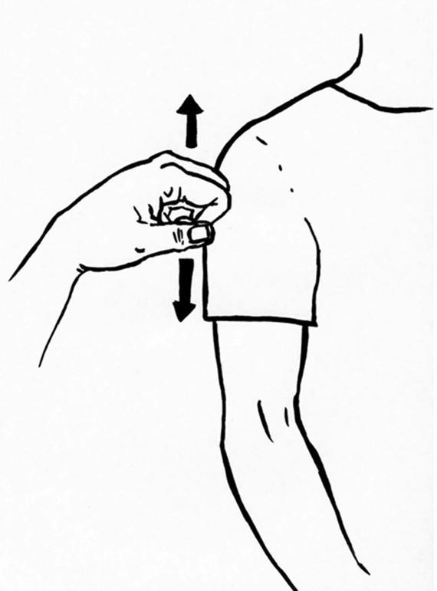 or 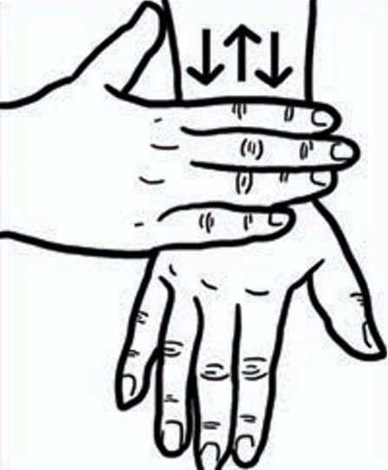
No  Closed fist moving in a shaking motion left-right-left-right  OR  rubbing the hand left to right on the person’s hand/ arm | 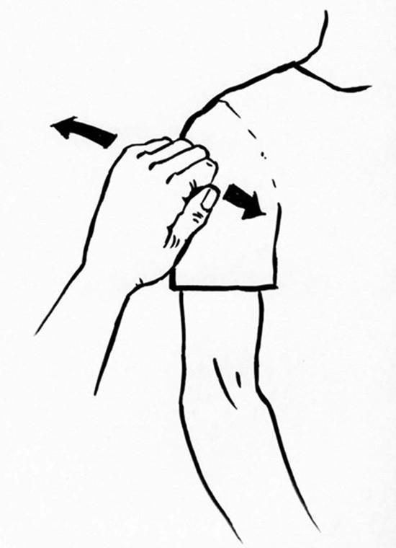 or 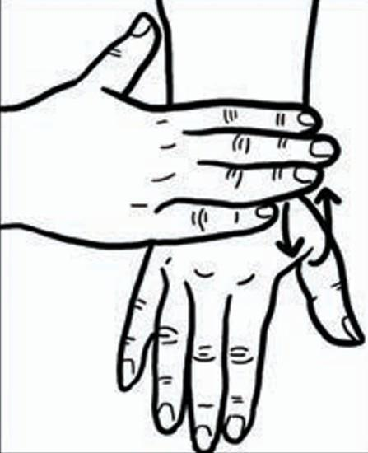

Length of treatment
Time  Tapping the tip of the finger onto the middle of the wrist | 
Wait, no movement  Placing a flattened hand onto the wrist/ arm | 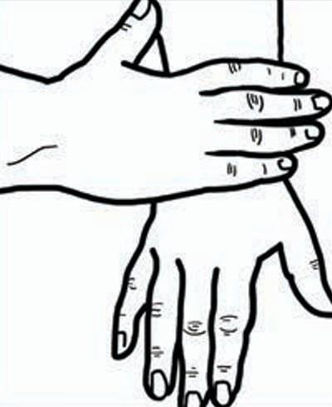
Emotions
Pain and where on the body Claw handshape on the part of the body. A doctor might press a clawed hand on the abdomen and then draw a question mark on the upper arm. This would signify asking: Do you have pain here? | 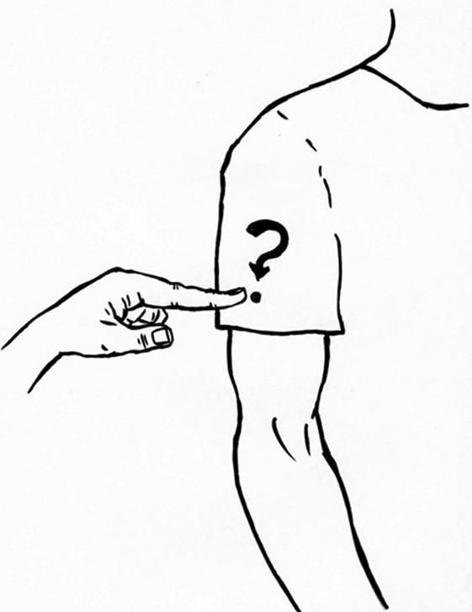
Stay calm, stay still  Hand on the shoulder with some firm but gentle pressure. | 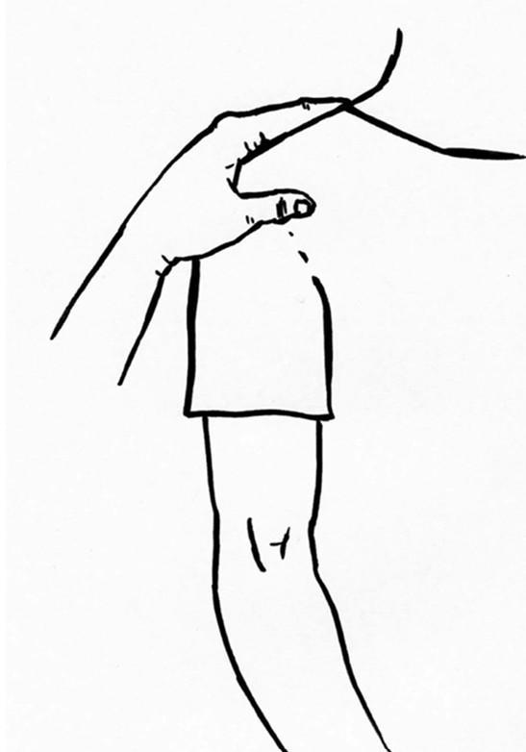
Are you ok? (Three ways of doing this)
Thumbs up and grab the thumb  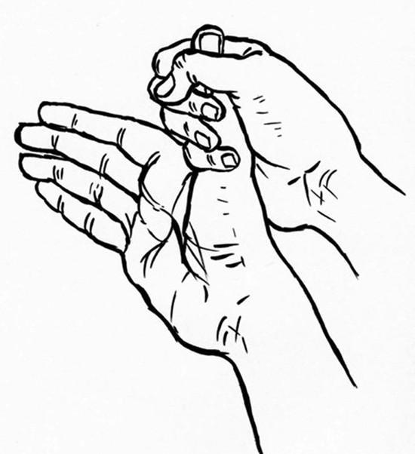 | or, Smiling emotion haptice on the upper arm with a question mark drawn on the upper arm.  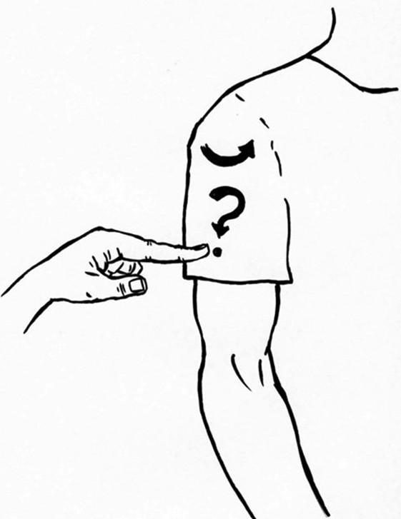 | or, You can also just draw a question mark on the upper arm.

Different measurements/ treatment
Blood pressure  Use hand to form a “cuff” around the upper arm (in the manner of a blood pressure cuff) and squeeze gently | 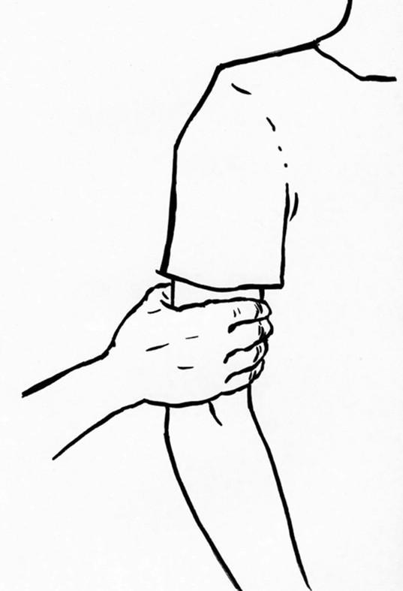
Tablets to take  Use thumb and forefinger to make a pecking motion on the palm of the person with DSI’s hand. This simulates the picking up of pills or tablets and swallowing them | 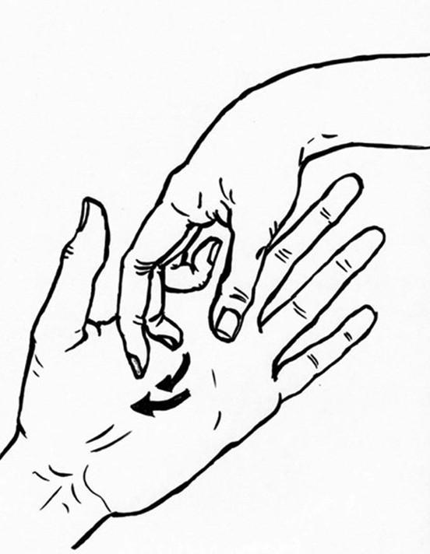
Injection
Lightly grasp/pinch with thumb and index finger the webbing between the person’s thumb and forefinger. Then move finger to the part of the body where the needle will go, e.g., fingertip for finger prick; back of the hand for an intravenous drip; crook of the elbow for a blood test or drip; or the muscle of the upper arm for a vaccination for example
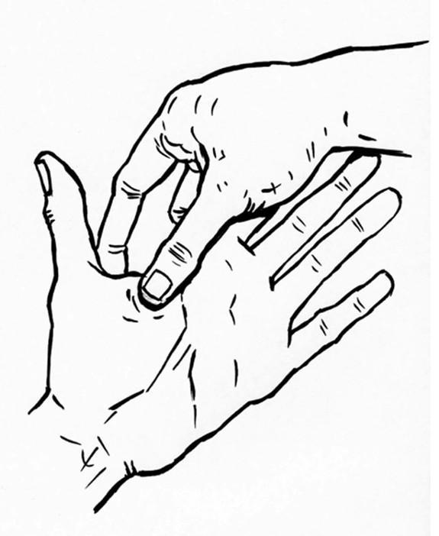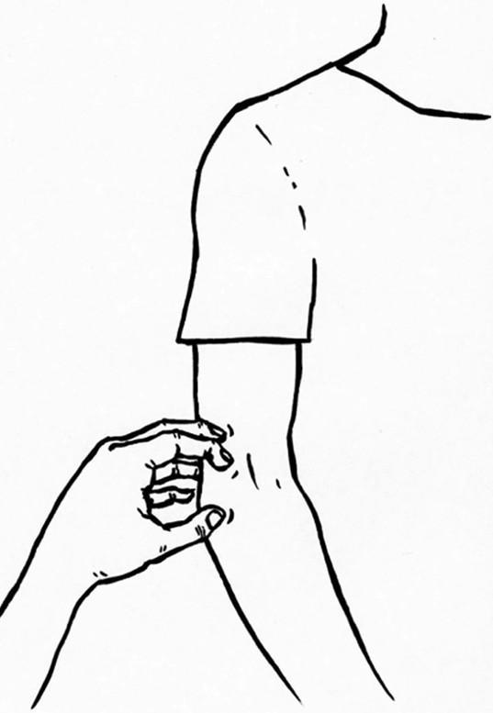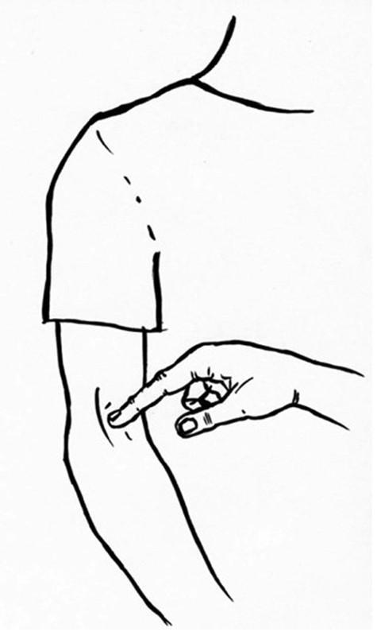
Others
Emergency  Draw a large ‘X’ on the back with blade of the hand or finger (press firmly). This means come with me now and I will explain later. | 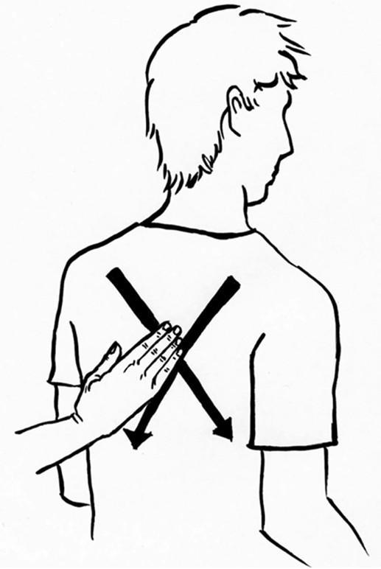
I’m here
Hand on shoulder light to moderate pressure
Illustration credits: Sophie Hague, referenced from photos provided by Riitta Lahtinen

Communication in Emergency Situation
During an emergency, people with deafblindness may not be able to access alarms, announcements, signs or verbal instructions. Communication may also be more difficult because of stress, noise or changes to the environment.
Having an emergency communication plan can help others communicate clearly and safely.

Communicating during an emergency
- Gain their attention using their preferred communication method.
- Use their usual or agreed on communication method to let them know what is happening and what they need to do.
- Give one piece of information at one time.
- Tell them where they are going and who is with them.
- Check that they have understood before moving on.
- If time allows, refer to their Personal Emergency Communication Profile for additional guidance.

Emergency Haptices
Some people who use social haptic communication may use agreed emergency haptices. For example, some people use a large X traced on the back to indicate an emergency or the need to evacuate. Emergency haptices should only be used if they have been agreed on in advance and are included in the person’s Personal Emergency Communication Profile.

Have a backup communication method
A person’s usual communication method may not always be available during an emergency. It is helpful to have one or more backup communication methods that the person already knows and uses. Record these methods in the Personal Emergency Communication Profile.

Contacting emergency services
The person may contact Police, Fire or Ambulance through Triple Zero (000) using a standard voice call if this meets their communication needs. Otherwise, they can access Triple Zero through a suitable National Relay Service (NRS) option.

Their preferred and backup methods for contacting emergency services should be recorded in their Personal Emergency Communication Profile.
For more information, see Appendix Services and Organisations – National Relay Service (NRS).

Communication Strategies
People with dual sensory impairment (DSI) communicate in many different ways. Some people use speech, while others use sign language, touch, written information, assistive technology, or a combination of different strategies.
There is no single communication method that suits everyone. The best approach depends on the person’s hearing and vision, existing communication skills, preferences, previous experiences, environment and situation. People may use different strategies in different situations or change their strategies as their hearing or vision changes. For example, someone may use speech for one-to-one conversations, an FM microphone in noisy environments, customised subtitles when watching television, and hearing aids when socialising with family or friends.
If hearing and vision change suddenly, it may be helpful to start with familiar ways of communicating, such as objects, gestures, written language or agreed signals. Other communication methods may take more time and practice to learn. For this reason, this chapter broadly introduces strategies from those that may be easier to use straight away to those that may require more learning. However, there is no set order. The best place to start depends on what works for each person.
Every person is different. Taking the time to ask, listen, and adapt to their preferred way of communicating is one of the best ways to build understanding and meaningful connections. If the person cannot tell you directly, the Personal Communication Profile in this book may help you understand their:
- hearing and vision condition
- communication preferences
- strategies that work well
- things they do or do not like

Personalised Signs Used with Family and at Home

Introduction
Personalised signs are gestures, movements or touch cues developed by the person and people who know them well. They may identify familiar people or communicate needs, choices, feelings and everyday activities.
These signs may not be part of an established language. People who are unfamiliar with them may need instructions to understand and use them.
Record each sign and its meaning in the person’s Personal Communication Profile. This allows family members, friends, support workers and health professionals to use the signs consistently.

When to use it?
- Personalised signs may be useful for familiar, everyday messages between the person and people who know them well.
- Another communication method may be needed when sharing unfamiliar, detailed or complex information.

How to use it?
- Find out which signs the person uses and what they mean.
- Record each sign in their Personal Communication Profile.
- Gain the person’s attention.
- Make the sign clearly in the agreed way.
- Give them time to recognise and respond.
- Update the profile when a sign changes.

Name Signs or Body Names

Introduction
A name sign is a unique sign made with the hands to identify a person, like a spoken or written name. It is traditionally created for a person by someone from the Deaf community.

When to use it?
When someone:
- lives with hearing loss and needs to identify a person visually.
- lives with dual sensory impairment (DSI) and needs to identify a person through touch.

How to use it?
- Work with the person to agree on the name sign or touch cue used to identify each person. The person with DSI should be able to recognise the sign clearly.
- Record each sign and the person it identifies in the Personal Communication Profile. This helps family, friends, support workers and health professionals use the correct signs consistently.
- Gain the person’s attention.
- Make the name sign clearly in the agreed way.
- Give the person time to recognise it.
- Continue using their preferred communication method.
- Let the person know when someone arrives or leaves.
If the person already has a name sign, continue to use it. If a new sign is needed or an existing sign needs to change, decide this with the person and record the change in their profile.

Examples of Name Signs
Maddie
Maddie’s name sign is a swirl drawn on the hand, to represent mixing ingredients in a bowl, as Maddie enjoys baking.

(Figure X. Demonstration of Maddie’s name sign performed on the palm. Illustration by Sophie Hague. )

Skye
The letter “S” (for Skye) from the manual alphabet (signer’s index finger wrapped over the receiver’s pinky finger).

(Figure X. Demonstration of Skye’s name sign performed on the palm. Illustration by Sophie Hague. )
Suzie
Two lines drawn with thumb and forefinger on the upper arm, decreasing in width towards the shoulder. This name sign has two interpretations: the Eiffel Tower, as Suzie loves France, and a bottle of champagne – as Suzie also loves champagne!
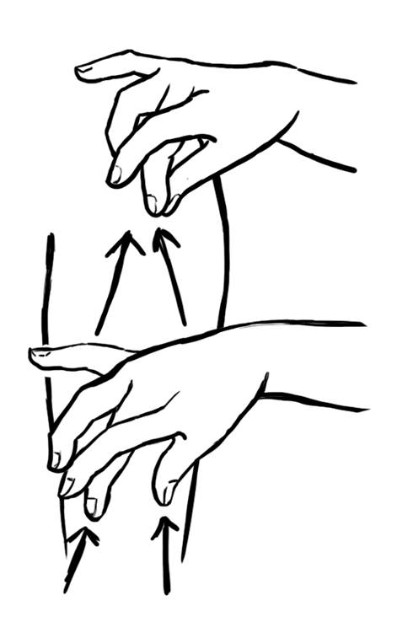
(Figure X. Demonstration of Suzie’s name sign performed on the palm. Illustration by Sophie Hague. )
Diana
The letter “D” (for Diana) from manual alphabet but using the upper arm as a touch point.

(Figure X. Demonstration of Diana’s name sign performed on the palm. Illustration by Sophie Hague. )
Natalie
A circular movement of a closed fist on the upper arm, to represent cheerleading, a sport that Natalie competes in. If you take the movement away from the arm and into the air, it looks like waving a pom pom.


(Figure X. Demonstration of Natalie’s name sign performed on the palm. Illustration by Sophie Hague. )

Objects of Reference

Introduction
Objects of reference are real objects or parts of objects that represent a person, place, activity, or idea. They help people understand what is happening or what will happen next by using touch and familiar objects. For example, a cup may mean "a drink," or a sponge may mean "bath time." The object should be personal to the user and allows people to associate specific items with an upcoming event.

When to use it?
When someone:
- Lives with vision loss or dual sensory impairment (DSI) and benefits from using touch to understand information or everyday activities.

How to use it?
- Select a small number of familiar objects that represent common people, places, or activities.
- Introduce the object before the activity. For example, hand the person a spoon before mealtime or a towel before showering.
- Use the same object in the same way each time to help build a clear association.
- Keep the object with the person during the activity, if appropriate, to reinforce its meaning.
- Encourage the person to use the object to make choices or express preferences. For example, offering a mug to mean "have a drink" and a hat to mean "go for a walk."
- Observe how the person responds and adjust the objects if they are not meaningful or easy to recognise.
- Introduce new objects gradually as the person becomes familiar with the system.
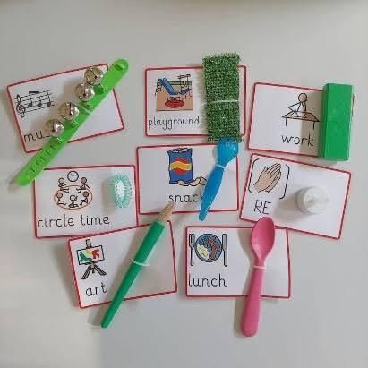
(Picture showing examples of objects of reference. Picture cards representing everyday activities, such as music, playground, work, circle time, snack, art, lunch, and religious education, are paired with real objects that relate to each activity. For example, a spoon represents lunch, a paintbrush represents art, and a bell bracelet represents music. These objects provide tactile cues to help communicate activities and routines.)

Print on Palm (POP)
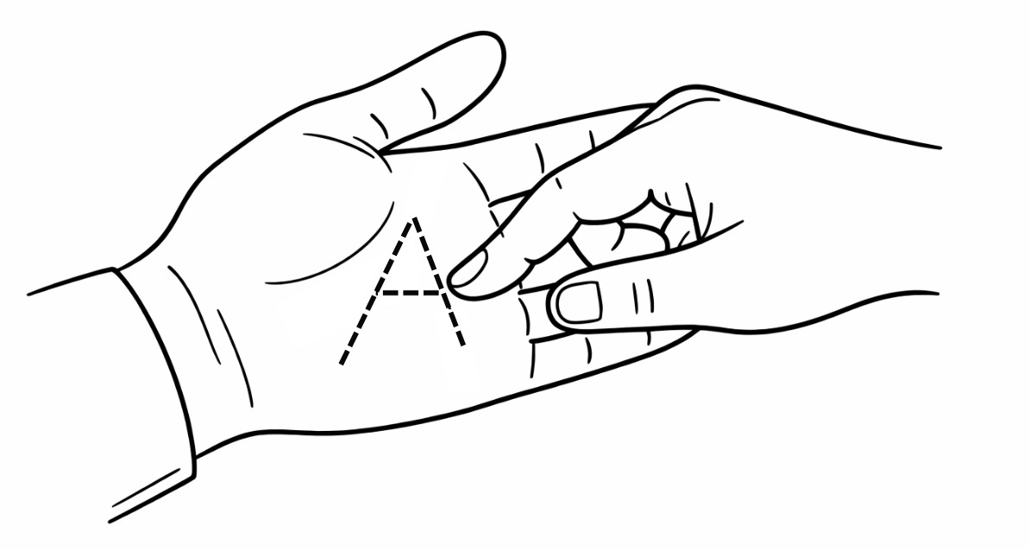

Introduction
Print on Palm is an alternative method for communication used by individuals with DSI. To use this method, people need to print out the words on the palm of the individual’s hand with their index finger.

When to use it?
When someone:
- has limited vision and hearing.
- does not use Auslan or manual alphabet.
- loses vision later in life.
- is learning other tactile communication methods.
- needs to communicate simple requests when no other method is known.
- especially useful in hospital settings to communicate what is about to happen, such as giving an injection, or asking and answering questions.

How to use it?
- Ask for permission before touching the person's hand.
- Hold or support their hand if needed.
- Use your index finger to trace capital letters onto the palm.
- Leave a small pause between each letter. Pause slightly longer between words.
- Repeat information if requested.
- Confirm that the message has been understood.
- Make sure the letters are large enough and in good spelling.

Social-Haptic Communication

Introduction
Social-Haptic Communication (SHC) is a system of short messages shared through touch on the body during social interaction. These touch messages can provide information that may be difficult to see or hear.
SHC can communicate:
- emotions and facial expressions
- agreement or disagreement, such as “yes” or “no”
- who is nearby
- what is happening in the room
- the layout of an environment
- simple information during everyday activities, healthcare or emergencies
SHC is not a language and does not replace the person’s preferred communication method. It should not be used by itself for detailed discussions, shared decision-making or gaining consent.
It adds information that may otherwise be missed and can be used by family members, friends, support workers and health professionals.

When to use it?
When someone:
- lives with dual sensory impairment (DSI) and would benefit from additional information about their surroundings through touch.

How to use it?
- Gain the person’s attention.
- Agree with the person on the meaning of each touch message.
- Agree where the touch will be made. This may include the back, upper arm, forearm or hand.
- Make the touch message clearly and consistently.
- Use pressure, speed and size that the person can recognise easily.
- Give them time to understand the message.
- Check that the message has been understood.

The picture in this section shows examples of Social-Haptic Communication cues. In this example:
- a hand moving up the upper arm means “speak louder”
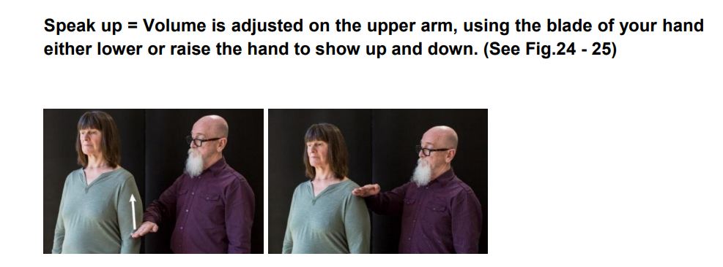
(Figure X. Social-Haptic Communication cue for “speak louder.”)
- a hand moving down the upper arm means “lower voice”
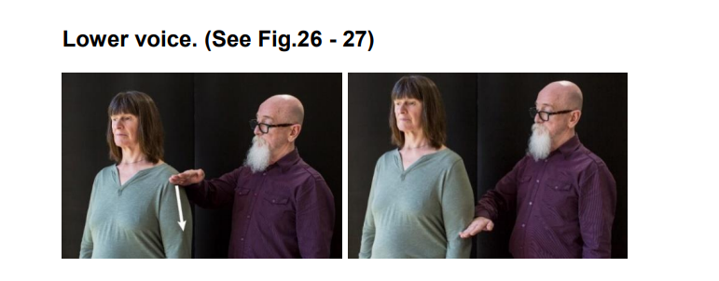
(Figure X. Social-Haptic Communication cue for “lower voice.”)
- two gentle taps on the upper back mean “yes”. The way the taps are made can also express emotion. For example, “yes” may show excitement, impatience or confirmation. The pressure, speed and size of the taps can be adjusted to match the intended feeling, as agreed with the person.
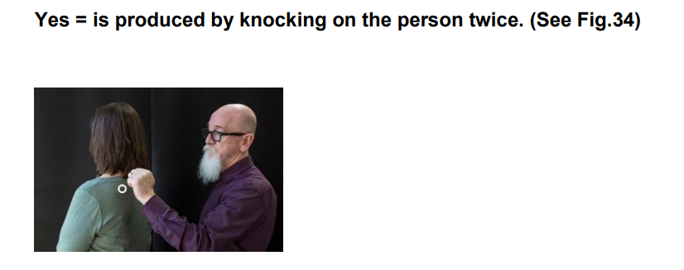
(Figure X. Two taps on the upper back communicate “yes.”)

Personal Touch Messages
- Social-Haptic Communication can be personalised. A person may develop touch messages that meet their individual communication needs.
- Record these messages in their Personal Communication Profile so other people can understand and use them consistently. Update the profile when a touch message is added or changed.

Deafblind Manual Alphabet/ Tactile Alphabet/ Fingerspelling

Introduction
The Deafblind Manual Alphabet is an adaptation of Auslan, and it is based on the Auslan alphabet. It is easy to learn and use, although it may be slow to start at first. Words are spelt directly onto a deafblind person’s hands using the modified alphabet. It’s also called Deafblind Fingerspelling or Tactile Fingerspelling. Different regions or countries may have different manual alphabet systems.

When to use it?
When someone:
- lives with dual sensory impairment (DSI) and prefers to communicate through touch.
- has little or no functional vision, making it difficult to see Auslan or visual fingerspelling.
- knows or is familiar with the Deafblind Manual Alphabet.
- needs to communicate names, places, unfamiliar words, numbers, or short messages, particularly when there is no established sign for a word.
- prefers tactile communication instead of, or alongside, other communication methods such as Tactile Auslan or Print on Palm (tracing capitalised letters on palms).

How to use it?
- Introduce yourself and ask if the person would like to use the Deafblind Manual Alphabet.
- Ask which manual alphabet system they use and how they prefer to position their hands.
- Form each letter using the agreed tactile hand or finger positions.
- Pause between words and sentences.
- Repeat or clarify information if requested.
- Confirm that the message has been understood.
- For instance, use the alphabet for every first letter of a word, maybe B for bathroom, to simplify the communication.

The following pictures showing hand position of Deafblind Manual Alphabet from A to Z.
A | 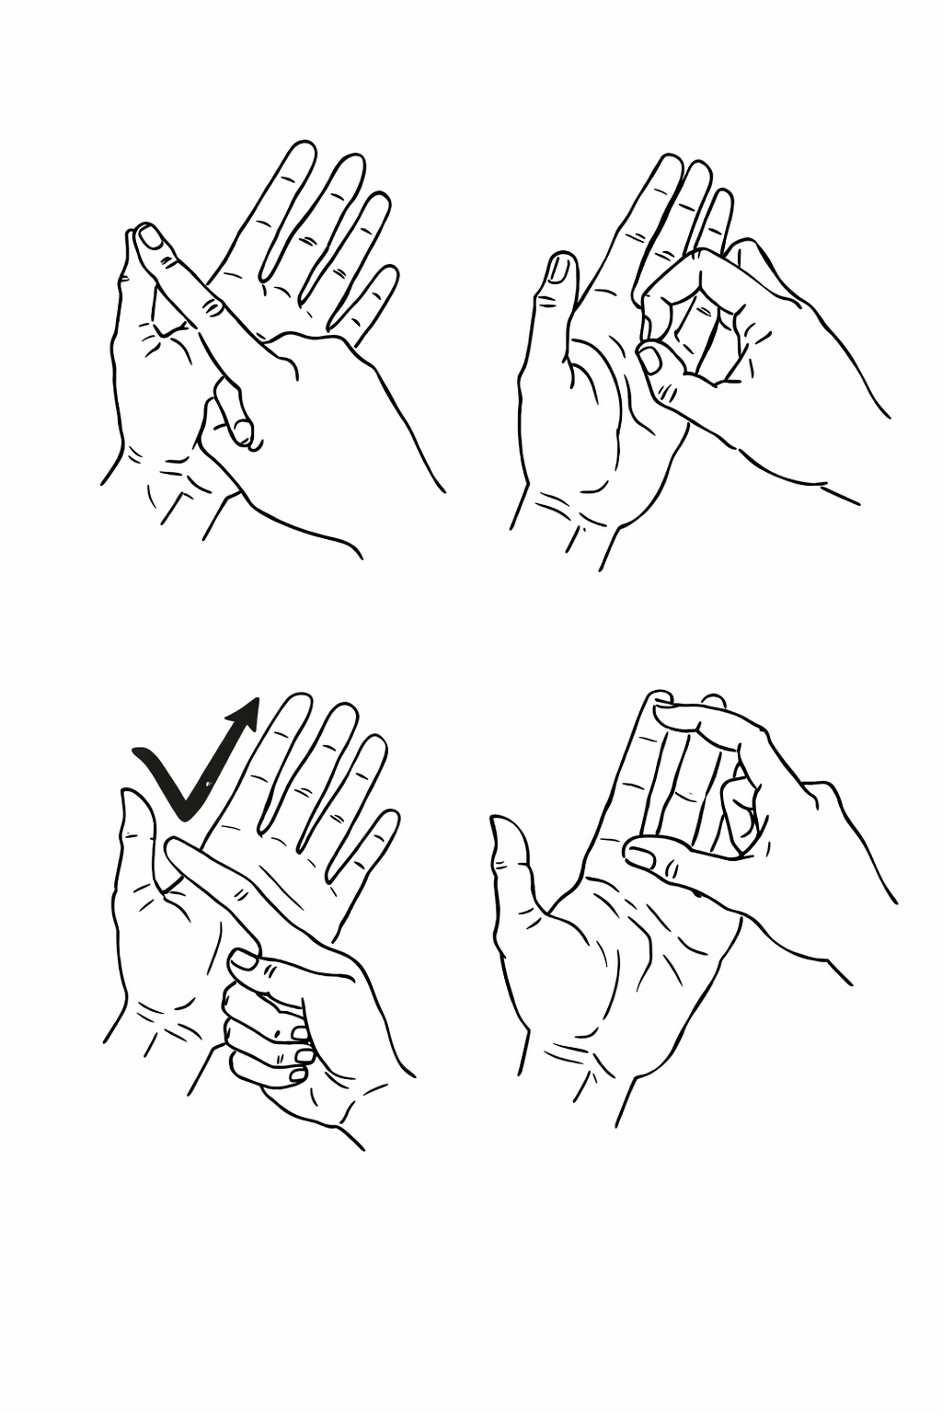 | B |  | C
D |  | E |  | F | 
G |  | H |  | I | 
J | 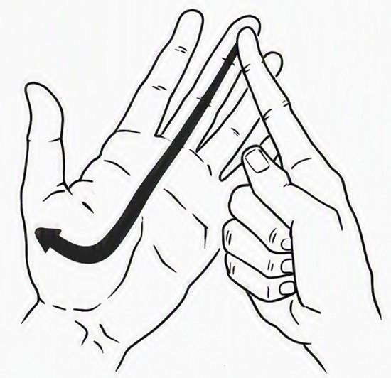 | K |  | L | 
M |  | N |  | O | 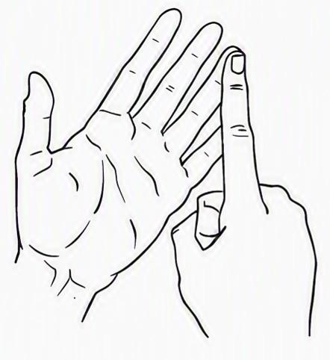
P |  | Q |  | R | 
S |  | T |  | U | 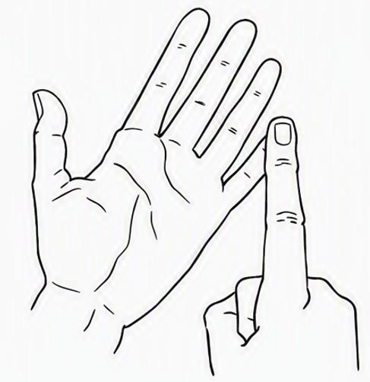
V |  | W |  | X | 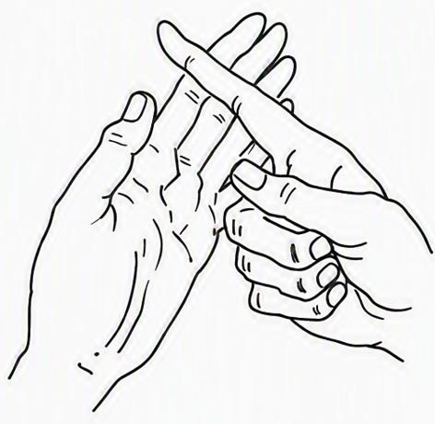
Y | 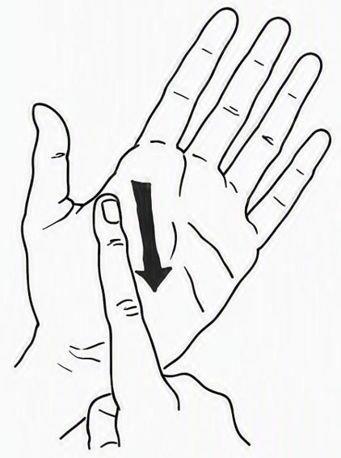 | Z | 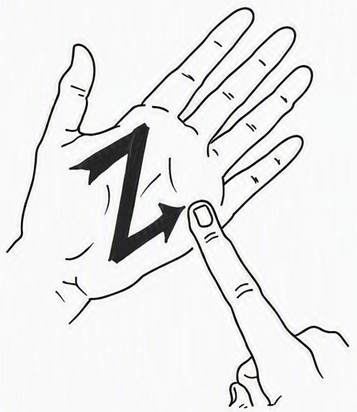

Tactile Auslan (Hands-on-hands)
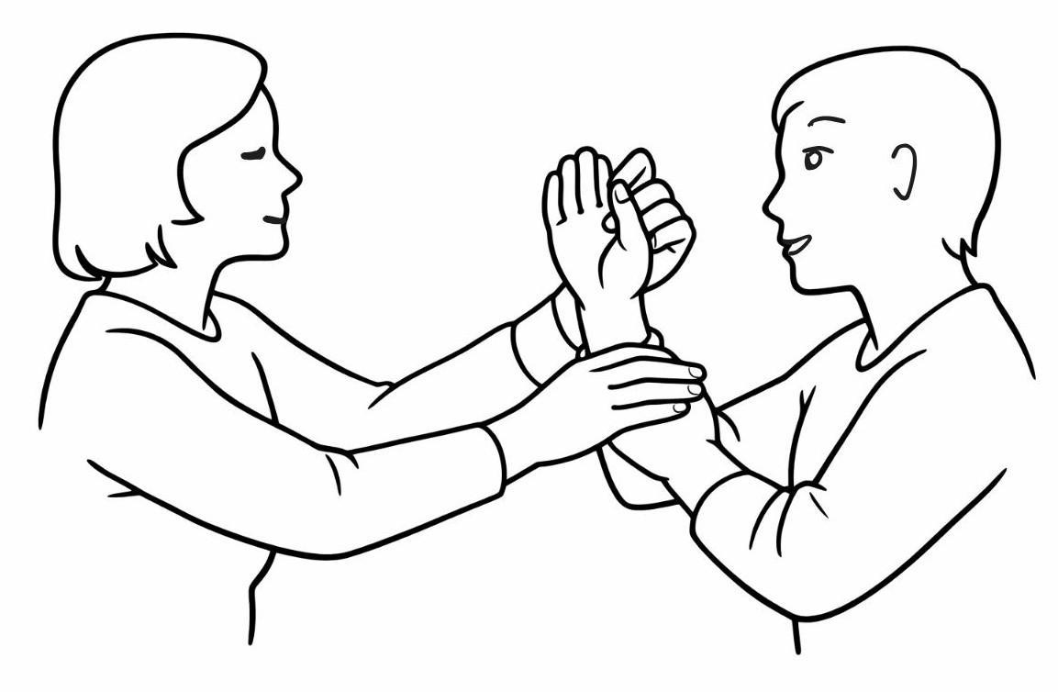

Introduction
Tactile Auslan (Australian Sign Language) is an adaptation of Auslan, where Auslan signs are interpreted through touch rather than sight. The Deafblind person places their hands over the signer’s hands to feel the shape, movement and location of the signs. Emotions and non-manual features will be conveyed through the hands as facial expressions are inaccessible.

When to use it?
When someone:
- lives with dual sensory impairment (DSI) and prefers to communicate through tactile signing
- has learned Auslan

How to use it?
- Gain the person's attention before starting.
- Ask if they would like to use Tactile Auslan.
- Sit facing each other in a comfortable position, close enough for person with dual sensory impairment to touch and feel the signer’s hand. A small table can be used to support the arms of both people, especially in longer conversation.
- Allow the person to place their hands lightly over yours.
- Sign clearly and naturally.
- Pause regularly to allow processing.
- Check that the message has been understood.

Australian Sign Language (Auslan)

Introduction
Auslan is the sign language of the Australian Deaf Community. It uses hand shapes, movements, facial expressions, and body language to communicate. Auslan has its own grammar and vocabulary, so it is different from spoken or written English. For people with different sensory impairments, Auslan can be adapted according to their remaining vision and communication preferences. Common adaptations include:
- Close range signing
- Visual frame signing
- Tracking
- Tactile signing (hand-over-hand signing)
- Deafblind fingerspelling/deafblind manual alphabet

When to use it?
When someone:
- lives with hearing loss and uses Auslan as their preferred language.
- lives with DSI and has enough vision to see signs clearly. Some people may use adapted Auslan, such as signing within a smaller visual field or using Tactile Auslan if their vision changes.

How to use it?
- Start by asking whether the person understands and prefers to use Auslan. Not everyone who is deaf or has DSI uses Auslan, and another communication method may suit them better.
- Try to get the person's attention before you begin signing.
- Position yourself where the person can clearly see your hands, face, and upper body. Good lighting, a plain background, and high-contrast clothing can make signs easier to see, particularly for people with reduced vision.
- Sign at a comfortable pace and allow enough time for the person to respond.
- If the person has reduced vision, ask whether an adapted form of Auslan would make communication easier. Depending on the person's needs, this might include:
  - Close-range signing: the signer moves closer, so the signs are easier to see.
  - Visual frame signing: signs are made within a smaller signing space for people with a restricted visual field.
  - Tracking: the person lightly places their hands on the signer's wrists or forearms to help follow the signs visually.
  - Tactile Auslan: the person places their hands on the signer's hands to feel the hand shapes and movements when vision is very limited.
  - The Deafblind Manual Alphabet: can be used to spell names, unfamiliar words, terminologies, or short messages through touch.
- For important conversations, such as healthcare appointments or legal matters, a qualified Auslan interpreter may be helpful if the person wishes to use one.
- If the person uses an Auslan interpreter, ask about their preferences. For example, they may have a preferred interpreter, prefer an interpreter with experience supporting people with DSI, or have specific seating, lighting, or positioning needs.
- If an Auslan interpreter is present:
  - Speak directly to the person, rather than the interpreter.
  - Talk at your normal pace. The interpreter will let you know if they need you to slow down or repeat something.
  - Allow a little extra time for interpretation, as Auslan has a different grammar from English.
  - If possible, sharing important information or documents with the interpreter beforehand can help the conversation run more smoothly.

Braille

Introduction
Braille is a tactile reading and writing system that uses patterns of raised dots to represent letters, numbers, punctuation and symbols. Braille characters are composed of combinations of dots from a matrix of three rows and two columns, which is called the Braille Cell:
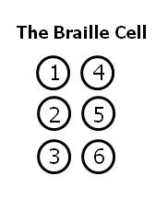
(A picture shows the Braille Cell: a combination of three rows and two columns, consisting of six possible dot positions. The dots are numbered from top to bottom: dots 1–3 on the left and dots 4–6 on the right. )
People read Braille by moving their fingertips lightly across the raised dots. In Australia, the Unified English Braille (UEB) code is the standard used for English Braille.
Braille has two grades. Grade 1 Braille represents each letter individually and is often used by people who are learning Braille or for simple information such as labels. Grade 2 Braille uses contractions to represent common words or letter combinations, making reading and writing faster and reducing the amount of space needed. People usually learn Grade 1 before progressing to Grade 2.

When to use it?
When someone:
- lives with vision loss and cannot read standard print or find print difficult to read;
- lives with dual sensory impairment (DSI) combined and relies on touch to access written information.
Not everyone with vision loss or DSI uses Braille. It is most helpful for people who have learned Braille and prefer it for reading and writing.

How to use it?
If the person uses Braille:
- Ask whether they would like information in Braille.
- Provide documents, labels or signs in Braille whenever possible.
- Use Braille translation software and a Braille embosser to produce Braille versions of important documents, such as letters, appointment information, or instructions.
- For digital communication, Electronic Braille displays can help users reading electronic text through touch. Ensure documents are compatible with screen readers and Braille displays.
- Place Braille labels in an appropriate location so they are easy to find.
- Braille can also support participation in leisure activities. Many board games and card games, such as Monopoly®, Scrabble®, and UNO®, are available in Braille versions, allowing people who read Braille to play with family and friends.
- Allow enough time for the person to read at their own pace.
- If you are unfamiliar with Braille, ask the person how they would like information presented rather than making assumptions.

Appendix – Services and Organisations

The following services and organisations provide information and support related to deafblindness, hearing, vision and communication. These resources can help with finding support, learning about communication options, accessing services and connecting with relevant organisations.

Part 1. Deafblindness

Able Australia
Provides support and resources for people with deafblindness. Their deafblind resources include practical information about communication methods, Social-Haptic Communication and ways to support communication in everyday life.
https://ableaustralia.org.au/resources/deafblind-resources/

Deafblind Australia
A national organisation representing people who are deafblind. It provides information, advocacy and opportunities to connect with other people with deafblindness and deafblind communities across Australia.
https://deafblind.org.au/

Deafblind Information Australia
Provides practical information about deafblindness, communication, assistive technology and available services. It also has a service directory that can help people, families and professionals find deafblind-related support in their state or territory.
https://www.deafblindinformation.org.au/

Part 2. Vision and hearing support

Vision Australia
Provides services for people who have vision loss. Support may include advice about daily activities, assistive technology, orientation and mobility, and ways to make everyday environments and information easier to access.
https://www.visionaustralia.org/

Hearing Australia
Provides hearing assessments, hearing devices and ongoing support for people with hearing loss. Information is also available about hearing aids, accessories, batteries, care and other hearing technology.
https://www.hearing.com.au/

Hearing Matters Australia
Provides information, education and support for people living with hearing loss.
https://www.hearingmattersaustralia.org/

Hearing Services Program
An Australian Government program that provides eligible people with access to hearing services and hearing devices.
https://www.health.gov.au/our-work/hearing-services-program

Part 3. Communication and access

Communication Support

Communication Guide
A Communication Guide supports a person with deafblindness to access communication, information and the community. They may assist with communication methods, guiding, orientation, activities and accessing the surrounding environment. Able Australia provides Communication Guide support and specialist training, and Deafblind Information Australia has a directory for finding relevant services.
Link: https://ableaustralia.org.au/communication-guide-training
http://deafblindinformation.org.au/services/directory-of-services/?dir-category-slug=communication-guide-support-work

Interpreter
An interpreter helps communication between people who use different languages or communication methods. For example, an Auslan interpreter interprets between Auslan and spoken English. Some interpreters have experience working with people who are deafblind and can adapt communication to individual needs.
Link: https://deafconnect.org.au/services/interpreting
https://deafconnect.org.au/community_resources/working-with-interpreters

Speech-to-Text Reporter
A speech-to-text professional converts speech into written text in real time using specialised equipment. The text can be displayed on a screen for the person to read as the conversation or event takes place. In Australia, this type of support is commonly offered as live captioning. Deaf Connect provides live captioning for appointments, meetings and events.
Link: https://deafconnect.org.au/services/interpreting

National Relay Service (NRS)
Supports people who have difficulty hearing or speaking over the phone, and people who want to contact them, to make and receive free and confidential phone calls using different relay options.
https://www.accesshub.gov.au/about-the-nrs
There are other communication options available that do not use the NRS. More information is available at:
https://accesshub.gov.au/other-ways-to-connect

NRS Helpdesk
The NRS Helpdesk can provide support for making relay calls and using NRS services.
Phone: 1800 555 660
Fax: 1800 555 690
SMS: 0416 001 350
TTY: 1800 555 630
Email: helpdesk@relayservice.com.au
Online: https://accesshub.gov.au/about-the-nrs/nrs-helpdesk/enquiries
Chat: https://nrschat.nrscall.gov.au/nrs/helpdeskchat
Video: https://nrschat.nrscall.gov.au/nrs/contactus
The NRS Helpdesk operates from 8 am to 6 pm, Eastern Standard Time.


(Figure X. A series of pictures to help users identify which National Relay Service (NRS) option may suit their communication needs, including NRS Chat, SMS Relay, NRS Captions, TTY, Voice Relay and Video Relay.)

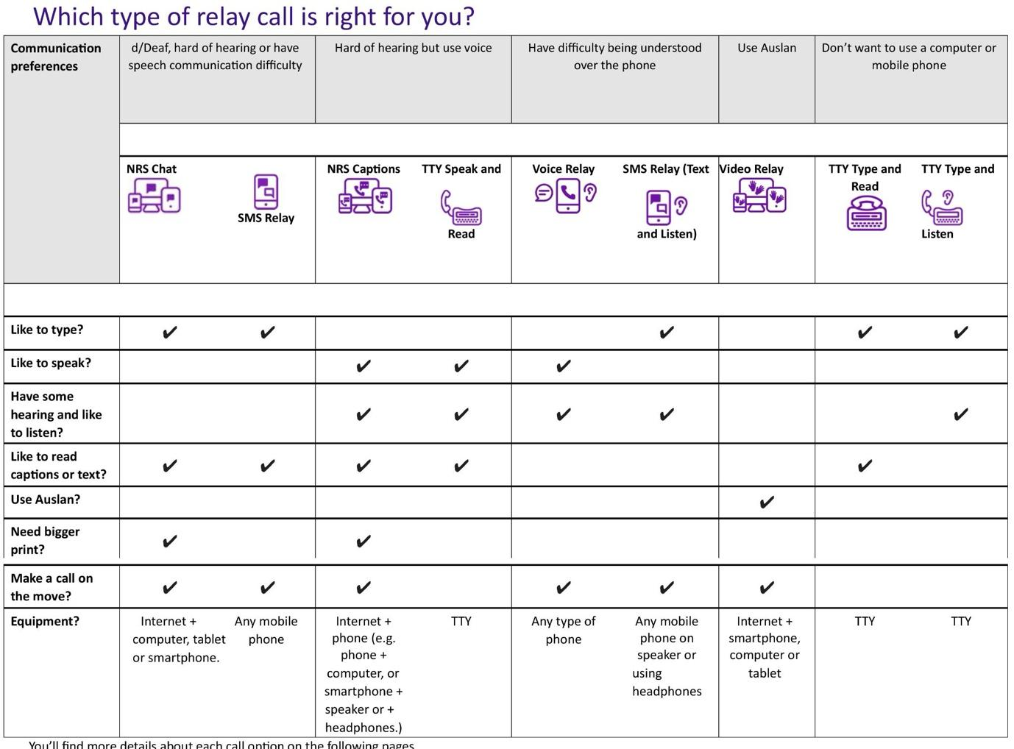

(Figure X. A guide table to help identify which NRS relay option may suit different communication preferences.)
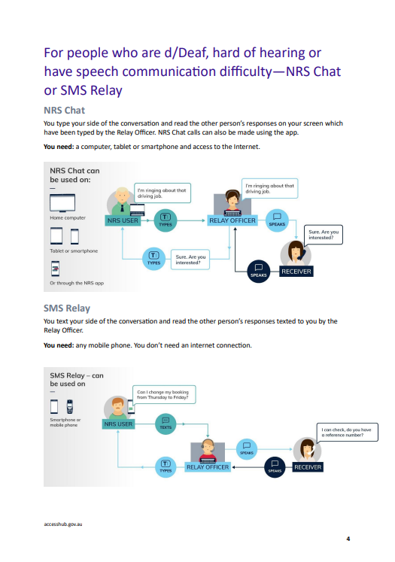
(Figure X. How NRS Chat and SMS Relay support communication between an NRS user and another person through a Relay Officer.)
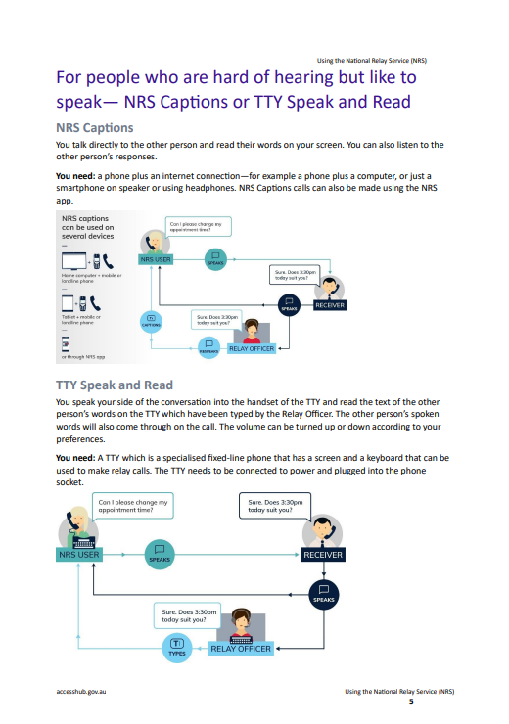
(Figure X. How NRS Captions and TTY Speak and Read support people who prefer to speak and read the other person’s responses.)
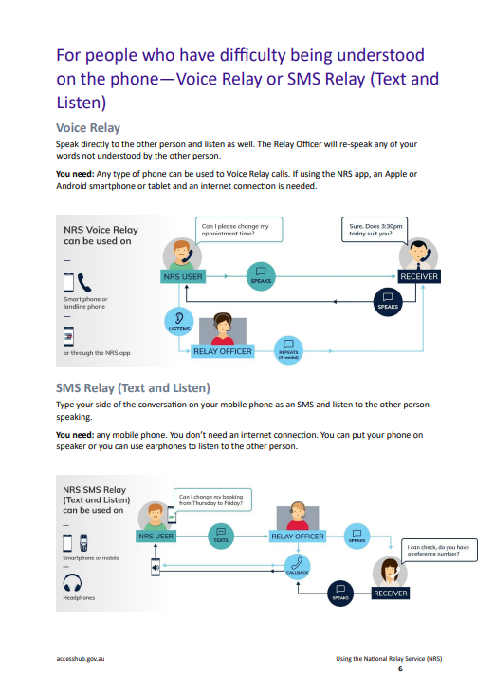
(Figure X. How Voice Relay and SMS Relay (Text and Listen) support people who have difficulty being understood over the phone.)
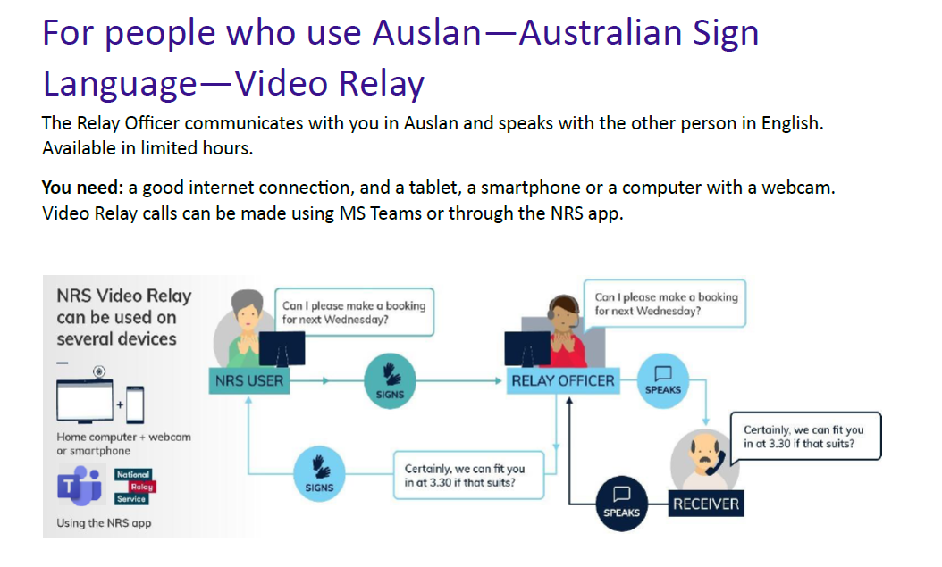
(Figure X. How Video Relay allows an NRS user to communicate in Auslan with a Relay Officer, who speaks with the other person in English.)
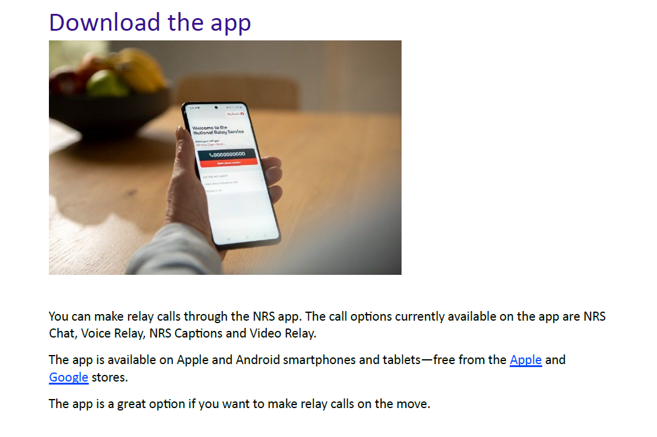
(Figure X. The NRS app, which can be used to access selected relay call options on a smartphone or tablet.)
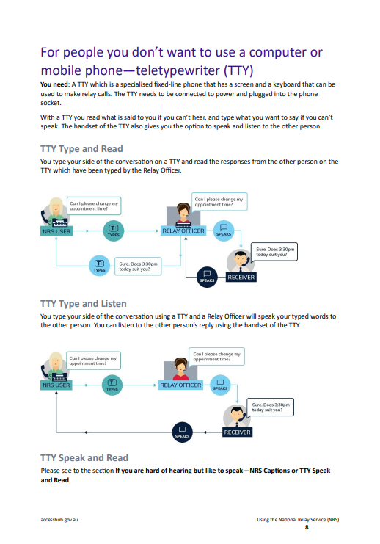
(Figure X. How TTY Type and Read and TTY Type and Listen support communication through a Relay Officer.)

How to register for NRS Service
Registration is required to use some NRS services. Personal information, such as proof of identity, may be required as part of the registration process to help prevent fraud.
https://nrschat.nrscall.gov.au/nrs/registration

Emergency call with NRS
In a life-threatening or time-critical emergency, the NRS can be used to contact fire, police or ambulance services.

Connect to the NRS and ask for Triple Zero (000). The Relay Officer will stay on the line and relay the conversation.

People who use a TTY can contact emergency services directly by dialling 106 on their TTY.

https://www.accesshub.gov.au/about-the-nrs/how-to-make-an-emergency-call-using-the-nrs
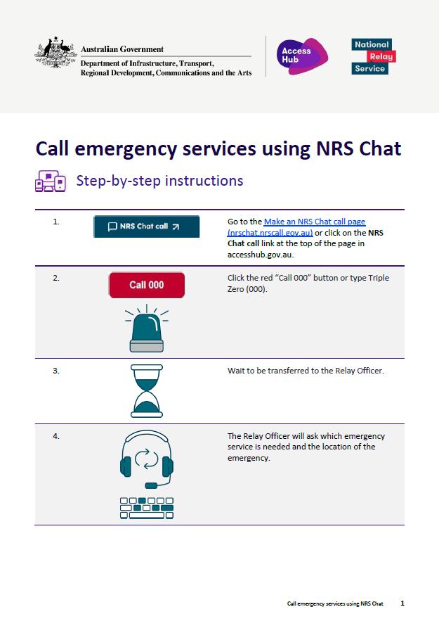
(Figure X. Step-by-step instructions for starting an emergency call to Triple Zero (000) using NRS Chat.)
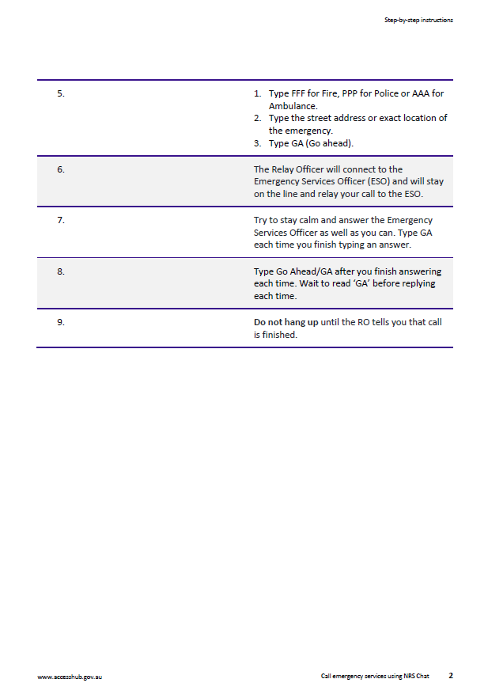
(Figure X. Continued instructions for communicating with emergency services through NRS Chat and completing the call.)

Part 5. Captioning

Ava
Provides live speech-to-text captioning that can support communication in conversations, meetings and other situations.
https://www.ava.me/

Part 6. Community and advocacy

Deafness Forum Australia
Provides information and advocacy relating to hearing loss, deafness and communication access in Australia.
https://deafnessforum.org.au/

Part 7. Local deafblind services and peer groups
Services and peer groups available may differ between states and territories.
Refer to Part 1, Deafblindness, for Deafblind Information Australia and Deafblind Australia to find deafblind services, organisations and community connections in different states and territories.

Appendix - Resources
The resources below have been selected to support people living with dual sensory impairment (DSI), their families, carers, and health professionals. They include practical information, communication guidance, training opportunities and further reading.
(audio books & braille books)

Resources

Deafblind Learning Resources
Next Sense provides free online learning modules introducing deafblindness, communication approaches and practical strategies. Guest access is available. Deafblind Information Australia has free recorded webinars presented by people with lived experience and professionals on communication, services and everyday life with DSI.
Link: https://courses.nextsense.org.au/ https://www.deafblindinformation.org.au/training/watch-our-webinars/

Individual Communication Handbook Template
Deafblind Information Australia provides a downloadable template to document an individual's communication preferences, sensory abilities, communication methods, environmental considerations and support needs. It can be shared with family members, carers and health professionals to promote consistent communication.
Link: https://www.deafblindinformation.org.au/living-with-deafblindness/deafblind-communication/individual-communication-handbook/

Deafblind Communication Methods and Strategies
Deafblind Information Australia provides plain-language information explaining different communication methods (e.g., tactile signing, Deafblind Manual Alphabet, print on palm, Braille, speech and AAC) and how communication needs vary between individuals.
Link: https://www.deafblindinformation.org.au/living-with-deafblindness/deafblind-communication/

Adapting Communication
Deafblind Information Australia provides practical advice on adapting communication as hearing or vision changes, with strategies to reduce communication breakdown and maintain social participation.
Link: https://www.deafblindinformation.org.au/living-with-deafblindness/deafblind-communication/adapting-communication/

Deafblind Australia Resource Hub
A collection of lived-experience videos and accessible resources on communication, self-advocacy, technology, mental health and Deafblind awareness, developed with Deafblind Australians.
Link: https://www.deafblind.org.au/resource/deafblind-led-resource-hub/

Self-Advocacy Resources
Deafblind Australia provides practical guidance on common challenges such as accessing services, emergency preparedness, communicating with service providers and advocating for your needs.
Link: https://www.deafblind.org.au/resource/deafblind-self-advocacy/

Deafblind Awareness Resource
Short videos and practical communication tips for Deafblind people, families and the wider community, developed by Deafblind Australia.
Link: https://www.deafblind.org.au/resource/deafblind-awareness/

Introductory Online Deafblind Course
Deafblind Information Australia provides an introductory online course covering the fundamentals of deafblindness and communication.
Link: https://www.deafblindinformation.org.au/training/online-deafblind-introductory-training-course/

Audio and Braille Books

Vision Australia Library
A free library service for eligible Australians who cannot easily read standard print. It offers audiobooks, Braille books, newspapers and magazines in accessible formats. Braille books can also be delivered by post.
Link: https://www.visionaustralia.org/services/library

Braille House Library
A free Australia-wide library for people who are blind or have low vision. It provides Braille books and magazines, digital Braille, Moon books, audiobooks and tactile resources. Braille materials can be posted free of charge within Australia.
Link: https://www.braillehouse.org.au/library-red/join-the-library

Bookshare
An online accessible library for people with print disabilities. Books are available in formats such as audio, electronic Braille and accessible digital text and can be used with compatible assistive technology.
Link: https://www.bookshare.org/

Local public libraries
Many public libraries provide audiobooks, eAudiobooks and large-print books. In NSW, people can ask their local library about accessible collections and services such as indyreads.
Link: https://www.sl.nsw.gov.au/visit-us/accessibility-library

Recommended Books
- Communication with People who are Deafblind:
Assessment and intervention (Perspectives on Deafness). (2026). Marleen J. Janssen (Editor), Timothy S. Hartshorne (Editor), Walter Wittich (Editor). https://global.oup.com/academic/product/communication-with-people-who-are-deafblind-9780192887177?lang=en&cc=au
- Communication and Congenital Deafblindness (4 books: 2006 - 2009): https://www.amazon.com/Communication-Congenital-Deafblindness-Inger-Redbroe/dp/0999263714
- Improving the Experience of Health Care for People Living with Sensory Disability: Knowing What is Going On (Disability Studies) by Dr Annmaree Watharow: https://www.amazon.com.au/Improving-Experience-Health-Sensory-Disability-ebook/dp/B0B8Q9DQRZ

Appendix - Assistive Technology
Assistive Technology can help people with DSI access information, communicate, move around environments more safely, and participate more independently in everyday life. The most suitable device depends on a person's hearing, vision, communication preferences, and daily needs. They can make communication easier, but they do not fully restore hearing or vision. They work best when combined with supportive environments and an understanding of each person's needs.

A. Hearing devices and hearing support
Hearing loss can affect communication, independence and participation in everyday activities. For people with deafblindness, hearing devices and other forms of hearing support may make it easier to communicate, hear important information and stay connected with others.
There are different types of hearing devices and supports, and not every option will suit everyone. Finding the right support may take some time, and professional advice can help identify options that match individual hearing and communication needs.

Finding the right hearing support
The most suitable hearing device or support depends on hearing needs, daily activities, communication preferences and cost. An audiologist or hearing service can assess hearing, discuss suitable options and help with fitting and adjustments.
A hearing assessment can be booked through Hearing Australia:
Book a hearing test with Hearing Australia

Hearing Devices

1. Hearing aids
Hearing aids make sounds easier to hear. A microphone picks up sound, an amplifier makes the sound stronger, and a speaker sends the sound into the ear.
An audiologist can assess the person’s hearing and program the hearing aids to the sounds and volume levels they need. Hearing aids purchased online may not be suitable or correctly adjusted for individual hearing needs. An audiologist can make further adjustments to improve how the hearing aid works for the person.
Common types include:
Behind-the-ear hearing aids – sit behind the ear and connect to a receiver, ear mould or ear tip.
In-the-ear hearing aids – sit partly or completely inside the ear and are made to fit the shape of the ear.
How to change a hearing aid battery
Open the battery door gently and remove the old battery.
Remove the tab from the new battery and wait about one minute before inserting it.
Place the new battery into the hearing aid in the same direction as the old battery.
Close the battery door gently. If it does not close easily, check that the battery is facing the right way.
Rechargeable hearing aids
Some hearing aids have a rechargeable battery and do not need regular battery changes. Place the hearing aids in their charger when they are not being used, such as overnight, so they are ready for the next day.
Charging instructions may differ between devices, so follow the instructions provided with the hearing aids.
A regular battery check
Choose a regular day, such as the first Monday of each month, to check the hearing aid battery. Regular checks can help prevent the battery from running out unexpectedly.
For rechargeable hearing aids, use this day as a reminder to check that the hearing aids and charger are working properly.

2. Cochlear implants
Cochlear implants may be suitable for people with severe or profound hearing loss when hearing aids do not provide enough support. Unlike hearing aids, cochlear implants require surgery to place part of the device inside the ear. After surgery, the implant is programmed and may need further adjustments over time.

3. Bone conduction hearing devices
Bone conduction hearing devices may help when sound cannot pass easily through the ear to reach the inner ear. Instead of making sounds louder like a hearing aid, they send sound through the bones around the ear directly to the inner ear. Some types of devices are worn externally, while others require a small implant to be placed through surgery.

4. Remote microphone and FM systems
Remote microphone systems can help when it is difficult to hear someone because of background noise or distance. The person speaking uses a wireless microphone, which sends their voice directly to a receiver worn by the listener or connected directly to their hearing device. This helps the listener hear the speaker’s voice more clearly.

5. Hearing amplifiers
Hearing amplifiers make surrounding sounds louder. They may help people with minimal or mild hearing loss hear sounds around them more easily in daily life.
Unlike hearing aids, hearing amplifiers are not programmed to match a person’s individual hearing loss and are not regulated as medical devices in Australia. This means they are not a replacement for hearing aids that have been selected and adjusted for a person’s hearing needs.

Cost and financial support
Hearing devices and other hearing supports can be expensive. Eligible people may receive subsidised hearing devices, assistive listening devices and related services through the Australian Government Hearing Services Program. Other funding may be available through the NDIS, depending on the type of device and individual eligibility.
An audiologist or hearing service provider can help identify suitable devices and check which funding options are available.
Find out about eligibility:
Eligibility for the Hearing Services Program

B. For Vision

Magnifiers
Magnifiers enlarge print, pictures or objects to make them easier to see. They may be handheld, stand-mounted or electronic. Electronic magnifiers can also provide features such as adjustable contrast, brightness and colours. The best type and level of magnification depend on the person's vision and the task they want to complete.
If you are unsure which magnifier may suit your needs, you can contact Vision Australia for information and support with choosing and using magnification technology.
Link: https://secure.visionaustralia.org/technology-products/resources/using-technology/magnifiers

Computer Screen Readers
Screen readers help people who have vision impairment access computers. They read text and other information displayed on the screen aloud using synthesised speech. Some screen readers can also provide information through a refreshable braille display.
If you would like help choosing or learning to use a screen reader, Vision Australia provides assistive technology information and support.
Link: https://secure.visionaustralia.org/technology-products/resources/using-technology/computer-screen-readers

Refreshable Braille Displays
A refreshable braille display is a tactile electronic device that connects to a computer, tablet or smartphone. Small pins move up and down to form braille characters, allowing information from the screen to be read by touch. This may be particularly useful for people who use braille and cannot easily access information visually or through audio.
If you would like to learn more about refreshable braille displays and whether they may be suitable for you, you can find information and technology support through Vision Australia.
Link: https://www.visionaustralia.org/technology-products/resources/using-technology/braille

C. For Mobility

Sunu Band
The Sunu Band is a wearable electronic mobility aid designed for people who have sensory impairment. It uses ultrasonic sensing to detect nearby obstacles and provides information through vibrations on the wrist. It is intended to supplement, rather than replace, established mobility strategies such as a white cane or dog guide.
If you are interested in Sunu Band, you can check Low Vision Specialists for more information.
Link: https://lowvisionmd.org/sunu-band-2/

White Canes
White canes can support safe and independent mobility for people who are blind or have low vision. Different types of canes serve different purposes. For example, a long mobility cane can detect obstacles, steps and changes in the ground, an identification cane primarily lets other people know that the person has vision loss, while a support cane is used to aid balance and as a means of physical support for a person who has vision impairment.
If you are unsure which cane is appropriate or would like to learn how to use one safely, Vision Australia provides White cane beginners guide where you can find more information.
Link: https://secure.visionaustralia.org/news/white-cane-beginners-guide

Dog Guides
Dog guides are specially trained to help people who are blind or have significant vision impairment travel safely and independently. They may help the person avoid obstacles, stop at kerbs and stairs, move through crowds and locate destinations. A person's needs, mobility skills and circumstances should be assessed to determine whether a dog guide is suitable.
If you are considering a guide dog, an assessment can help determine whether it is suitable for your needs and lifestyle. The NDIS provides information about animal supports and recognised providers.
Link: https://www.ndis.gov.au/participants/assistive-technology/animal-supports

Navigation and wayfinding technology
GPS, mapping applications and other navigation technologies can help people who are blind or have low vision plan routes, identify locations and travel more independently. Some technologies can provide spoken or tactile information about surroundings. These tools should complement, rather than replace, appropriate orientation and mobility skills.
If you would like help finding accessible navigation technology or learning how to use it, or learn more about strategies to increase your independence and safety accessing the community, Vision Australia can provide information and support.
Link: https://www.visionaustralia.org/services/staying-connected/events/getting-around-made-easy

D. Smart phone & Computer Application

Built-in Smart Phone Application

iPhone (iOS)
Information provided on August 2026. Accessibility features and settings may change with iOS updates. For the latest information, detailed instructions and tutorials, please visit Apple Accessibility Support website: https://support.apple.com/en-au/accessibility

For Hearing
- Live Captions
- provides captions for speech in supported situations
- set up:
  - Open “Settings” and select “Accessibility”
  - Select and turn on “Live Captions”
- Visual/vibration alerts
- LED Flash for Alerts, vibration and custom notification settings
- set up:
    - Open “Settings” and select “Accessibility”
    - Select “Audio & Visual”
    - Turn on “LED Flash for Alerts”
- Sound Recognition
- alerts with written notification when it hears recognised sounds, such as alarms
- set up:
    - Open “Settings” and select “Accessibility”
    - Select “Sound & Name Recognition”
    - Turn on “Sound Recognition”
- Hearing-device support
- pair and stream audio directly to Made for iPhone (MFi) hearing aids and sound processors
- set up:
    - Open “Settings” and select “Accessibility”
    - Select “Hearing Device”
    - Turn on your hearing devices' Bluetooth and pair with iPhone

For Vision
- Voice Over
  - reads what is on the screen and supports touch gestures
  - set up:
    - Open “Settings” and select “Accessibility”
    - Select and turn on “Voice Over”
- Voice Control
  - control the device using spoken commands
  - set up:
    - Open “Settings” and select “Accessibility”
    - Select and set up “Voice Control”
- Zoom
  - enlarges parts or all of the screen
  - set up:
    - Open “Settings” and select “Accessibility”
    - Select and turn on “Zoom”
- Text size & colour/contrast settings
  - larger text, bold text, increased contrast, colour filters, etc.
  - set up:
    - Open “Settings” and select “Accessibility”
    - Select “Display & Text Size”
    - Select “Larger Text”, “Increase Contrast” or “Colour Filters” for adjustment
- Speak Screen/ Speak Selection
  - text-to-speech function, reads selected text or screen aloud
  - set up:
    - Open “Settings” and select “Accessibility”
    - Select “Read & Speak”
    - Turn on “Speak Screen/ Speak Selection”
- Assistive Access
  - simplifies interface into large, high-contrast buttons and text
  - set up:
    - Open “Settings” and select “Accessibility”
    - Select and set up “Assistive Access”
- Dictation (Speech-to-text)
  - converts your spoken words into written text in real time
  - set up:
    - Open “Settings”
    - Select “General” and then “Keyboard”
    - Select and turn on “Enable Dictation”
    - When you tap in the text box, tap the microphone button on the keyboard to start dictation
    - Tap the microphone again or stop speaking to end dictation.

Android
Information provided on August 2026. Accessibility features and their names or locations may vary depending on the Android version and device manufacturer. For the latest information, detailed instructions and tutorials, please visit Google Android Accessibility Help website: https://support.google.com/accessibility/android?sjid=3968717459478135625-NC#topic=6007234

For Hearing
- Live Caption
  - automatically captions speech for media that playing internally on your device, like videos, podcasts, phone calls, etc.
  - set up:
    - Open “Settings” and select “Accessibility”
    - Select and turn on “Live Caption”
- Live Transcribe
  - uses your phone's microphone to listen to external sounds and conversations happening around you in the real world, and converts speech and sounds into text in real time
  - set up:
    - Go to “Google Play”
    - Search and install “Live Transcribe” app
- Visual/vibration alerts
  - Flash notifications, vibration and notification settings
  - set up:
    - Open “Settings”
    - Search “Flash notifications” or “Vibration & haptics” for set up
- Sound Notifications
  - alerts you to important environmental sounds such as smoke alarms and doorbells
  - set up:
    - Open “Settings” and select “Accessibility”
    - Select and open “Sound Notification”

For Vision
- TalkBack
  - provides spoken feedback and touch-based navigation
  - supports braille displays and a braille keyboard
  - set up:
    - Open “Settings” and select “Accessibility”
    - Select and turn on “TalkBack”
- Voice Access
  - control the device and enter text using your voice
  - set up:
    - Go to “Google Play”
    - Search and install “Voice Access” app
- Magnification
  - enlarges the screen, including temporary or partial-screen magnification
  - set up:
    - Open “Settings” and select “Accessibility”
    - Select and turn on “Magnification Shortcut”
- Text size & colour/contrast settings
  - font/display size, colour correction, colour inversion, dark theme and other display options, etc.
  - set up:
    - Open “Settings” and select “Accessibility”
    - Select “Display Size” and “text to font size or display size”
    - Select “Colour and motion” to adjust colour correlation, colour inversion, etc.
- Select to Speak
  - reads selected content aloud
  - set up:
    - Open “Settings” and select “Accessibility”
    - Select “Select to Speak” and turn on shortcut
- Dictation (Speech-to-text)
  - converts your spoken words into written text in real time
  - set up:
    - Open “Settings”
    - Select “Genera”l and then “Keyboard”
    - Select and turn on “Enable Dictation”
    - When you tap in the text box, tap the microphone button on the keyboard to start dictation
- Lookout
  - provide information about objects, text and surroundings
  - set up:
    - Go to “Google Play”
    - Search and install “Lookout - Assisted vision”

Built-in Computer Application

macOS
Information provided on August 2026. Accessibility features and settings may change with macOS updates. For the latest information, detailed instructions and tutorials, please visit Apple Accessibility Support for Mac website: https://support.apple.com/en-au/guide/mac-help/mh35884/mac

For Hearing
- Live Captions
  - provides real-time captions for conversations and audio from apps
  - set up:
    - Open Apple menu
    - Select “System Settings” and then “Accessibility”
    - Select and turn on “Live Captions”
- Visual alerts
  - captions, visual alerts and other hearing accessibility settings
  - set up:
    - Open Apple menu
    - Select “System Settings” and then “Accessibility”
    - Select “Audio” and turn on "Flash the screen when an alert sound occurs"
- Hearing-device support
  - pair and manage Made for iPhone (MFi) electronic hearing aids and compatible audio gear directly
  - set up:
    - Open Apple menu
    - Select “System Settings” and then “Accessibility”
    - Select “Hearing Device”
    - Turn on your hearing devices' Bluetooth to pair

For Vision
- VoiceOver
  - reads information on the screen aloud and supports braille displays
  - set up:
    - Open Apple menu
    - Select “System Settings” and then “Accessibility”
    - Select and turn on “VoiceOver”
- Voice Control
  - control the Mac and dictate text using your voice
  - set up:
    - Open Apple menu
    - Select “System Settings” and then “Accessibility”
    - Select and turn on “Voice Control”
- Zoom
  - makes part or all of the screen larger
  - set up:
    - Open Apple menu
    - Select “System Settings” and then “Accessibility”
    - Select and turn on “Zoom”
- Text size & colour/contrast settings
  - adjust text size, contrast, colours and other display settings
  - set up:
    - Open Apple menu
    - Select “System Settings” and then “Accessibility”
    - Select “Display” and adjust “Text size”, “Colour filters”, “Contrast” or other display settings
- Read & Speak
  - simplify and customise text for easier reading
  - reads text on the screen aloud
  - set up:
    - Open Apple menu
    - Select “System Settings” and then “Accessibility”
    - Select “Read & Speak” and turn on the reading option you need

Windows
Information provided in August 2026. Accessibility features and settings may change with Window updates. For the latest information, detailed instructions and tutorials, please visit Microsoft Accessibility Help & Learning website: https://support.microsoft.com/en-us/accessibility/

For Hearing
- Live Captions
  - converts spoken audio into text on screen
  - set up:
    - Open “Start”. Select “Settings” and then “Accessibility”
    - Select “Captions” and turn on “Live Captions”
- Visual alerts
  - visual alternatives to sounds and hearing-device settings
  - set up:
    - Open “Start” and select “Settings”
    - Select “Accessibility” and then “Audio”
    - Choose your preferred flashing style from the “Flash my screen during audio notifications” dropdown menu

For Vision
- Screen reader “Narrator”
  - built-in screen reader that can read and navigate apps, websites and documents
  - set up:
    - Open “Start”. Select “Settings” and then “Accessibility”
    - Select and turn on “Narrator”
- Voice Access
  - control Windows, open apps, browse and write using voice
  - set up:
    - Open “Start”
    - Select “Settings” and then “Accessibility”
    - Select “Speech” and set up “Voice Access”
- Magnifier
  - enlarges content on the screen
  - set up:
    - Open “Start”
    - Select “Settings” and then “Accessibility”
    - Select and turn on “Magnifier”
- Text size & colour/contrast settings
  - adjust text size, contrast themes , pointer and cursor settings
  - set up:
    - Open “Start”
    - Select “Settings” and then “Accessibility”
    - Select “Text size”, “Contrast themes” or “Colour filters” and choose your preferred settings
- Reading tools
  - “Immersive Reader” in Microsoft apps such as Word, Edge, OneNote and Teams can make text easier to read

E. Everyday Technologies

Simple tools and everyday solutions can make daily activities easier and safer. Different items may be helpful depending on the person’s level of vision and hearing, communication needs and daily activities and habits.

Tactile dots
Tactile dots are small raised markers that can be placed on frequently used items, such as appliance buttons, switches or containers. They can help a person find and identify important buttons or items by touch.

Tactile bands
Tactile bands can help tell similar bottles or containers apart by touch. For example, different bands can be used to identify shampoo and conditioner, or salt and sugar.

Contrasting non-slip mats
Contrasting non-slip mats can make items easier to spot and help stop them from moving. For example, a mat in a contrasting colour can be placed under a cup, plate or other frequently used item to make it easier to find and use.

Magnifying lamps
Magnifying lamps combine magnification with additional lighting. They can make small print, objects and close-up activities such as sewing or crafting easier to see.

Smart locks
Smart locks provide different ways to lock and unlock a door, such as using a keypad, phone or other connected device. Different options may suit different levels of vision and hearing.

Sensors in the home
Sensors can detect movement or changes around the home, such as a door opening or someone entering an area. They can be connected to another device that sends an alert to the person.

Alerting devices
Alerting devices can help a person notice important events without relying only on sound. They may use flashing lights or vibration to alert the person.
Examples include:
Smoke alarm systems – may use flashing lights, vibration or sound to alert the person to smoke or fire.
Bed shakers – vibrate under a pillow or mattress to wake the person when an alarm is activated.
Doorbell, telephone and baby monitor alerts – may use flashing lights, vibration or other signals to let the person know when someone is at the door, the phone is ringing or the baby monitor is activated.
Some systems can also send different vibration patterns to a pager worn on the body. Alerting devices can also be connected to home sensors or other equipment.

Identification wristband
An identification wristband can let other people know that a person is deafblind, has vision loss or has hearing loss. It may be particularly useful in unfamiliar or emergency situations by helping others recognise that the person may have communication or access needs.
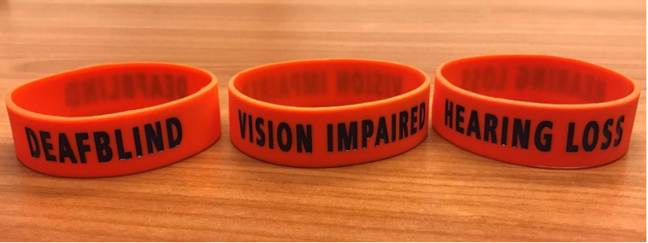
（Figure X. Identification wristbands that can help let others know that a person is deafblind, has vision impairment or has hearing impairment.)

Creative everyday solutions
Simple and personalised solutions can also support communication in daily life. For example, a photo album can include pictures of family members, familiar places or important items. Photos or clipart can also be used to express needs or concerns, such as showing a picture of a toilet to indicate the need to use the bathroom.

This idea was shared by Wilma, who contributed her lived experience to the development of this communication book.
Wilma also shared how she uses assistive technology creatively to take part in ballroom dancing. She uses two wireless remote microphones with her hearing aids, one to hear the teacher’s instructions and another to access the music. For her, ballroom dancing is more than a form of exercise. It gives her a way to express her creativity, enjoy time with others and take part in something she genuinely looks forward to each week.
Her experience shows how building on a person’s strengths and using technology creatively can help them continue doing the things they enjoy and value. The focus is on what the person wants to achieve in their life, with practical and creative solutions shaped around their goals, strengths and preferences.

Survey of the Deafblind Communication Book
Thank you for taking the time to review our Deafblind Communication Book. We would like to hear your feedback to help us improve the content, layout and usefulness of the book.

- What is your occupation? (Please tick all that apply)
☐Person with lived experience
☐Family member or friend ☐Support worker/ carer
☐Member of service organization:
☐Health Professional: ☐Other Professional:
☐Others:
- Is the book easy to read and use?
☐Very Easy | ☐Easy | ☐Somewhat Easy | ☐Difficult
Comments

- How useful do you find the book?
☐Very Useful | ☐Useful | ☐Somewhat Useful | ☐Not useful
Comments

- Which part(s) of the book did you find most useful?
- What could be improved or added to the book?
- Other comments:
Thank you for your feedback!

