Australian Dual Sensory Impairment Home Modifications Guidance
(2026)

By Dean Caccamo, Ling Chuen Kong (Zoe) & Gabrielle Campbell

Acknowledgements

We would like to acknowledge the Gadigal people of the Eora Nation, the traditional custodians of the land on which we live, work and study. We pay our respects to Elders past, present, and emerging and recognise their ongoing connection to the Country.

We would like to sincerely thank Dr Annmaree Watharow for her guidance and support developing this project. Her knowledge and lived experience of Dual Sensory Impairment has been a key resource that has helped guide the development of this book. We would also like to thank staff of the Centre for Disability Research and Policy and the Dual Sensory Impairment Project for their provision of knowledge and resources.

We would also like to acknowledge the contributions of the individuals from the Dual Sensory Impairment community, their families and support networks. Their experiences, knowledge and insights have helped co-design this resource.

We would specifically like to thank the following people and organisations who have helped provide insight, resources and feedback to guide the content of this booklet:
Meredith Prain – Deafblind Information Australia
Hannah McPierzie – Deafblind West Australians
Emma Scanlan – Hearing Australia
Leyla Craig – Fire and Rescue NSW
Jason Markou – Manages accessibility at the University of Sydney
Paola Murray – Deafblind Australia
Jarryd Busuttil – Occupational Therapist from Vision Australia
Steve Rose – Speech Pathologist and Deafblind Consultant from Vision Australia
Armstrong Chiu – Hong Kong Society for the Blind
Claire Rennie – National Relay Service

For an accessible version of this booklet with larger images and no tables, please scan the QR code above.

Contents
Disclaimer 5
Chapter 1: Learning Objectives / Scope / Aim 7
1.1 Scope 8
1.2 Learning Objectives 8
Chapter 2: Understanding Dual Sensory Impairment 11
2.1 Terminology & Acronym Selection 12
2.2 The Population Profile 12
2.3 The Nordic Definition of Deafblindness 13
2.4 Challenges and Complexities 16
2.5 Demographics & Logistics (The Australian Data) 17
2.6 Systemic Funding Frameworks 18
2.6.1 National Disability Insurance Scheme (NDIS) 19
2.6.2 My Aged Care (MAC) 29
Chapter 3: How to Use an Interpreter Effectively 37
3.1 Self-Advocacy 38
3.2 Clinical Best Practice 39
3.3 Simple Communication Practices during Home Visit 41
Chapter 4: General Environmental Advice 43
4.1 Home Layout 44
4.2 Lighting & Glare Management 44
4.2.1 The Five Key Principles of Accessible Lighting 45
4.2.2 Household Design Tips: 46
4.3 Colour and Contrast 58
4.3.1 Architectural & Furniture Colour Contrast Tips 60
4.4 Textures 66
4.4.1 Household Tactile Adaptation Tips 66
4.4.2 Example of Comfortable Tactile Materials 70
4.5 Acoustics 73
4.5.1 Household Acoustic Adaptation Tips 73
Chapter 5: Safety & Emergency 77
5.1 Multi-Sensory Alerting Systems & Home Safety Tips 78
5.2 Contacting Emergency Services via the National Relay Service (NRS) 82
5.2.1 Easy NRS Emergency Options 84
5.2.2 Signing Up & Tips for Smooth Calls 87
5.3 General Safety Ideas around the Home 89
Chapter 6 Kitchen 91
6.1 Safe Kitchen Habits & Helpful Routines 92
6.2 Practical Kitchen Adaptation Tips 93
6.3 Tips When Choosing New Kitchen Appliances 111
Chapter 7 Bathroom and Laundry 113
7.1 Introduction 114
7.2 Practical Bathroom and Laundry Adaptation Tips 114
7.3 Tips When Choosing New Bathroom/Laundry Appliances 123
Chapter 8 Bedroom 125
8.1 Introduction 126
8.2 Practical Bedroom Adaptation Tips 126
8.3 Tips When Modifying the Bedroom 134
Chapter 9 Living Room 136
9.1 Practical Living Room Adaptation Tips 137
9.2 Tips when Setting Up TV & Media 146
Chapter 10 Exterior Space 148
10.1 Introduction 149
10.2 Practical Exterior Adaptation Tips 149
Chapter 11 Leisure 153
10.1 Introduction 154
10.2 Home Modifications 155
10.3 Adaptive Equipment 157
10.4 Groups 159
Chapter 12 DSI Community Resources 161
12.1 Key Deafblind & Support Organisations Mentioned in This Guide 162
12.2 Assistive Technology & Equipment Suppliers 166
12.3 Accessible Telecommunications & Guide Dog Services 169
12.4 Government Schemes, Advocacy & Dispute Bodies 171
References 173
Appendix 1 184
National Relay Service 185

Disclaimer
Please be aware that the information included in this guide is intended to be general and may not be suitable for all individuals living with dual sensory impairment. It is important that this information is used as a reference point to begin your own research and to determine which products and home modifications are most suitable for the individual.
This guide does not replace an individualised assessment or professional advice from an occupational therapist or other suitably qualified professional. The appropriateness of any product or home modification will depend on the individual’s functional needs, preferences, home environment and circumstances.
The recommendations included within this guide are heavily informed by DeafBlind Ontario Services’ 2020 Accessibility Guidelines of Sensory Loss, the relevant Australian Standards, and the experiences of those within the Dual Sensory Impairment community, their families, and their support networks.
Some recommendations have been informed by international resources and may not directly reflect Australian environments, services or regulatory requirements. Where possible, these recommendations have been considered alongside relevant Australian Standards and input from Australian professionals and people with lived experience.
We do not endorse any of the products included in this guide. Although we have conferred with various organisations regarding their products, we are not affiliated with any of the organisations mentioned. Please also note that this is not an exhaustive list, so we highly recommend conducting your own research before purchasing any of the products included.
We would also like to acknowledge that we are not members of the Dual Sensory Impairment community; therefore, we have put significant effort into conferring with individuals living with Dual Sensory Impairment and their support networks to ensure this guide reflects their perspectives.
Every effort has been made to ensure the information within this home modification guide is accurate and current at the date of publication. However, technology is constantly changing, and product specifications and information may shift over time, meaning some details in this booklet may eventually become inaccurate or outdated.

Chapter 1: Learning Objectives / Scope / Aim

1.1 Scope
We are Masters of Occupational Therapy students from the University of Sydney, who have been tasked with creating a Home Modifications Guidance booklet for the people living with Dual Sensory Impairment, both acquired and congenital. This book is intended for use by both the Dual Sensory Impairment (DSI) community, their families, support networks and clinicians. The aim of this book is to create more accessible homes for those living with DSI and ultimately promote a healthier, happier and safer life. We are working within our own limitations listed above, please view this booklet as a starting point for home modification suggestions rather than an exhaustive list.

1.2 Learning Objectives
By creating this guidance booklet, we hope it can:
For People living with DSI, Family & Support Networks
Further your understanding of:
- How changes in both sight and hearing can impact your general sense of safety, confidence, and independence at home.
- How your energy levels and changing home lighting can cause your daily vision and hearing abilities to fluctuate.
- How sensory changes create a shared family experience, and how homes can be setup to reduce communication frustration for everyone in the household.

Empower you to ask:
- Visiting support workers, interpreters, and family members to strictly follow your home's organisation rules and preferred ways of communicating.
- Family members or support workers to take extra time when conducting interviews/assessments or providing education.
Help you identify:
- Simple, low-cost tricks around the house to quickly make things easier to navigate.
- Clear ways to organise daily household areas.
Provide you with:
- An organised home layout built on predictability, where everyday items like keys, furniture, and appliances remain in their designated place.
- Easy backup safety methods in your home, including a reimagined emergency "sustainability kit" if you ever need urgent help.
Practice:
- Confident daily self-advocacy using individualised communication strategies and specialised services (e.g., National Relay Service) to maintain independence.
- Taking breaks to recharge in your own way when you start to feel overly fatigued from tracking conversations.

For Clinicians (OTs) & Support Workers
Further your understanding of:
- The unique daily challenges the DSI community face when living with a combined hearing and vision loss.
- How to build a strong funding report for home modifications by clearly linking environmental changes directly to safety, health risks, and long-term cost savings.
- Why standard accessibility regulations are often unsuitable for a person living with DSI, and how to justify non-standard home modifications in funding reports.
Begin to ask:
- Your clients about their personal touch boundaries and safe touch zones before guiding them or starting a physical task.
- Your clients directly about their own individual requirements to ensure the home environment is set up in a way to keep them comfortable.
- Family members and carers what daily routines they already use to keep communication smooth to reduce stress.
Help you identify:
- Unseen structural hazards that can cause confusion or falls.
- Room-by-room suggestions to replace sight and hearing demands in core functional areas like the kitchen, bathroom, and bedroom.
Provide you with:
- Clear, medical explanations to use in reports to show funding bodies why a client's individualised body/sensory functioning requires specific environmental modifications.
- Accessible, large-print resources that use high-contrast text, clear photos, and image descriptions to eliminate communication misunderstandings.
Practice:
- Inclusive co-design by treating the person living with dual sensory loss as the true expert of their own home layout.
- Careful booking protocols to ensure you match the client with a qualified interpreter with specialised training, who is confident interpreting for the specific communication methods used by people living with DSI.
- Reporting advocacy by using practical report-writing guides to confidently handle funding rejections or complaints.
- Suggesting and starting home modifications early in a medical timeline to act in a proactive manner rather than reactively after an accident or dangerous situation.

Chapter 2: Understanding Dual Sensory Impairment

2.1 Terminology & Acronym Selection
Throughout this booklet, we use the acronym DSI (Dual Sensory Impairment) to refer to people with co-occurring hearing and vision loss, that is, those living with dual sensory impairment. However, “deafblind” and “deafblindness” are widely accepted umbrella terms for people with different combinations and levels of vision and hearing loss. The World Foundation for deafblindness (WFDB) and Deafblind Institute (DbI) Deafblind Diversity Statement describes deafblindness as a broad spectrum. This recognises that people who are deafblind have diverse experiences, needs and ways of describing themselves (Baur, 2026).
People may prefer different terms to describe themselves. Terminology in this field can be contentious territory, with ongoing debates between identity-first language (e.g., deafblind) and person-first language (e.g., person living with DSI). In this work, we will adopt person-first language to align with standard Australian healthcare framework preferences. However, clinicians should always ASK each person which term they prefer rather than assuming or choosing a label for them.

2.2 The Population Profile
Dual Sensory Impairment is a distinct and often poorly misunderstood condition of great diversity that combines hearing and vision losses. Total loss of sight and hearing is rare with most individuals possessing unique residual senses. These residual senses can decline over time and often fluctuate with fatigue, stress, and environmental light management (Watharow et al., 2024)
“DSI is a unique condition where neither sense can act as a compensatory backup for the other, meaning information is naturally received in fragments” (Simock, 2016).

2.3 The Nordic Definition of Deafblindness
The Nordic definition of deafblindness from the Nordic Welfare Centre provides greater depth into the complexities of the condition and how it might fluctuate or deteriorate over time.
The following passage is taken directly from “Nordic definition of deafblindness” by the Nordic Welfare Centre:
Nordic definition of deafblindness
(Nordic Welfare Centre)
Deafblindness is a combined vision and hearing impairment of such severity that it is hard for the impaired senses to compensate for each other. Thus, deafblindness is a distinct disability.
Main implications
To varying degrees, deafblindness limits activities and restricts full participation in society. It affects communication, access to information, orientation, and the ability to move around freely and safely.
To help compensate for the combined vision and hearing impairment, the tactile sense becomes especially important. There is a high risk that the physical and psychological health, as well as social life will be affected.
Comments
On the combined vision and hearing impairment
The severity of the combined vision and hearing impairment
depends on:
- The time of on-set, that is whether it is congenital, acquired or age related. Especially in relation to communication development and language acquisition.
- The degree and nature of the vision and hearing impairments.
- Whether it is combined with other impairments.
- Whether it is stable or progressive.
On the distinct disability
The fact that it is hard for the impaired senses to compensate
for each other means that:
- Attempting to use one impaired sense to compensate for the other one is time-consuming and energy-draining; thus, sensory perception is often fragmented.
- A decrease in the function of vision and hearing increases the need to utilise other sensory stimuli (i.e., tactile, kinaesthetic, proprioceptive, haptic, smell and taste).
- It limits the access to information from a distance.
- It creates a need to rely on information within the near surroundings.
- To create meaning, it becomes necessary to rely on memory and draw conclusions from fragmented information.
On activities and participation
Deafblindness limits activities and restricts full participation in society.
According to the Convention on the Rights of Persons with Disabilities (UNCRPD) participation is a given right for all human beings. Thus, in order to enable the individual to use their potential capacity and resources, society is required to facilitate specialised services.
The individual and their environment should be equally involved, but the responsibility for granting access to activities lies with society. An accessible society should at least include:
- Available competent communication partners.
- Available specialised deafblind interpreting, including interpreting of speech, environmental description and guiding.
- Available information for everyone.
- Human support to ease everyday life.
- An adapted physical environment.
- Accessible technology and technological aids.
A person with deafblindness may be more disabled in one activity and less disabled in another. Variation in functioning might be the consequence of both environmental and personal factors.
Specialised competence related to deafblindness, including an interdisciplinary approach, is vital for proper service provision.

2.4 Challenges and Complexities
To effectively tailor home modifications, clinicians must recognise that individuals living with DSI are divided into distinct, diverse diagnostic profiles, which alter how a person learns, navigates, and communicates. Research commonly describes four subtypes of deafblindness. These subtypes include:
- Congenital deafness and blindness
- Congenital deafness and acquired vision loss
- Congenital blindness and acquired hearing loss
- Acquired DSI
Because each profile alters language acquisition and coping strategies in different ways, it is a clinical error to apply a “one-size-fit-all” layout checklist. Clinicians should ASK and understand the person’s sensory history, preferences and current strategies before recommending home modifications.

2.5 Demographics & Logistics (The Australian Data)
DSI is often underdiagnosed and often underreported. As a result, its true prevalence is difficult to determine.
- Studies report that from 0.2% to 2% of world population may be living with DSI (WFDB, 2018).
- Survey of Disability, Aging and Carers (SDAC, 2019), found that there are 8:1000 (~200,000) Australians living with DSI.
- Prevalence of DSI increases significantly with very old age to 26.8% for people aged >80 years (Schneider et al., 2012). This data is almost 15 years old and as the population has continued to age, this is likely an underestimate.
- With an aging population, estimates show the global population ages >80 years is expected to triple by 2050 (WHO, 2025), which will further increase the prevalence of DSI.
Current available data for the prevalence of DSI are underestimated with many ‘invisible’ populations being under-reported or completely unreported. These include:
- Older people with unacknowledged or unrecognised DSI - older people often see sensory loss as a natural part of ageing and as a result don’t receive the targeted support they need
- Residents of aged care facilities
- Veterans, who have higher rates of noise-induced hearing loss alongside higher rates of low vision
- Prisoners, who often experience premature ageing which includes sensory loss
- First Nations peoples
- Homeless people, who often experience premature ageing which includes sensory loss
- Those with other comorbidities or multiple disabilities
This means that many Australians may be living with unrecognised DSI and may not be receiving the assessment, funding, or support they need.
Different definitions of deafblindness have also made it difficult to collect and compare data across countries. The international WHO is Deafblind? project was developed to help address this issue. Through an international consensus process, the project developed The International Classification of Functioning, Disability and Health (ICF) Core Set for Deafblindness.
The Core Set provides a shared framework for describing how deafblindness affects communication, mobility, daily activities and social participation. It also considers the environmental barriers, supports and personal assistance each person may need (Who Is Deafblind?, 2024).

2.6 Systemic Funding Frameworks
There are currently minimal official DSI-specific home modification guidelines in Australia, and this guidance booklet aims to fill this gap.
To access government-funded home modifications and assistive technology, people living with DSI could navigate one of two primary funding streams depending on their age when applying: the National Disability Insurance Scheme (NDIS) or My Aged Care (MAC).
What Home Modifications Are
Home modifications are changes made to a person’s home that help them move around more safely and easily, perform daily tasks, or help carers. A person may need home modifications if they:
- Have safety concerns or difficulty moving around their home.
- Have trouble getting into or using a shower.
- Cannot enter or use the rooms they need to use.
- Face difficulty working towards their goals in their home.
(NDIS definition)

2.6.1 National Disability Insurance Scheme (NDIS)
The information in this section is based on official National Disability Insurance Scheme (NDIS) guidelines, including the Guide to Providing Home Modifications and official NDIS assessment framework.

Who it is for & Eligibility:
- Australians living with permanent and significant disability who are under 65 years of age when first applying to the scheme.
- NDIS participants who find it difficult or unsafe to move around or use essential areas of their home because of their disability.
- Any requested changes must directly connect to your disability needs, help you reach your goals, and build your independence (including but not limited to self-care, communication, mobility, or home safety).
- You can apply for home modifications whether you own your home, live in public/social housing, or rent privately (provided the property owner gives written consent).

Key People & Roles in the NDIS Process:
- National Disability Insurance Agency (NDIA) Planner – A NDIA staff member who creates and approves your NDIS plan and decides what NDIS supports will be funded based on laws, goals, and clinical evidence.
- Home Modification Assessor – An Occupational Therapist (OT) registered with AHPRA who has completed tertiary education or training specifically in assessing, specifying, and implementing home modifications. They assess your disability needs, complete home modification assessment forms, and recommend supports.
- Building Construction Practitioner – An independent professional with building expertise who gives advice on design, cost, scope of work, and drawings for complex modifications.
- Building Works Project Manager – An independent professional who helps manage complex projects, ensures builders meet building standards/contracts, and supervises construction.

Categories of NDIS Home Modifications:
- Simple Home Adaptation
Cost & setup | - Cost less than $1,500 each  - Easy to set up  - Usually funded as low-cost assistive technology
Examples | - Grab rails  - Accessible tapware  - Hand-held showers  - Lever door handles and more
Requirements | Can be bought directly from hardware or disability equipment shops and installed by a handyperson or tradesperson.

- Minor Home Modifications:
Cost & setup | - Straightforward  - Non-structural changes with relatively low risk  - Generally, costs less than $25,000 in total
Examples | - Door widening  - Non-structural ramps  - Stair lifts without structural changes  - Bidets requiring plumbing or electrical work
Requirements | Assessed by a Home Modification Assessor. Quotes are generally not required unless the participant lives in a remote area or the cost exceeds standard NDIS budget levels (where two itemised builder quotes are needed).

- Complex Home Modifications
Cost & setup | - Custom-built changes that are structural  - Higher risk  - Impact multiple areas of the home  - Generally, costs more than $25,000 in total (some under $25,000 can still be complex due to their nature).
Examples | - Structural changes to a bathroom (like changing floor levels for a stepless shower)  - Removing or altering load-bearing walls  - Permanent ramps costing over $10,000 that need building permits.
Requirements | Assessed by a specialised Home Modification Assessor using the official Complex Home Modifications Assessment Template. Requires review by an independent Building Construction Practitioner, floor plans/drawings, written property owner consent, and two itemised builder quotes (or cost estimates breaking down dimensions, separate stages, and fixtures).

How to Access & Progress Through NDIS Home Modifications:
Stages | What to Do
Plan & Goal Setting | Work with a NDIA planner during your plan meeting to include goals related to living independently and safely at home.
Home Assessment | Your Home Modification Assessor visits your home to assess your functional capacity across mobility, transfers, self-care and safety. They evaluate what modifications will help you reach your goals.
Gathering Quotes & Approvals | For larger or more complex home modifications, you may need:  - Advice or drawings from a qualified building professional (Building Construction Practitioner)  - Two quotes from different builders  - Written permission from the property owner or body corporate, if you do not own the property.
Submitting Evidence | The assessment template and supporting documents (photos, floor plans, quotes) are submitted to the NDIA for funding review.
Building & Payment | Once approved, building work is completed. The NDIS recommends that final practical completion payments are held until all building work, approvals, and certifications are fully finished.

Preparing Questions for Your NDIS Planner & OT Assessor:
Preparing your questions ahead of time helps ensure your sensory needs are clearly understood and accurately documented in your reports.
Here are some helpful questions you might like to prepare before your NDIS Plan Meeting or OT Home Modification Assessment:
- How can we write my NDIS goals, so they clearly cover my sensory safety and home independence needs?
- What evidence do I need to provide if my sensory needs (like task lighting or high-contrast painting) require specific funding justification?
- How will my funding periods be set up, and how do I manage payments for my home modifications across these periods?
- What happens if I need temporary accommodation while major modifications are being built in my home?

The Barrier (The DSI Reality under Current NDIS Rules):
- Official NDIS assessment templates (like the Complex Home Modifications Assessment Template) specifically measure physical criteria, such as "wheelchair footprint," "circulation space," "transfers," and "upper limb reach".
- Because standard NDIS forms and guidelines focus heavily on physical or wheelchair accessibility, non-physical sensory modifications, such as custom high-contrast painting, specialised task lighting, or tactile spatial markers, are easily overlooked or misclassified. Home Modification Assessors must provide detailed clinical evidence explaining how environmental changes directly address sensory functional limitations to ensure funding criteria are met.

2.6.1.1 What If My Home Modification or AT Request Is Not Approved?
(The information in this section is based on the National Disability Insurance Scheme (NDIS) official Guide to Decision Reviews.)
If the NDIS decides not to fund a home modification, assistive technology item or other support you requested, you can ask them to review the decision. The NDIS review process also applies to decisions about whether someone is eligible for the NDIS.
Step 1: Ask why the decision was made
You can contact the NDIS if you do not understand or agree with the decision. They can explain why the decision was made. You can also have someone help you through the review process, such as a family member, friend, support coordinator or recovery coach.
Step 2: Ask for an Internal Review
You have 3 months from the day you receive the decision to request an internal review.
An internal review means that a different person at the NDIA will look at the decision again. They will consider the facts and your circumstances and check whether the correct decision was made under the law.
You can request an internal review by:
- completing the Request a Review of a Decision form;
- submitting an enquiry through the NDIS Service Hub with supporting evidence; or
- calling the NDIS on 1800 800 110.
Tip: Include useful supporting evidence
If your request relates to a sensory home modification, consider providing clear evidence explaining how the requested modification or equipment relates to your disability and everyday function. For example, your OT report may explain how a lighting, contrast, tactile or alerting modification supports your safety, communication, mobility or independence at home.
The NDIS specifically allows supporting evidence to be included when requesting a review.
Step 3: External Review
If you still disagree after the internal review is completed, you can ask the Administrative Review Tribunal (ART) to review the decision.
You must complete the NDIS internal review first before requesting an external review. An application to the ART generally needs to be made within 28 days of receiving the internal review decision, although the ART may allow more time depending on your circumstances.
The ART is separate from the NDIA and reviews whether Australian Government decisions are legally correct and fair.

Getting Support
You have the right to seek an advocate or legal support for an external review. The NDIS Appeals Program may also provide support to help explain your situation at the Tribunal.
NDIS funding cannot be used to pay someone, such as a lawyer or support coordinator, to represent you at the Tribunal. However, if you are already a NDIS participant, your NDIS funding may be used for disability-related supports you need to participate in the hearing, such as personal care or communication support.

2.6.2 My Aged Care (MAC)
The information in this section is based on official My Aged Care (MAC) guidelines, including the Support at Home program's Assistive Technology and Home Modifications (AT-HM) scheme and official aged care assessment frameworks.

Who it is for & Eligibility:
- Older Australians who require help with everyday tasks and are
  - Aged 65 years or older, or
  - An Aboriginal or Torres Strait Islander person aged 50 or older, or
  - Homeless or at risk of homelessness and aged 50 or older.
- To help older Australians access products, equipment, and modifications to their house so they can live safely and independently at home or within their community for longer.
- Veterans and war widow(er)s may be eligible for some aged care support without an assessment through the Department of Veterans' Affairs.

What the Assistive Technology and Home Modifications (AT-HM) Scheme Can Fund:
The AT-HM scheme operates under the Support at Home program. Funding for AT-HM is provided upfront and separate from regular ongoing home support services, meaning you can start home modifications as soon as funding is available without waiting for other services.
Funding Level | Funding Amount | Access Period
Low | Up to $500 | 12 Months
Medium | Up to $2000 | 12 Months
High | Up to $15000* | 12 Months  (can be extended to 24 months for complex modifications or progressive conditions)
*Higher amounts for assistive technology can be approved with clinical evidence.

Categories of AT-HM Supports
Assistive Technology: Products and equipment that make tasks easier and safer (can be bought, rented, or loaned), including but not limited to:
- Mobility aids: Wheelchairs, walking frames, or walking sticks.
- Bathroom & Toileting: Shower chairs, bath boards, bedpans, and commodes.
- Kitchen & Daily Living: Adaptive cutting boards, modified cutlery, and communication products.
Home Modifications: Changes to the home to increase safety and accessibility, including but not limited to:
- Lever taps or lever door handles.
- Grab rails in showers or bathrooms.
- Internal and external handrails.
- Ramps and stair lifts.
- Non-slip materials and mats for floors and stairs.
Assessment & Installation Process: Your Support at Home provider arranges an assessment from an Occupational Therapist (OT) to determine what you need, gets your agreement, and coordinates installation with a qualified installer.

How to Access & Progress Through MAC:
Stage | What to Do
Applying for an Assessment | You can apply in three ways:  - Online: Complete the online application form at myagedcare.gov.au using your Medicare card (takes 10 to 15 minutes).  - Over the phone: Call My Aged Care on 1800 200 422.  - In person: Book an appointment with an Aged Care Specialist Officer (ACSO) at a Services Australia centre by calling 1800 227 475.
Assessment Visit | An assessment organisation calls to confirm eligibility and arrange an in-person assessment, usually at your home. You can have a family member, friend, carer, registered supporter, Elder Care Support worker, care finder, or free interpreter present.
Approval & Support Plan | If approved, you receive a Notice of Decision letter and a support plan detailing the services and AT-HM funding you are approved to receive.
Connecting with Providers | You receive a unique referral code to give to your chosen Support at Home provider. You have 56 days (with an optional 28-day extension) from the date of your allocation letter to enter into a service agreement with a provider before funding is withdrawn.

Preparing questions to ask the assessor
You may also like to prepare some questions in advance. These include:
- What services are available to help me reach my goals?
- What services are available locally, and what are the waiting times? What support is there for my carer?
- Are there service providers and staff that speak my language or understand my identity, life experiences, and spiritual and cultural beliefs?
- How can I contact the assessor if I have any questions after the assessment?

The Barrier:
- Older adults experiencing progressive, age-related Dual Sensory Impairment often view vision and hearing loss as an "inevitable part of ageing" rather than a formal disability. This leads to under-reporting during initial assessment calls, resulting in inaccurate priority sorting or missed AT-HM scheme approvals.
- Funding allocation wait times depend on priority categories and assessment approval dates. Because AT-HM allocations have strict 56-day activation limits to sign a service agreement with a provider, delays in finding specialised OTs or qualified builders who understand combined sensory loss can risk funding being withdrawn. Furthermore, generic assessors may overlook DSI environmental needs (like high-contrast boundaries or specialised lighting) unless explicitly advocated for during the assessment visit.

2.6.2.1 What If I Do Not Agree with My MAC Decision?
(The information in this section is based on official My Aged Care guidance, including Receiving Your Assessment Outcome and Preparing for Your Assessment.)
After your assessment, you will receive a Notice of Decision, which explains the outcome of your assessment. If you are eligible for services, you will also receive a support plan describing the services available to you.
If you do not agree with the decision in your Notice of Decision, you have the right to ask for the decision to be reviewed. This is called an internal review.
Step 1: Talk to Your Assessment Organisation
If you have questions or concerns about the decision, you can first discuss them with the assessment organisation that completed your assessment. Their contact details will be included in your assessment outcome letter.
You can have a friend, relative or another support person help you with this if you wish.
Step 2: Ask for an Internal Review
An internal review is free. The Department of Health, Disability and Ageing will check whether the correct decision was made based on:
- your circumstances;
- the information available; and
- the law.
You can also provide new information to support your request.
You or your registered supporter can request an internal review by:
- completing the Request for an Internal Review of a Decision form and submitting it by email or post; or
- writing to the System Governor at the Department of Health, Disability and Ageing asking for the decision to be reviewed.
The instructions for doing this are included in your Notice of Decision.
Important: You must request an internal review within 28 days of receiving your Notice of Decision.
Getting Support
You do not need to go through the process alone. You can involve a family member, friend, carer or registered supporter. If you need an interpreter, you can request one during the My Aged Care process.
The Older Persons Advocacy Network (OPAN) can also provide free information and advocacy support to people seeking or receiving aged care services. The National Aged Care Advocacy Line is 1800 700 600.
If You Were Assessed as Not Eligible for Government-Funded Aged Care
Your assessment organisation will send you a letter explaining why. You can still request an internal review if you disagree with the decision.
Other options may also be available. For example, you may choose to explore non-government-funded aged care services. If you are under 65, My Aged Care also suggests checking whether you may be eligible for the NDIS through a NDIS Access Request.
Feedback or Complaints
If your concern is about the assessment process, or you want to provide feedback or make a complaint about your assessment outcome, My Aged Care also has a separate complaints process.

Chapter 3: How to Use an Interpreter Effectively

Effective communication is vital for every home modification assessment. Working with an interpreter requires a collaborative, three-way partnership between the person living with DSI, the interpreter, and the visiting clinician or support worker. Because communication preferences and sensory capabilities vary across the spectrum of DSI, interpreting setups should always be tailored to suit the person's preferred way of communicating (e.g., Auslan, Tactile Signing, or Spatial Haptic Communication).

3.1 Self-Advocacy
For People Living with DSI & Support Network:
- You have the right to request a trusted interpreter you feel comfortable with for home visits, rather than having to accept a randomly assigned agency interpreter.
- Communicating through touch or sign language takes significantly more energy and time to process. Remind visiting clinicians and support workers to book longer appointments so you don’t feel rushed.
- Advise visiting interpreters and clinicians about your touch boundaries, safe touch zones, and how you prefer to be guided around your house.
- Please feel free to communicate in the way you are most comfortable with. If you acquired DSI later in life, feel free to ask for text-based tools, direct speech, or assistive listening setups if that feels more natural for you.
- If listening or receiving tactile signs becomes tiring, ask your interpreter to pause the session. Taking short breaks to rest your eyes, hands, or mind can help prevent sensory burnout.

3.2 Clinical Best Practice
For Clinicians & Support Workers:
STAGE | WHAT TO DO | WHY IT HELPS
Pre-Booking | Ask for Client Preference | Always check with the client or family carer to see if they have a preferred interpreter. Out of around 100 registered interpreters, only a specialised few have the specific skills and confidence needed for DSI interpreting.
Booking Duration | Schedule 2 to 4 Hours | Standard 30-to-60-minute appointments are usually not long enough for DSI home assessments. Booking longer sessions (often 2 to 4 hours) allows plenty of time for clear communication, moving around the home safely, and taking rest breaks.
Pre-Session | Brief the Interpreter Early | Send clinical terminology, session goals, plans, assessment forms, and materials to the interpreter prior to the visit so they can prepare appropriate signs or tactile cues.
During Assessment | Speak Directly to the Client | Face and speak directly to the person rather than speaking through the interpreter. For example, ask “Where would you like the grab rail?" rather than telling the interpreter, “Ask them where they would like it.”  Position yourself within the person’s preferred visual field and communication distance. Do not assume that they can or should maintain eye contact.
Pacing | Slow the Pace & Stay Flexible | Give plenty of time for information to be processed. Never rush. If you are unsure how to proceed, simply ask: "I haven't worked with a person with DSI before, could you guide me on how you prefer to communicate?"

3.3 Simple Communication Practices during Home Visit
For Clinicians & Support Workers:
The following practical communication strategies are informed by guidance from the Royal College of Speech and Language Therapists (RCSLT, 2021) and Deafblind Australia (DBA, 2023). These practices should be used during every home visit, whether or not an interpreter is present.
- Approach from the front: Where possible, approach the person from the front so they have a better chance of seeing or sensing you. Make sure you have their attention before beginning to speak.
- Introduce yourself: Clearly identify yourself at the beginning of the interaction. Do not assume the person can recognise you by your face or voice.
- Ask about positioning: Check whether the person sees or hears better from a particular side. Ask where they would like you to sit or stand and how close you should be.
- Adjust the environment: Face the person and make sure light falls evenly on your face and hands. Avoid standing in front of a bright window or light source. Reduce background noise by turning off televisions, radios or noisy appliances where possible.
- Speak clearly: Speak clearly and at a comfortable volume. Avoid shouting or exaggerating your lip movements, as this can make speech more difficult to understand.
- Ask before using touch: Do not touch or guide the person without warning. Ask permission and confirm where and how they are comfortable being touched.
- Explain what is happening: Tell the person when someone enters or leaves the room, when you move to a different location, or when something in the environment changes.
- Try another method if needed: If something is not understood, repeat or rephrase the message, or use another agreed communication method. Simply speaking louder may not help.
Communication needs vary between people and may change depending on the environment, activity and level of fatigue. Always follow the person’s preferred method and check whether the communication setup is working for them (RCSLT, 2021; DBA, 2023).

Clinical Reasoning Corner - For Clinicians & Support Workers
Avoid Using Family Members as Formal Interpreters
Relying on clients’ family members or friends to interpret during assessments can compromise clinical objectivity, lead to communication misunderstandings, and put unnecessary emotional strain on personal relationships. (Leyla Craig). Family members may participate as support figures, but formal interpretation should always be handled by a qualified, professional interpreter.
Formal Clinical Documentation of Interpretation Modes
Always document in assessment notes the exact form of interpretation used during the appointment (e.g., Live Auslan, Tactile Signing, Auslan, Spatial Haptic Communication) (Leyla Craig). Documenting any communication processing time or fatigue experienced helps justify funding for extended sessions in future NDIS or My Aged Care plan reviews.
Language Deprivation VS. Cognitive Ability
It is important to remember that having limited access to formal sign language or spoken English (language deprivation) does not mean a person has a cognitive impairment. (Leyla Craig). People living with DSI are the true experts on their own homes and personal needs. (Leyla Craig & Hannah McPierzie). Clinicians and support workers should adapt the environment and communication pace, so the client's choices guide every decision (Leyla Craig).

Chapter 4: General Environmental Advice

This section provides general, house-wide environmental principles. These strategies could be applied across all areas discussed later in this booklet, including the living room, kitchen, bathroom, laundry, and bedrooms. Please ensure you read this general information section before moving on to specific rooms.

4.1 Home Layout
- Where possible, the layout should have well defined areas, straight lines, and right angles to assist with paths of travel and lines of sight.
- To help with orientation in open areas, consider using furniture as landmarks, as well as changes in texture of floors and walls to signal room changes.
- Try to keep general areas free from clutter.
- To avoid confusion and help with organisation, everyday objects (such as keys, wallet, etc.) can be allocated designated spaces.
- Devices placed at room entries can be used for room identification and wayfinding. For example, bracelets and smartwatches that emit unique vibrations when entering specific rooms (DeafBlind Ontario Services, 2020).

4.2 Lighting & Glare Management
For people living with DSI with residual functional vision, lighting is an invaluable tool for maintaining independence at home. Lighting should be tailored to each person’s specific visual condition, as requirements vary across a wide spectrum. Some individuals may require dimmer environments due to high-glare sensitivity, while others require lots of natural and artificial lighting to navigate and work in their environment. As we age, we generally require more lighting, therefore, lighting requirements should be continually assessed and amended as needed (DeafBlind Ontario Services, 2020).

4.2.1 The Five Key Principles of Accessible Lighting
When making adjustments around the home, consider these core concepts from the Accessibility guide for sensory loss deafblind Third Edition DeafBlind Ontario Services (2020) and Senses Foundation Western Australia (2013) frameworks to help build a highly supportive environment:
- Evenness
Try to avoid single, intense spotlights that create harsh shadows or bright pockets of light next to dark corners. Spreading light consistently through a space helps prevent sudden changes in brightness as a person moves around.
- Transition
Aim to ensure lighting levels flow smoothly from room to room. For instance, moving from a dimly lit hallway directly into a highly illuminated living space can cause temporary vision drops while the eyes try to adjust.
- Glare
Look to eliminate sharp reflections from highly polished or glossy surfaces, as glare can mask potential hazards and act as a blinding visual barrier.
- Colour
Lighting preferences vary between individuals, even when they have the same diagnosis. Some people may prefer cooler light, while others may find warmer light more comfortable. Best practice is to ask the person about their preferences and trial different lighting options in their home (Vision Australia). Where possible, consider dynamic or adjustable lighting that allows the person to change the colour and brightness to suit their needs, activities and comfort.
- Task
Try to position focused light exactly where a functional activity is happening (such as cutting vegetables or reading a label). Placing task lights closer to the workspace is often much more effective than relying on distant overhead ceiling lights.

4.2.2 Household Design Tips:
Tips for residential lighting from the Accessibility guide for sensory loss deafblind Third Edition Deaf Blind Ontario Services 2020.
Organising lighting options by complexity allows households to trial simple strategies first, then consider equipment or fixed modifications where needed.

Modification Level: Low-Cost / DIY
(Immediate, budget-friendly changes that can be trialled before larger modifications.)
TARGET AREA | WHAT TO DO | WHY IT HELPS
Natural Light & Glare Control | Make use of natural daylight where it is helpful. Use existing vertical or horizontal blinds to control strong sunlight and adjust them throughout the day as needed. | Natural daylight can improve visibility, while adjustable blinds can reduce direct sunlight and glare. Lighting needs vary between people, so the amount of daylight entering the room should be adjusted to the individual’s comfort and functional vision (Deafblind Ontario Services 2020, p. 9; DBIA, 2026).
Balancing Existing Lighting | Where possible, use existing room lights together to create more even lighting across the space. Avoid relying on one very bright light that leaves other areas dark or creates strong shadows. | Even lighting reduces sudden changes from bright to dark areas and can make it easier to move around and identify objects. Consistent lighting between spaces can also reduce the need for the eyes to repeatedly adjust to large changes in brightness.
Targeted Storage Areas | Consider installing small, push-lights or strip LED lighting directly inside pantries, closets, deep shelves, and under overhanging cupboards.  [Image description – overhead cupboard with strip LED lighting on the under edge]  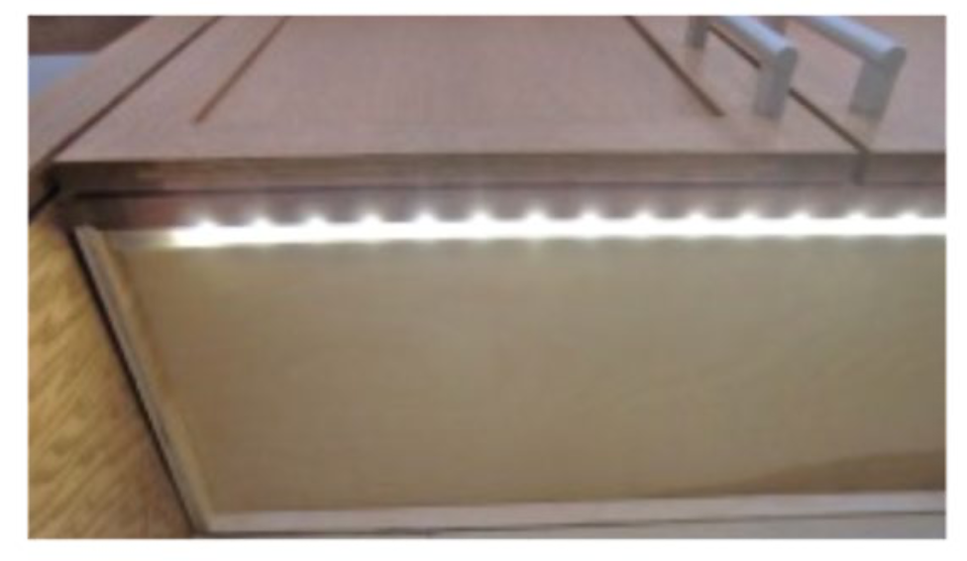Image credit: (Deafblind Ontario Services 2020, p. 74) | Dedicated internal lighting significantly increases visibility inside deep, shadowed storage zones where overhead ambient light cannot easily reach. (Deafblind Ontario Services 2020, pp. 9, 15, 74)
Lamp & Bulb Selection | Select lamp shades that disperse light broadly and opt for daylight-simulating globes. | Ensures light spreads softly across the environment rather than casting a single, intense glow. (Deafblind Ontario Services 2020, p. 9)

Modification Level: Assistive Technology/ Equipment
(Products that may support lighting, glare management and close visual tasks without necessarily changing the structure of the home.)
The examples below are not exhaustive, and suitability will depend on the individual’s functional vision, glare sensitivity, preferences and daily activities.
TARGET AREA | WHAT TO DO | WHY IT HELPS
Adjustable Task Lighting | Consider a sturdy portable desk, table or floor lamp with an adjustable arm so the light can be positioned close to activities such as reading, writing, craft or other detailed tasks.  [Image description – a table lamp with adjustable arm]  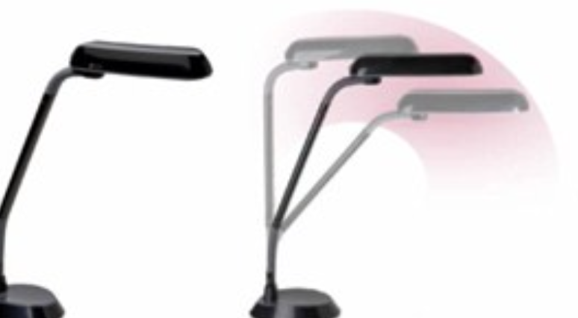  Image credit: (Senses Foundation Western Australia, 2013)  If the lamp will be used very close to the face or hands, consider a light shield (such as replacing a metal shield to a plastic shield) that remains relatively cool to touch. | Bringing a light source closer to the task can significantly increase the amount and spread of light compared to relying only on ceiling or wall lighting. The Senses Product Guide also notes that fluorescent tube lighting with a plastic shield can reduce the risk of burns when a lamp is positioned close to the user. (Senses Foundation Western Australia, 2013)
Magnifying Lamps | Where both additional lighting and magnification are helpful, consider a magnifying lamp for close activities such as reading, writing or craft.  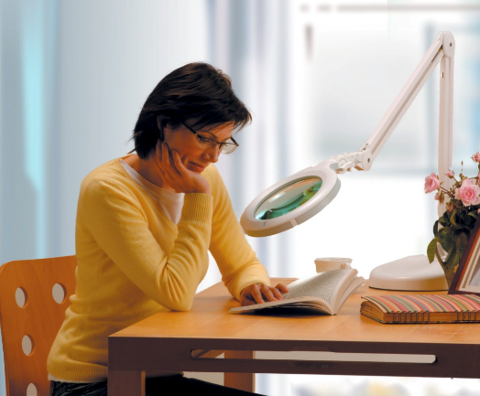  [Image description – a magnifying lamp being used to help with reading a book]  Image credit: (Senses Foundation Western Australia, 2013) | A magnifying lamp combines localised lighting and magnification in one device. However, the level of magnification is generally limited and may not be sufficient for someone with severe vision impairment. (Senses Foundation Western Australia, 2013)
Portable Lighting | Consider a small torch, key-ring LED light or the inbuilt torch in a smartphone for short tasks where extra light is needed, such as locating a keyhole or finding an item in a darker area.  [Image description – a key-ring LED light]  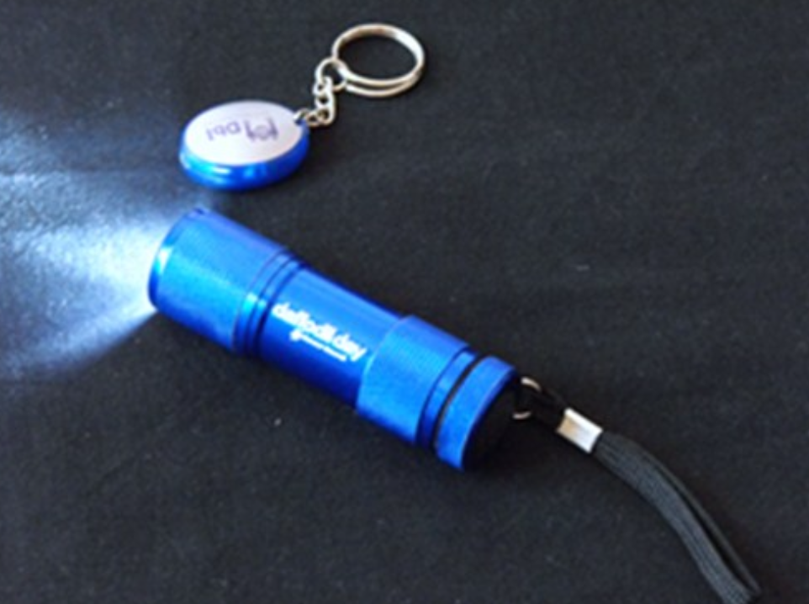  Image credit: (Senses Foundation Western Australia, 2013) | A portable light can provide additional illumination, when and where it is needed without needing to alter the lighting of the whole room.
Smart / App-Controlled Lighting | Where useful, consider Wi-Fi-connected smart globes that allow brightness and colour temperature to be adjusted from an accessible device like smartphones. Settings may also be programmed to change automatically at different times of day or according to sunset schedules. | Adjustable lighting allows the person to change the environment when their visual needs fluctuate rather than being limited to one fixed brightness or colour temperature. Vision Australia specifically recommended smart globes that can adjust brightness and colour temperature according to sunset schedules and seasonal changes. (Vision Australia)
Motion-Activated Lighting | Where locating or operating a light switch is difficult, consider installing motion-activated lighting in appropriate areas of the home. | Automatic activation can provide predictable lighting when a person enters a space without requiring them to first locate a switch. The Ontario Guide discusses motion-activated lighting in living areas, bathrooms and bedrooms, and motion-activated lighting in laundry areas. (Deafblind Ontario Services 2020, pp. 14, 63)

Modification Level: Structural / Capital
(Requires plan budget or minor building works)
TARGET AREA | WHAT TO DO | WHY IT HELPS
Wall & Surface Finishes | Explore utilising pastel or matte paint throughout rooms, avoiding high-gloss paints or highly reflective wallpapers. | Matte surfaces maximise light reflection across the space softly without creating a blinding, glossy shine. (Deafblind Ontario Services 2020, pp. 9, 32)
Fixed Indirect / Diffused Lighting | Where existing lighting creates glare, strong shadows or uneven illumination, consider fixed lighting that directs light towards ceilings or walls. Diffusers may also be used where appropriate.  [Image description – a ceiling light with diffuser]  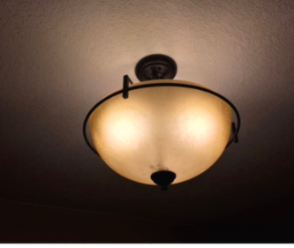  Image credit: (Deafblind Ontario Services 2020, p.17) | Reflecting or diffusing light across walls and ceilings can create a more even spread of illumination and prevents harsh overhead glare from bare bulbs. (Deafblind Ontario Services 2020, pp. 9, 15)
Floor & Pathway Navigation | Consider installing low-voltage LED strip lighting along the skirting boards at the base of kitchen and bathroom cabinets.  [Image description – cabinet skirting board with LED strip lights]  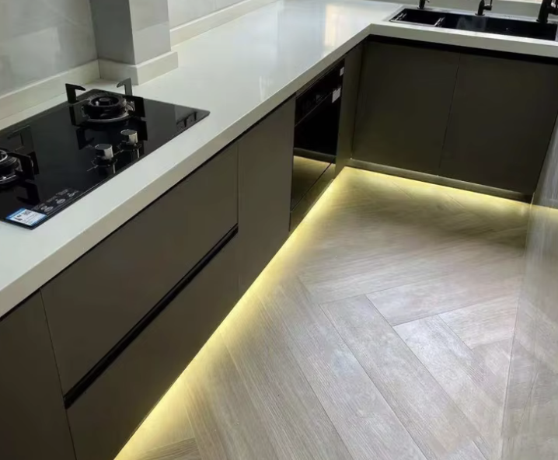Image credit: (Guangzhou Chubang Hardware Decoration Co., Ltd., 2026) | This directly illuminates the floor surface right next to boundaries, helping to cleanly define and map out safe walking pathways. (Deafblind Ontario Services 2020, p. 15)
Adjustable Dimmer Controls | Where appropriate, consider installing dimmer controls so the brightness of fixed lighting can be adjusted by the individual. | A fixed level of brightness may not always suit the person. Dimmers allow lighting to be adjusted according to individual preferences and changing visual needs.

Clinical Reasoning Corner - For Clinicians & Support Workers
The 2-to-3x Illumination Rule
Be mindful that people living with progressive low vision or combined sensory loss generally require two to three times more light than a fully sighted person to perform daily tasks safely (Vision Australia). Clearly outlining this medical necessity and functional needs can help provide justification in home modification funding reports.
Manipulating Brightness with Adjustable Dimmers
Consider the functional limitations of fixed-brightness lighting. Where appropriate, it is highly beneficial to recommend installing adjustable dimmer switches (Vision Australia; Deafblind Ontario Services 2020, p. 16). This accommodates the user's daily vision fluctuations, offering the flexibility to manually dial brightness up or down depending on fatigue or environmental strain. This can also prevent the need for future lighting modifications if a person’s individual lighting needs change as they age.
Ask, Trial, and Adjust
Lighting needs are highly individual. Even people from the same family or with the same diagnosis may prefer different colours and level of light. Clinicians and support workers should work with the person and, where appropriate, consult an orthoptist or low-vision specialist when assessing home lighting (Vision Australia). Rather than recommending one fixed type of light, trial different options and ask the person which setting works best.
Dynamic lighting may be helpful because it allows the person to adjust the colour and brightness for different activities and times of day (Steve - Vision Australia).

4.3 Colour and Contrast
Visual colour contrast is important to assist orientation of those with low vision or progressive vision changes within the home. Contrast is built using two complementary methods: Colour Contrast (the absolute difference between two colours on a colour wheel) and Luminance Contrast (the difference in the amount of light reflected from one surface compared to another).
By focusing on clear colour wheel dynamics, everyday home items and architectural boundaries can be clearly highlighted from their backgrounds. This enables individuals to maximise their remaining residual sight for spatial depth perception, letting them safely identify, map, and navigate their surroundings independently.

Calculating Luminance Contrast
The 2021 Australian Standard recommends the use of the Bowman–Sapolinski equation to calculate luminance contrast.

C = 125(Y₂ - Y₁)
Y₁+Y₂+25
- C = luminance contrast (%)
- Y₁ = Light Reflectance Value (LRV) of the darker surface
- Y₂ = Light Reflectance Value (LRV) of the lighter surface
(Standards Australia, 2021, Appendix B)
While AS 1428.1 recommends a minimum luminance contrast of 30%, emerging research suggests higher contrast is needed for those with vision impairment, particularly on room features such as door handles and light switches (Manandhar et al., 2022).

Light reflectance values can be found on manufacturer specification sheets, paint chip labels and brand colour libraries. For example, Dulux paints publish all their LRV’s for the paints on their website.

4.3.1 Architectural & Furniture Colour Contrast Tips
Dividing colour and contrast strategies into simple, immediate adjustments and longer-term environment upgrades helps ensure that a home can adapt smoothly to individual goals and funding options.

Modification Level: Low-Cost / DIY
(Immediate, budget-friendly changes that can be trialled before larger modifications.)

TARGET AREA | WHAT TO DO | WHY IT HELPS
Solid Colour Background Mats | Try placing simple, solid-coloured mats underneath essential daily objects (like keys, white canes, or medicine bottles) on benches and tabletops.  [Image description – 3 non-slip mats in yellow, red, and black from left to right]  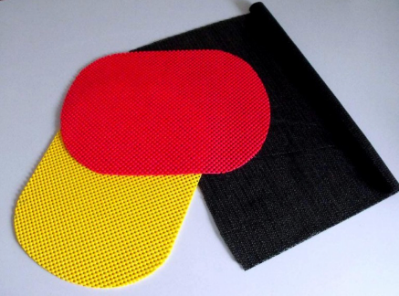  Image Credit: (DBIA, 2026) | Provides a clear background block that separates small items from visually complicated or busy surfaces. (DBIA, 2026)
Rule of Permanence | Keep these solid background mats and high-use items strictly in the same designated spots across living spaces. | Moving items breaks a person's mental map of the house, which can drastically increase spatial confusion and cognitive fatigue. (Consumer Survey, 2026)

Modification Level: Structural / Capital
(Requires plan budget or minor building works)

TARGET AREA | WHAT TO DO | WHY IT HELPS
Room Boundaries | Consider installing solid, dark-coloured baseboards (skirting boards) that contrast with light-coloured walls and flooring. | Creates a continuous visual guide around the edges of the floor, helping with orientation and reducing the risk of trips. (Deafblind Ontario Services 2020, pp. 11, 36)
Doors & Pathways | Paint interior doors, door trims and frames in a colour that contrasts with the surrounding walls. | Makes doorways and room entrances easier to identify, supporting safe navigation and reducing the risk of bumping into closed doors. (DBIA, 2026; Deafblind Ontario Services 2020, pp. 9, 36)
Operating Controls | Choose light switches, power outlets and wall thermostats that contrast with the surrounding wall. | Makes important controls easier and quicker to find without having to search the entire wall. (Consumer Survey, 2026; Deafblind Ontario Services 2020, p. 65)
Living Spaces & Furniture | Choose large furniture, such as sofas, armchairs and beds, in solid colours that contrast with the floor and walls. | Helps furniture stand out from the background, making it easier to judge its position and move around the room safely. (Deafblind Ontario Services 2020, pp. 9, 28)
Support & Grab Rails | Choose handrails and bathroom grab rails in colours that contrast with the surrounding walls or tiles. | Makes these supports easier to see, locate and grip when they are needed for balance and safety. (Deafblind Ontario Services 2020, pp. 9, 42)

4.3.2 Designing with the Right Colour Combinations
When selecting interior paints, appliance controls, or home furnishings, placing noticeably different colours directly side-by-side provides the best visual clarity. The following colour combinations are specifically discussed in the Accessibility guide for sensory loss deafblind Third Edition Deaf Blind Ontario Services 2020:
High-Contrast Colour Combinations (Recommended)
(Deafblind Ontario Services 2020, p. 10)
• Black / white  TEST | • Yellow / black  TEST
• Dark blue / white  TEST | • Dark purple / white  TEST
• Dark red / white  TEST | • Yellow/green  TEST
• Dark green / White  TEST | • Dark brown / white or cream  TEST
• Bright red / white  TEST | • Dark grey / white  TEST
Low-Contrast Colour Combinations (Avoid)
(Deafblind Ontario Services 2020, p. 10)
• Yellow/grey  TEST | • Light grey/white  TEST
• Yellow/white  TEST | • Blue/red  TEST
• Light blue/white
TEST
Colour Blindness Alert
Avoid placing Red / Green TEST or Blue / Green TEST configurations directly adjacent to one another. These spectrum pairs are exceptionally difficult for individuals with co-occurring colour vision deficiencies to tell apart
(Deafblind Ontario Services 2020, p. 10).

Clinical Reasoning Corner - For Clinicians & Support Workers
The Colour Selection & User Preference
When developing a colour contrast track, clinicians should avoid assuming that clients automatically want loud or vibrant paint schemes. Evidence shows that personal preferences within the community often lean heavily toward neutral colour schemes (DBIA, 2026). Effective contrast can be elegantly achieved using darker and lighter shades of the exact same neutral colour to define doorframes, steps, and floor borders while maintaining a calming home environment (DBIA, 2026).

4.4 Textures
For people living with DSI, the sense of touch is a reliable sensory alternative to explore when visual or auditory information feels fragmented.
Incorporating different physical textures across household surfaces can act as a gentle physical map, helping individuals navigate spaces with greater confidence and locate everyday items using their own preferred touch boundaries.
Because every person's sensory preferences vary, tactile markers should be applied thoughtfully and consistently to support mental mapping without creating an overwhelming environment.

4.4.1 Household Tactile Adaptation Tips
Dividing tactile and touch strategies into simple, immediate adjustments and longer-term environmental upgrades help ensure a home can adapt smoothly to individual goals and funding options.

Modification Level: Low-Cost / DIY
(Immediate, budget-friendly changes that can be trialled before larger modifications.)
TARGET AREA | WHAT TO DO | WHY IT HELPS
The Single Marker Approach | Consider placing one clear tactile shape (like a small, raised dot or texturised stripe) on high-use buttons, microwaves, or remote controls. | Rather than marking every button, a single, distinct marker can help guide fingers quickly to a starting landmark without causing confusion. (Vision Australia)
Product Identification | Try wrapping simple rubber bands or texturised bands around matching bottles. | This can create an easy, low-cost tactile clue to help differentiate identical containers instantly in the shower or bathroom. (Vision Australia; Deafblind Ontario Services 2020, p. 74)
Textured Navigation mats | Lay down mats of different sizes and textures flatly across core open spaces to denote specific zones. | Serves as an immediate underfoot clue that assists the individual with navigating through open layouts independently. (Customer survey, 2026)

Modification Level: Structural / Capital
(Requires plan budget or minor building works)
TARGET AREA | WHAT TO DO | WHY IT HELPS
Floor Transitions | Where possible, try to limit the home layout to three unique underfoot textures (such as timber halls, carpeted bedrooms, or tiled wet areas). | Changes in flooring texture can softly signal a transition into a new room. Keeping the variety to three distinct textures helps ensure the layout remains intuitive to remember. (Deafblind Ontario Services 2020, pp. 11, 52)
Wall Trailing | Explore using non-abrasive finishes like matte wallpapers or lightly textured decorative tiling along core reference walls or hallways. | Provides a smooth, comfortable boundary to trace safely with a hand while moving down a hall. It is usually best to avoid rough, bare brick or splintered wood surfaces which can be abrasive to touch. (Deafblind Ontario Services 2020, pp. 11, 31)
Orientation Rails | Consider limiting orientation handrails to one specific tracking wall in extended or open spaces. | Installing rails on every single wall can sometimes make corridors feel identical. A single dedicated rail can serve as a helpful directional anchor and balance aid. (Deafblind Ontario Services 2020, p. 11)
High-Risk Step Transitions | Consider placing thin, texturised safety strips or low-profile tactile mats permanently fastened at the top and bottom of internal stairs or step-downs. | This mirrors public safety design by providing a clear, dependable underfoot warning to gently signal a change in floor levels before a person takes a step. (Compliance Solution Canada)

4.4.2 Example of Comfortable Tactile Materials
When trialling DIY orientation markers, check which textures feel most intuitive and comfortable to the individual (Deafblind Ontario Services 2020, p. 11):
- Structured Sandpaper (Coarse/Rough)  [Image description – 3 sandpapers with different grades and grits, yellow, orange, and brown from left to right]  Image credit: (Empire Abrasives, 2026) | - Texturised Rubbers (Bumpy/Grippy)  [Image description – black rubber sheet with dotted texture]  Image credit:(aiTextured, 2026)
- Ridged Corduroy Fabrics (Grooved)  [Image description – fabric with raised parallel lines or ridges]    Image credit: (Haining Lesun Textile Technology Co.,Ltd, 2026) | - Soft Felt or Fur (Smooth/Soft)  [Image description – felt fabric]  Image credit: (EU Fabrics, 2026)
Clinical Reasoning Corner - For Clinicians & Support Workers
Balancing Accessibility Codes with Tactile Landmarks
Be mindful that while standard building code regulations often encourage large, open physical spaces for mobility equipment like wheelchairs, large open voids can occasionally remove the predictable tactile landmarks a person relies on to find their way around. Because open layouts can be challenging to navigate, explore organising furniture lines, wall textures, or underfoot paths to serve as clear, orienting physical anchors (Deafblind Ontario Services 2020, p. 8).
Securing Ground Mat Boundaries to Prevent Tripping
While texturised flooring mats provide tactile clues, loose rugs or mats that are not flatly secured present a high tripping hazard for individuals tracking surfaces with their feet (Deafblind Ontario Services 2020 p. 32). Clinicians and support workers must ensure that any floor mats are fastened or flush with adjacent surfaces to support independence without compromising physical safety at home (Deafblind Ontario Services 2020 p. 32; Consumer Survey).
Adapting Residential Indicators for Higher-Risk Zones
When addressing internal steps, entry thresholds, or ramps, consider using of localised tactile indicators (Compliance Solution Canada). While public spaces utilise standardised raised tiles, home environments can benefit from simplified, low-profile textured strips placed right at transition points to softly alert the individual to an upcoming level change (Compliance Solution Canada).

4.5 Acoustics
For people living with DSI, the acoustic environment can influence how everyday sounds such as the telephone, doorbell or conversations are heard and understood. Hard surfaces can create echo and background noise, which can make communication more difficult and tiring. Adding soft furnishings can help absorb excess sound and improve speech clarity. However, the room should not become completely silent, as some natural sounds can also help with orientation and understanding the surrounding space.

4.5.1 Household Acoustic Adaptation Tips

The following strategies are organised by modification level, from simple household changes to assistive technology and structural options.
Modification Level: Low-Cost / DIY
(Immediate, budget-friendly changes that can be trialled before larger modifications.)
TARGET AREA | WHAT TO DO | WHY IT HELPS
Soft Furnishings | Consider adding fabric curtains, fabric-covered furniture or carpet where appropriate. | Soft furnishings can absorb sound and help reduce echo and background noise in the room. (Deafblind Ontario Services 2020, p. 31)
Auditory Location Cues | Consider placing different wind chimes within reach at selected locations in the home, where this suits the person. | When touched, different sounds and vibrations can provide a cue that helps the person identify where they are in the home. (DBIA, 2026)
Reducing Background Noise | Where possible, choose quieter household equipment and reduce unnecessary mechanical noise. | A quieter environment can make everyday sounds and conversations easier to hear. (Deafblind Ontario Services 2020, p. 31)

Modification Level: Structural / Capital
(Requires plan budget or building works)
TARGET AREA | WHAT TO DO | WHY IT HELPS
Sound Dampening Flooring | When replacing hard flooring, consider materials such as carpet, cork or rubber, depending on the person’s needs and the room. | Carpet and vinyl can feel softer underfoot and help absorb sound, reducing noise and echo compared with harder surfaces such as timber or ceramic tiles. Cork and rubber are also identified as flooring materials that may help dampen sound. (DBIA, 2026; Deafblind Ontario Services 2020, p. 31)
Soundproofing & Sound-Dampening | When renovating, consider sound-dampening installation methods, soundproofing walls or ceilings, or using acoustic ceiling tiles where needed. | Reduces unwanted noise and echo in busy areas such as living and dining rooms. (Deafblind Ontario Services 2020, pp. 30, 31, 65)
Exterior Mechanical Placement | Where possible, place noisy outdoor equipment, such as air-conditioning units, away from windows and doors. | Helps reduce unwanted noise entering the room, making communication easier. (Deafblind Ontario Services 2020, pp. 30, 65)

Clinical Reasoning Corner - For Clinicians & Support Workers
Sound Absorption VS. Useful Room Echoes
Hard surfaces can create too much echo and make speech harder to understand. However, removing too much sound can also take away useful environmental cues that some people use to understand the size and layout of a room. (Deafblind Ontario Services 2020, p. 30). Aim for a balance. Soft furnishings, cork, rubber flooring or ceiling tiles may help reduce harsh echo, while still allowing the person to use natural sounds for orientation. (DBIA, 2026; Deafblind Ontario Services 2020, pp. 30, 31).
Reducing Background Noise to Prevent Fatigue
Ongoing background noise, such as air conditioners, fans or other equipment, can make it harder to focus on speech and may make communication more tiring.
Where background noise is a significant problem, consider practical options such as quieter equipment, sound-dampening materials, soundproofing, or moving noisy outdoor equipment away from windows and doors. (Deafblind Ontario Services 2020, pp. 31, 65)

Chapter 5: Safety & Emergency
Planning for emergencies when living with DSI requires special care. Standard emergency systems usually rely on loud sirens or flashing lights. However, if a person has combined vision and hearing loss, they might not see a light or hear a siren, especially when sleeping. Setting up multi-sensory alerts, creating simple touch signals, planning for power outages, and learning how to call Triple Zero (000) using accessible channels builds a dependable safety net at home.

5.1 Multi-Sensory Alerting Systems & Home Safety Tips
Regular alarms can fail if individuals are fatigued or if hearing aids are turned off at night. A safe home alerting setup combines light, loud sounds, and physical vibrations.

Modification Level: Assistive Technology/ Equipment
(Products that may support lighting, glare management and close visual tasks without necessarily changing the structure of the home.)
TARGET AREA | WHAT TO DO | WHY IT HELPS
House/ Driveway Identification | Consider a consistent, easy-to-identify visual landmark at the driveway or entrance, alongside clear house identification | A noticeable landmark may help visitors identify the correct property more easily. Paola Murray described using a pink light on her driveway to help rideshare drivers identify her home during drop-offs (Paola Murray). This is a lived-experience example rather than a universal recommendation.  A similar approach may also be useful when helping others locate the home quickly, including in an emergency, but this should not replace clear house numbers or other emergency identification requirements.
Arrival Alerts | Place smart video sensors or cameras (like Ring systems) further down the driveway instead of just at the front door. | Gives an early alert about who or what is approaching and where they are. This prevents the user from being scared or caught off guard by someone suddenly showing up at the front door. (Hannah McPierzie)
Emergency Phone Shortcuts | Set up quick emergency buttons (like a one-touch Police shortcut or SOS button) on your phone or smartwatch. | Allows individuals to quickly send a call for help if they fall, get lost, or feel unsafe. (Consumer Survey, 2026)
Evacuation Kit Preparation | Pack a portable "sustainability emergency kit" containing spare device batteries, tactile communication cards, and emergency contacts. | Keeps essential communication tools and backup power ready to go in case of a sudden evacuation or blackout. (Leyla Craig)
Tactile & Vibrating Alarms | Install Australian-certified (TGA-Therapeutic Goods Administration) smoke alarms that connect to vibrating bed shakers and body pagers. Avoid buying cheap, uncertified alerting devices online. | A vibrating pad under the pillow wakes the person up if there is smoke or fire at night. Buying certified gear ensures it uses correct Australian electrical voltage. Cheap overseas imports often have the wrong voltage or poor quality, which can cause electrical shocks, short circuits, or physical injuries. (Consumer Survey, 2026; Hearing Australia)
TTY Setup | For individuals who find speech or touchscreens tricky, installing a fixed-line TTY (Teletypewriter) might be worth considering. | While new NRS registrations rarely use TTY units nowadays, it can still be a helpful option for individuals who prefer reading simple on-screen text.

Modification Level: Structural / Capital
(Requires plan budget or minor building works)
TARGET AREA | WHAT TO DO | WHY IT HELPS
Utility Shut-Off Access | Keep pathways clear to main water valves, power boxes, and gas switches, and mark them with clear tactile labels. | Helps the person or a family member quickly find and turn off house utilities during an emergency. (Consumer Survey, 2026)
Property Hazard Cleaning | Use home support or maintenance funding to hire handymen to clean roof gutters, clear drains, and pick up yard debris. | Directly lowers the risk of bushfires or water damage around the property.

5.2 Contacting Emergency Services via the National Relay Service (NRS)
Tips for contacting emergency services in an emergency:

In a life-threatening situation, you can make a call to emergency services (Fire, Police, or Ambulance and more) through the NRS.
Emergency calls using NRS Chat, SMS Relay, NRS Captions, Voice Relay and TTY to receive priority in the queue so calls are taken quickly.
If you’re an Auslan user, it’s better NOT to use Video Relay to make an emergency call. This is because:
- It’s not possible to identify (and therefore prioritise) emergency calls using Video Relay
- Video Relay is only available during limited hours.

You should only call emergency services if:
- someone is seriously injured or in need of urgent medical help, or
- your life or property is in danger right now, or
- you’ve just witnessed a serious accident or crime.
When making a call to emergency services, it’s important to:
- Ask for the service you need — police, fire or ambulance
- Say or confirm where you are (your location)
- Be ready to explain the emergency.
It’s a good idea to learn more than one NRS call type in case you need to make an emergency call. You could try NRS Chat or SMS Relay. There are two videos on Access Hub about using these two options.
Starting a call to emergency services is slightly different for each call type.

5.2.1 Easy NRS Emergency Options
(see Appendix 1 for official NRS information)

NRS CALL OPTION | HOW TO CONTACT TRIPLE ZERO (000) | STEP-BY-STEP INSTRUCTIONS | EQUIPMENT NEEDED
SMS Relay  (Texting) | Text: 0423 677 767 | 1) Send an SMS to 0423 677 767.  2) Type: 000 + [FIRE, POLICE, AMBULANCE] + [Your Location & Emergency].  (TIP: Save this number in your mobile phone contacts). | Any mobile phone (No internet required).
NRS Chat  (Web Text) | Go to: nrschat.nrscall.gov.au | 1) Open your web browser to nrschat.nrscall.gov.au  2) Click the red button: Call 000 - Chat.  3) Type your details to the Relay Officer.  (TIP: Save this web page as a favourite on your computer). | Computer, tablet, or smartphone + Internet connection.
NRS App  (Smart-phone App) | Open App: Download free from Apple or Google stores | 1. Open the NRS App.  2. Tap the red button: 000 - Make emergency call.  (You do not need to log in to make an emergency call). | Apple or Android phone/tablet.
TTY (Teletype-writer) | Dial: 106 | 1. Dial 106 on your TTY home phone.  2. Type the service you need (Police, Fire, or Ambulance) and your location. | TTY fixed-line phone plugged into power and phone line.
NRS Captions / Voice Relay | Call / Visit: 1800 555 727 or nrscaptions.nrscall.gov.au | 1. Connect and ask for 000.  2. Speak directly into your phone and read the typed captions on your screen. | Phone + Internet connection / Smartphone.

5.2.2 Signing Up & Tips for Smooth Calls
To help everyday calls (like booking doctor appointments) and emergency calls go smoothly, consider registering early and trying out a few simple setup tips:
Simple NRS Sign-Up Steps
- Register Online: Visit accesshub.gov.au/about-the-nrs/register-for-the-nrs
- Fill in Your Info: Enter your name, home address, and email.
- Upload ID: Attach 2 forms of identification (such as a Medicare card).
- Try a Practice Call: Reach out to the NRS Helpdesk for a friendly test call. This helps make sure everything is working comfortably before you need it.

Ways to Prevent Unexpected Disconnections
Medical clinics or businesses sometimes accidentally disconnect relay calls because they mistake the Relay Officer for an automated call or telemarketer. Here are three easy ideas to help keep your calls connected:
- Try a Short Opening Script: You can type or read a quick phrase at the start of a call:
"Hello, my name is [Your Name], and I am using the National Relay Service to call today..."
- Add a Note to Your NRS Profile: You might like to log into your NRS account and add a message: "I require extra time to type and respond via SMS." This signals to the Relay Officer to give you plenty of processing time without ending the call.
- Save Your Frequent Numbers: Storing your most common numbers (like your GP, family members, or local clinic) in your NRS profile can make placing outbound calls much quicker and easier.
Contact Card: NRS Helpdesk Details
(For easy reference in Appendix)
For help setting up, registering, or testing relay options, the NRS Helpdesk is available Monday to Friday, 8 am – 6 pm AEST:
- Phone: 1800 555 660
- TTY: 1800 555 630
- SMS: 0416 001 350
- Email: helpdesk@relayservice.com.au
- Online Enquiries & Chat: accesshub.gov.au/about-the-nrs/nrs-helpdesk/enquiries

5.3 General Safety Ideas around the Home
- In noisy or high-stress moments where seeing or hearing is difficult, simple pre-agreed touch signals can be wonderful. For example, softly drawing an "X" (cross) on someone's back could mean:
"There is an emergency, we need to head outside now, and I will explain the details as soon as we are safe." (DSI community member - Dr Annmaree Watharow)
- It can be helpful to complete free NRS registration before any emergency arises. Registering early at accesshub.gov.au/about-the-nrs/register-for-the-nrs ensures everything is ready if you ever need it.
- Considering a backup plan for blackouts can bring peace of mind. If Wi-Fi, screens, or powered devices go off, keeping portable battery packs or non-powered phone options handy can be very reassuring.
- If you feel comfortable, you or your support team could reach out to your local emergency station (e.g., fire station) to share your address and let them know about your preferred communication style.

Clinical Reasoning Corner - For Clinicians & Support Workers
Creating Emergency Plans Early in Assessments
People living with DSI are especially vulnerable during emergencies, but many only realise the importance of an emergency plan after they experience an unexpected accident, fall, or severe event (Leyla Craig & Hannah McPierzie). Clinicians can help fill this gap by making emergency planning a standard part of early home visits (Leyla Craig). Discussing plans for fire, flood, and power outage plans early builds safety ahead of time, rather than reacting after an accident happens (Leyla Craig & Hannah McPierzie).
Safety Certification & Online Purchasing Considerations
When suggesting home alerting equipment (like flashing lights or vibrating bed shakers), clinicians can help ensure products meet Therapeutic Goods Administration (TGA) standards (Hearing Australia). It can be helpful to discuss that cheaper overseas imports might carry wrong voltage settings or substandard wiring, which could increase risks of device failure or electrical issues (Hearing Australia). Additionally, exploring whether a client experiences tinnitus or dizziness before recommending intense vibrations or loud sounds can help keep things comfortable (Hearing Australia).
Balance Reflexes, Fall Risks & Safety Planning
Clients with inner ear or nerve changes (such as NF2) may experience reduced balance reflexes during trips. A minor fall outdoors could knock someone unconscious, leaving them unable to call for help (Hannah McPierzie). Including emergency response options and fall alarms in home modification plans can be a supportive way to ensure home safety (Leyla Craig & Hannah McPierzie).
Helping Clients Sign Up for the NRS
Clinicians and support workers can guide clients through registering for the NRS by helping gather ID documents and doing a practice call together (NRS). Helping clients set up quick opening scripts and save common numbers in their profiles prevents disconnections and cuts down on stress (NRS). Teaching clients at least two different NRS options (like SMS Relay and NRS Chat) gives them dependable backups during an emergency (NRS Access Hub).
Home Maintenance Funding VS. Home Modifications
In funding reports, clinicians can separate major structural changes from basic home maintenance (Vision Australia & Leyla Craig). Using NDIS maintenance funding to hire handymen for gutter cleaning and yard repairs is a great, practical way to lower fire and flood risks before emergencies happen (Leyla Craig).

Chapter 6 Kitchen
Please ensure you have read Chapter 4: General Environmental Advice before exploring this section. Chapter 4 explains house-wide principles relating to lighting, colour contrast, textures, acoustics, and navigation that form the foundation for a supportive home.
The recommendations below build directly on those principles with targeted strategies for kitchen safety, organisation, and meal preparation.

6.1 Safe Kitchen Habits & Helpful Routines
Meal preparation and managing hot liquids present distinct safety challenges when living with DSI. Establishing predictable routines and clear environmental boundaries promotes both safety and independent living.
- Keep the kitchen predictable
- Keep frequently used food, cookware and utensils in fixed, agreed locations, and encourage household members and support workers to return items to the same place after use. This may be especially important in shared households, where someone else moving an item can disrupt the person's established mental map of the kitchen. (Consumer Survey, Vision Australia)
- The consumer survey also cautioned against relying only on functional sight or hearing, because these may vary with fatigue and environmental conditions. Tactile strategies can provide a more consistent backup.
(Consumer Survey)

- Create a contained pouring area
- When preparing tea, coffee or other drinks, consider working over a tray, bowl or clean sink so accidental spills remain contained.
- Consumers specifically recommended trays when decanting liquids and described a tea/coffee tray as particularly useful for catching spills. Another strategy was placing the cup inside the sink or a bowl while pouring. (Consumer Survey)
- Safe Practice for Knife & Sharp Utensil
- After cutting, place the knife flat in a predictable position with the handle facing toward you and the cutting edge directed away from the working area. (Vision Australia)
- Avoid leaving knives or other sharp utensils inside a sink containing water or dishes. A person searching the basin by touch may not know that a sharp object is present that creates an unseen injury risk. Placing sharp items on a designated tray beside the sink is recommended. (Vision Australia)
- Safe Practice for Using Overhead Cupboards
- Open overhead cupboards can become an unexpected head-level obstacle. Developing a routine of closing cupboard doors immediately after retrieving or returning an item can help reduce the risk of accidental bumps or injury.
- One consumer also described placing a hand over the forehead when bending down as a simple protective technique against striking an unseen object overhead. (Consumer Survey)

6.2 Practical Kitchen Adaptation Tips
There is no single “right” way to organise or use a kitchen.
These ideas are examples only. Trial strategies with the individual before purchasing equipment or making permanent changes, as the most useful setup will depend on their routines, residual senses, communication preferences and home environment. (Consumer Survey)
Modification Level: Low-Cost / DIY
(Immediate, budget-friendly changes that can be trialled before larger modifications.)
TARGET AREA | WHAT TO DO | WHY IT HELPS
Appliance Controls & Dials | Add tactile markers (e.g., tactile/ Velcro dots) to frequently used controls. Avoid covering every control with markers.  [Image description – microwave with tactile dots of different shapes/ colours for commonly-used buttons. Red square marker for “Start”, dark blue circle marker for “Stop”, yellow circle marker for “1 minute”]  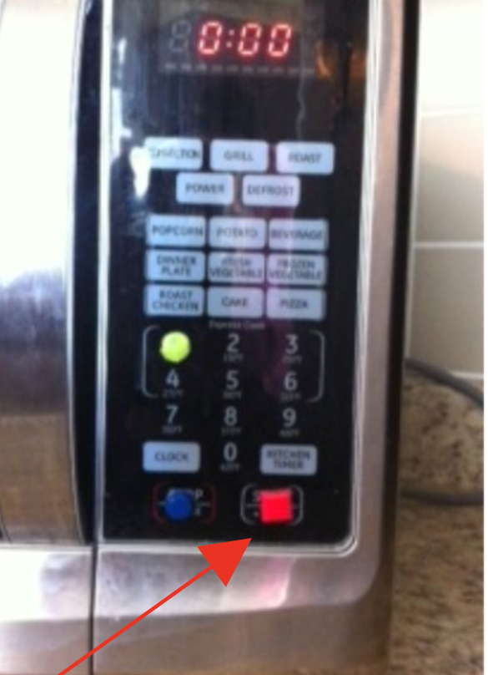  Image credit: (Deafblind Ontario Services 2020, p.86) | Contrasting or tactile markers provide a tactile reference point when visual markings are difficult to see. This can make appliance controls easier to identify and set.  A consumer specifically described marking these microwave functions, while Vision Australia recommended avoiding excessive tactile marking because too many markers may become confusing.  (Consumer Survey, 2026; DBIA, 2026; Deafblind Ontario Services 2020, p.86; Vision Australia)
Appliance Handles | Apply contrasting paint or wrap dark tape around appliance handles (such as white refrigerator doors).  [Image description – white refrigerator doors with black tape wrapped around its handles] 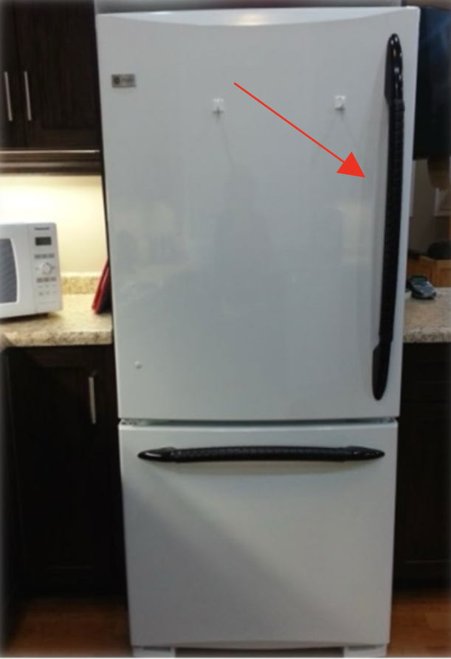  [Image description – white oven doors with black tape wrapping around its handles]  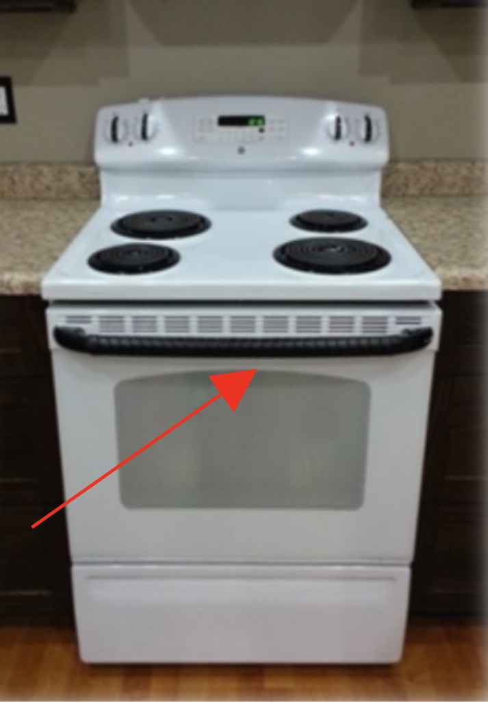  [Image description – white oven with knobs painted in black]  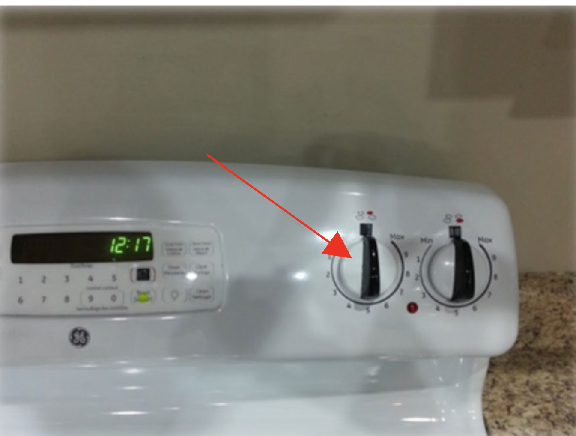  Image credit: (Deafblind Ontario Services, 2020, p. 85) | Ensures handles stand out clearly against surrounding appliance surfaces and can be easily identified. (Deafblind Ontario Services, 2020, p. 85)
Cupboard / Pantry Identification | Outline the interior edges of open cupboards with contrasting tape. Use consistent large-print, tactile or Braille labels on selected shelves, drawers or containers.  [Image description – open cupboard with inside edge marked with yellow tape]  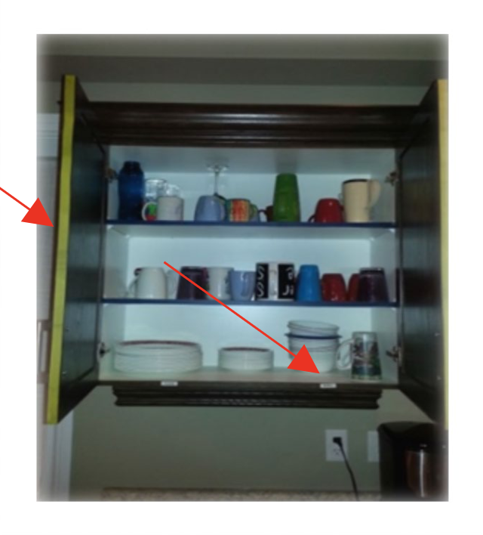  [Image description – open drawer/ shelf with inside edge marked with large font/ braille for item location indication]  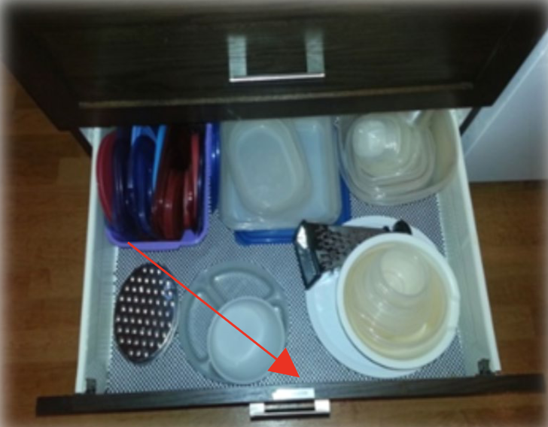  Image credit: (Deafblind Ontario Services, 2020, p. 87) | Highlights cabinet boundaries and allows contents to be identified prior to reaching inside. Braille and raised-print identification also supports independent identification of contents without requiring someone to visually search each cupboard. (DBIA, 2026; Deafblind Ontario Services 2020, pp. 38-29, 87)
Food Preparation Surface | Select cutting boards or preparation surfaces that contrast with the food being prepared (e.g. a white board for dark produce, or a dark/yellow board for light produce).  [Image description – blue cutting mat on light brown table with mushroom on top]  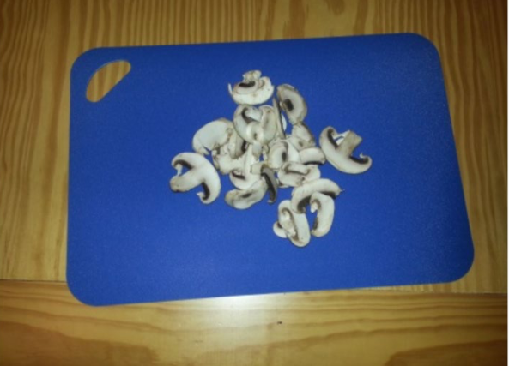  [Image description – white cutting mat on light brown table with tomato on top]  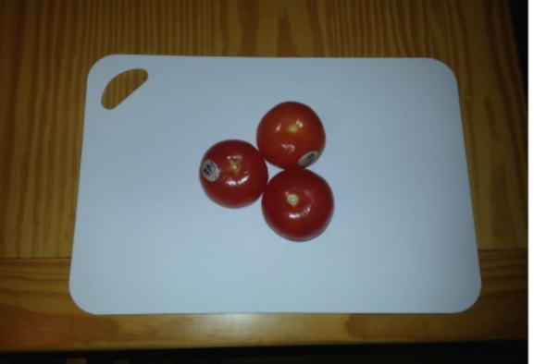  Image credit: (Deafblind Ontario Services, 2020, p. 89) | Colour contrast can make food, dishes and utensils easier to distinguish during preparation. (DBIA, 2026; Deafblind Ontario Services 2020, p.89)
Pouring Area | Place cups, jugs and ingredients on a solid-coloured, non-slip tray while preparing drinks. | Keeps items within a defined working area and contains spills if liquids overflow. (Consumer Survey, 2026)
Measuring Ingredients | Consider using clearly differentiated scoops or containers that represent familiar quantities rather than relying on visually reading small measurement markings. | One consumer described making different-sized measures from container caps for coffee, tea and sugar because they produced less spillage than spoons. (Consumer Survey, 2026)
Containers | Mark commonly confused containers using tactile dots, bands or labels (e.g., sugar versus another similar container.) | Provides a tactile method of identifying items where packaging looks or feels similar. (Consumer Survey, 2026)
Oven Protection | Consider a long oven mitt or glove that protects more of the hand and forearm when handling hot cookware. | A consumer specifically recommended a long, gloved oven mitt with fingers to provide additional protection when cooking. (Consumer Survey, 2026)

Modification Level: Assistive Technology/ Equipment
(Products that may support kitchen activities without necessarily changing the structure of the home.)
Assistive technology and equipment should be selected according to the individual’s needs and preferred form of feedback, such as audio, large print, visual or tactile information. The examples provided are not exhaustive, and products and specifications may change over time.
TARGET AREA | WHAT TO CONSIDER | WHY IT HELPS
Pouring Drinks | Consider an auditory and vibrating liquid level indicator placed on the rim of a cup to indicate when the liquid reaches a set level.  [Image description – yellow liquid level indicator placed on the rim of a cup of coffee]    Image credit: (Vision Store, Vision Australia) | The device buzzes and vibrates when liquid reaches the set level, helping indicate when to stop pouring and reducing reliance on vision (Senses Foundation Western Australia, p. 47, 2013). A consumer specifically identified liquid level indicators as one of several useful strategies for making drinks. (Consumer Survey, 2026; Vision Australia)
Pouring Hot Water | Consider a kettle tipper or an alternative water-dispensing setup where lifting and accurately tilting a kettle is difficult.  [Image description – black and white kettle tipper]    Image credit: (Vision Store, Vision Australia) | May reduce the need to lift and tilt a hot kettle while positioning the spout visually. A consumer specifically identified kettle tippers as one of several ways to make tea with less reliance on functional vision (Consumer Survey, 2026).
Glass Kettle | For some people with useful residual vision, a transparent/ glass kettle may be easier to monitor. | One consumer reported that seeing the water through a glass kettle helped them recognise when it had boiled (Consumer Survey, 2026)
Microwave Use | Consider a talking or otherwise accessible microwave, where its output format matches the person's combination of vision and hearing. | A consumer identified a talking microwave as supporting independence. Because auditory feedback may not suit every person living with DSI, it should be assessed individually. (Consumer Survey, 2026; Vision Australia)
Reading Recipes / Packaging | Consider a portable electronic/ video magnifier or other accessible reading technology to assist tasks such as reading recipes or product information where residual vision is useful.  [Image description –portable magnifier magnifying contents of a book]  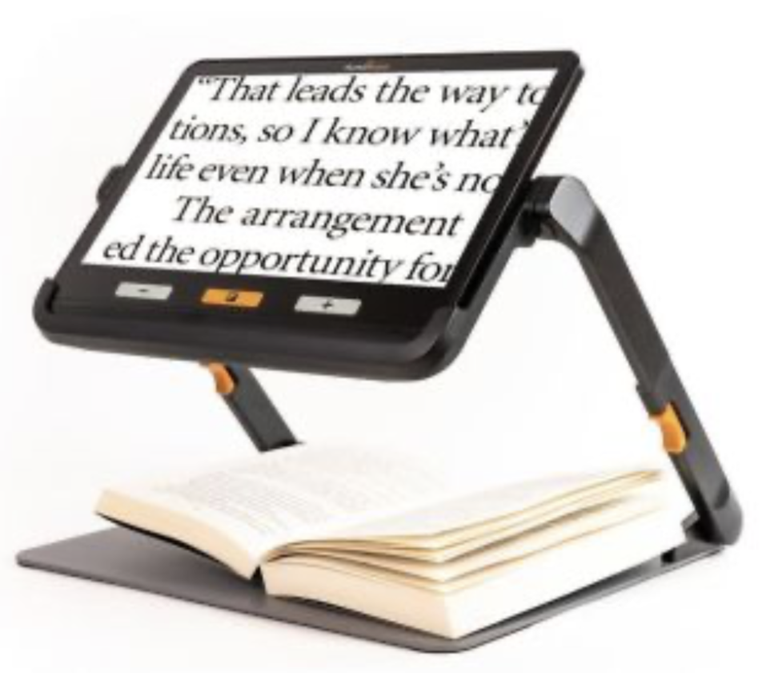  Image credit: (Vision Store, Vision Australia)  Most smartphones have built-in magnifier that can be accessed in the accessibility settings. | Video magnifiers enlarge print and images and may allow adjustment of magnification, brightness, background and print colour (Senses Foundation Western Australia, 2013, p. 41; Paola Murray)
Enclosed Cooking Appliances | Consider enclosed cooking appliances where appropriate for the person's preferred cooking methods. | Using enclosed cooking equipment such as a Thermomix to reduce exposure to open flame and direct contact with hot cooking surfaces. (Dr Annmaree Watharow; Paola Murray)

Modification Level: Structural / Capital
(Requires plan budget or minor building works)
TARGET AREA | WHAT TO DO | WHY IT HELPS
Cooktop & Stove Controls | When replacing or modifying a cooktop, consider controls located at the front (preferred) or side of the cooktop.  The person should also be able to identify burner location, heat status and controls in a way that suits their sensory needs. | Ensures the person does not need to reach across heated surfaces.  The Ontario Guide specifically recommends front or side cooktop controls to avoid reaching over heated surfaces (Deafblind Ontario Services 2020, p. 37). A consumer similarly described choosing front burner controls so their son would not have to reach across hot pots (Consumer Survey, 2026). Paola Murray uses an induction cooktop with visible red heating indicators and described this as safer for her than an open gas flame (Paola Murray).
Oven Safety | Where an oven is being replaced or repositioned, consider whether a wall oven with front-positioned controls and a side-opening door would be easier and safer for the person to access. A heat-resistant pull-out surface beside or below the oven may also be considered  [Image description – oven with side-opening door and a heat-resistant pull-out surface below the oven]  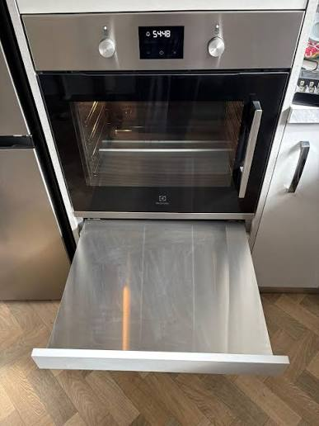  Image credit: (Dull Men’s Club) | Front-positioned controls and heat resistant pull-out surfaces can help reduce the risk of burns when retrieving hot trays from the oven.  (Deafblind Ontario Services 2020, p. 38)
Cabinetry & Storage | Where cabinetry is being replaced or modified, consider full-extension drawers or pull-out shelves, storage positioned within an accessible reach range, easy-to-identify handles, and consistent labels where useful.  [Image description – full height shelf with full-extension drawers]  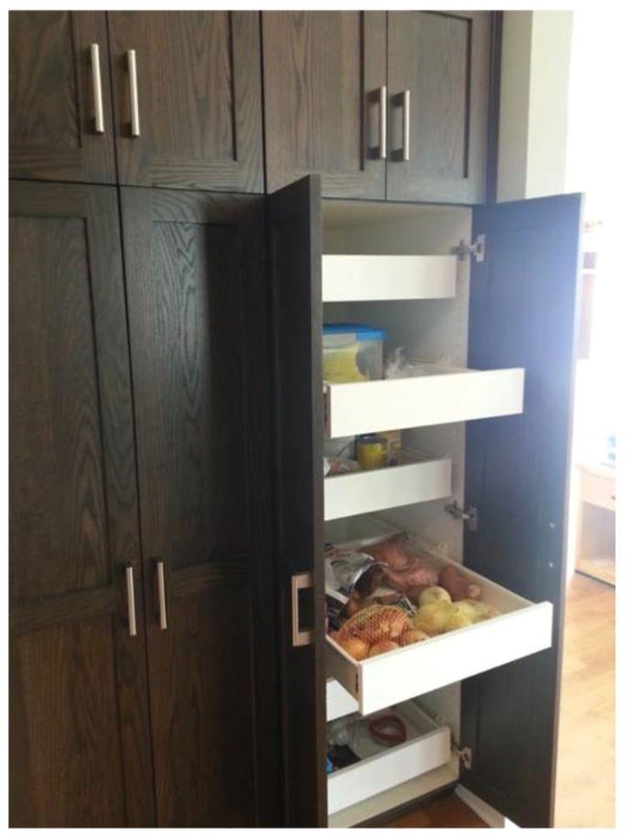  Image credit: (Deafblind Ontario Services 2020, p. 38) | The Ontario Guide recommends full-extension drawers and shelves, light-coloured interiors to improve visibility, “D”-type pulls that contrast with cabinetry, and accessible shelving (Deafblind Ontario Services 2020, p. 38). Its Quick Design Tips also recommends full-extension drawers/shelves and braille or raised-print labels on cabinets and drawers (Deafblind Ontario Services 2020, p. 67). The NDIS builder/designer guide identifies joinery changes to provide accessible storage as a possible kitchen modification (NDIS Home Modifications Guidance, p. 14).
Automatic Water Shut-Off | Consider a professionally installed water monitoring or automatic shut-off system where there is a risk that running water may not be noticed. | Paola Murray described using an automated water sensor that shuts off the main house water supply after approximately 20 minutes if a tap is left running, with a simple touch-button reset (Paola Murray). This is a lived-experience example rather than a universal recommended setting.
Sink & Tap Area | Where the sink is difficult to distinguish from the benchtop, consider a sink that contrasts visually with the surrounding counter.  [Image description – sink with silver colour contrasting with surrounding brown tabletop]  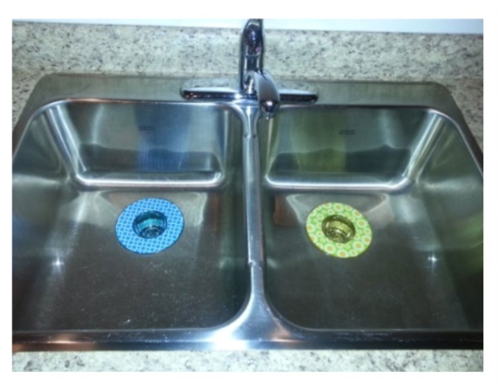Image credit: (Deafblind Ontario Services 2020, p. 88)  If taps are being replaced, automatically activated or lever-style taps may be considered where appropriate. | Colour contrast can make the sink easier to distinguish, while the automatically activated or lever-style taps can prevent the risk of unnoticed running water. (Deafblind Ontario Services 2020, p. 68)
Fixed Task Lighting | Where more localised lighting is needed for food preparation, consider installing under-cabinet task lighting, shelf lighting, or other fixed lighting directly onto work surfaces. | The Ontario Guide recommends task lighting over kitchen counters, including under-cabinet lighting, and also suggest lighting within shelf spaces (Deafblind Ontario Services 2020, pp. 15-16). The DBIA resource similarly recommends strip lighting under kitchen cupboards and additional lighting over pantry shelves (DBIA).
Accessible Electrical Outlets | Where electrical work is already undertaken, consider locating additional outlets within an accessible reach range and ensuring they can be distinguished from the surrounding surfaces. | The Ontario Guide recommends kitchen electrical outlets that contrast with surrounding walls/ counters (Deafblind Ontario Services 2020, pp, 36-37, 67). The NDIS builder/ designer guide lists additional General Purpose Outlets (GPOs) within an accessible reach range as a possible kitchen modification. (NDIS Home Modification Guidance, p.14)

6.3 Tips When Choosing New Kitchen Appliances
1. Try before you buy
Before purchasing a new appliance, there are things to explore, include (consumer survey, Vision Australia, Hearing Australia):
- Can buttons or dials be distinguished by touch
- Can tactile markers be added?
- Do controls require reaching over hot surface?
- Does the appliance rely entirely on a flat touchscreen?
- If it gives auditory information, is that information accessible with the individual’s residual hearing?
- Does the visual display work with the individual’s residual vision and glare sensitivity?
This was directly emphasised by a consumer contributor:
“Don’t spend money until you know the solution works for you.” (consumer survey, 2026)

Clinical Reasoning Corner - For Clinicians & Support Workers
For appliances with controls that need to be identified tactilely, clients may benefit from physically trialling the controls before purchase rather than ordering online immediately.

Do NOT Rely on One Compensatory Sense
A kitchen modification should not automatically replace visual information with sound, or auditory information with visual alert.
For people living with DSI, both senses are reduced, and functional vision or hearing may also change depending on fatigue and environmental conditions. Where possible, consider whether important kitchen information can be accessed in more than one way, including tactile information. (Consumer Survey, 2026; Vision Australia)

Think about the Whole Household
People living with DSI may also be parents, partners, carers, rather than only recipients of care. A lived experience parent (Paola Murray) living with DSI explained how kitchen recommendations need to consider the person’s household roles and routine, not only isolated ADLs.

Start with the Activity, NOT the Product
For example, difficulty making tea could relate to:
- Identifying the mug
- Measuring ingredients
- Locating tools (e.g. kettle, mug, spoon)
- Lifting hot water
- Judging the fill level
- Recognising that water has boiled
- Cleaning up spills
Different barriers may require different solutions. Hearing Australia recommends linking interventions to meaningful activities and personal goals rather than focusing only on the technology itself. (Hearing Australia).

Chapter 7 Bathroom and Laundry
Please ensure to read Chapter 4: General Environmental Advice before exploring this section. Chapter 4 covers house-wide principles on lighting, colour contrast, textures, acoustics, and general navigation that form the foundation for a supportive home.
The recommendations below build directly on those principles with targeted strategies for safe bathroom and laundry use including, organisation, orientation, and other specific activities.

7.1 Introduction
The bathroom and laundry are high-use rooms in the house that pose serious safety risks for people living with DSI. These spaces require thoughtful design, prioritising tactile orientation, visual contrast and predictable layouts to help facilitate safe use of bathroom and laundry areas.
Standard accessibility design rules often don’t account for the unique needs of people living with DSI, however, these accessibility guidelines may need to be considered in conjunction with the suggestions listed below. Standard guidelines such as requiring circulation spaces for wheelchairs can be detrimental for people with DSI but may be required for bathroom modifications especially for older adults or people who may have reduced mobility.

7.2 Practical Bathroom and Laundry Adaptation Tips
There is no single “right” way to organise or use a bathroom or laundry. The suggestions listed below are examples only and strategies should be customised to the individual based on their routines, home environment, residual senses, and any other factors.
Modification Level: Low-Cost / DIY
(Immediate, budget-friendly changes that can be trialled before larger modifications.)
TARGET AREA | WHAT TO DO | WHY IT HELPS
Contrast | Consider installing high contrast toilet seats.  Contrast between floors, walls, fixtures, sinks and countertops should be made, where appropriate.  Consider using colour contrasting, non-slip bathmats in showers or baths to help with orientation and safe showering.  [Image description – White toilet with a contrasting black toilet seat]  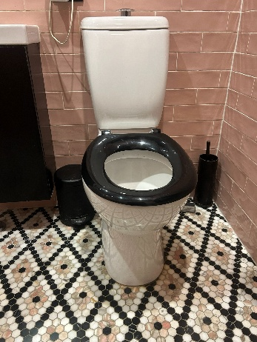  Image credit: (DSI community member – Dr Annmaree Watharow) | High visual contrast can help with detecting edges and openings, improving navigation and increasing task accuracy & efficiency.  Contrasting bathmats can not only provide safer use of showers and baths but can also provide both visual and tactile cues on where to stand (Deafblind Ontario Services 2020, pp, 69-70).
Tactile Markers | Tactile dots/bands, braille labels or rubber bands can be used to differentiate between similarly shaped packaging.  E.g.:  - shampoo vs conditioner  - toothpaste vs hand cream  - laundry detergent vs fabric softener  Tactile dots can also be used on commonly used appliance controls.  [Image description – shampoo and conditioner bottles with different tactile bands wrapped around them]  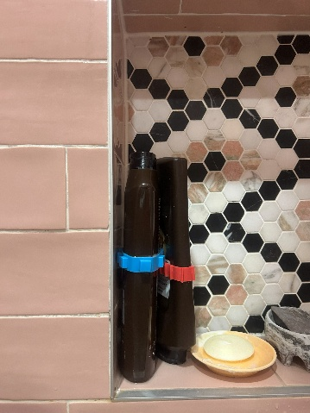  Image credit: (DSI community member – Dr Annmaree Watharow) | Using tactile markers allows for easy navigation of appliances and can help prevent potentially dangerous mix-ups with packaging.  Covering every appliance control with tactile markers can become confusing, so prioritise only covering commonly used controls (Consumer Survey, 2026; Dr Annmaree Watharow).
Storage | Dedicated storage areas with ample space and strict item placement.  If this is a shared space with family members or roommates, maintain consistent item placement to preserve spatial mapping. | Dedicated storage areas with strict item placement helps with tactile searching and reduces cognitive load. Maintaining consistency helps to preserve spatial mapping (Vision Australia).

Modification Level: Assistive Technology/ Equipment
(Products that may support bathroom/laundry activities without necessarily changing the structure of the home.)
Assistive technology and equipment should be selected according to the individual’s needs and preferred form of feedback, such as audio, large print, visual or tactile information. The examples provided are not exhaustive, and products and specifications may change over time.
TARGET AREA | WHAT TO CONSIDER | WHY IT HELPS
Raised laundry trolley | Rather than a laundry basket, use a raised laundry trolley to minimise bending.  [Image description – A laundry basket sitting atop a raised laundry trolley]  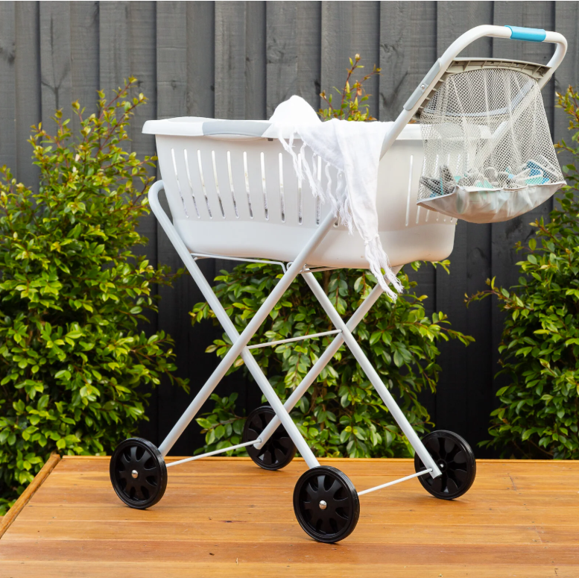  Image credit: (Hills Home Living) | Constant bending down and standing up can cause intense spatial disorientation and fatigue, increasing the risk of falls (Consumer Survey, 2026; Hannah McPierzie).
Long-handled shower sponge | Minimises bending and reaching required while showering.  [Image description – Long-handled shower sponge]    Image credit: (Independent Living Specialists) | Spatial disorientation can increase the risk of falls, which is further heightened by the slippery surfaces while showering. Minimising bending down and standing back up reduces the risk of falls in the shower (Consumer Survey, 2026).

Modification Level: Structural / Capital
(Requires plan budget or minor building works)
TARGET AREA | WHAT TO DO | WHY IT HELPS
Tiling | Consider installing floor and wall tiles in contrasting colours. Bathrooms can often be areas with higher levels of glare, so choosing tiles that are non-glare, have mid-tone colours and matte finishes can help minimise glare.  [Image description – Pink, non-glare bathroom tiles]  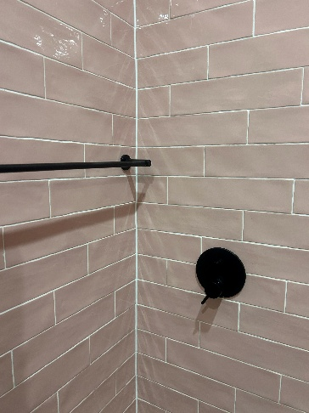  Image credit: (DSI community member – Dr Annmaree Watharow) | Creating contrast between floors and walls can help with orientation and navigation.  Reducing glare improves visual comfort and allows for safer use and navigation of bathroom and laundry areas (Deafblind Ontario Services 2020, pp, 69-70; Dr Annmaree Watharow).
Showers | Where possible, remove shower baths with level-entry, walk-in showers.  [Image description – Bathroom floor with a level shower entry]  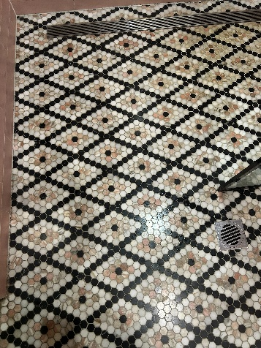  Image credit: (DSI community member – Dr Annmaree Watharow) | Bathtubs create major fall hazards and removing them for showers with continuous flooring provides safer and easier use when showering. (Dr Annmaree Watharow)
Fixtures and Grabrails | Where possible, make all fixtures, including towel racks, toilet paper holders and grabrails, into supporting fixtures which are fastened into the supports of the building.  Minimise sharp edges on any fixtures.  [Image description –Rounded black shower fixtures on pink tiled wall]  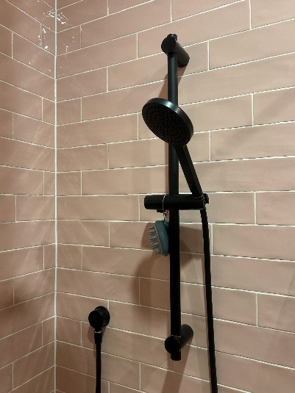  Image credit: (DSI community member – Dr Annmaree Watharow) | Providing supporting fixtures allow people to use these as wayfinding landmarks safely. By fastening them into the supports of the building, individuals can safely and reliably use them to navigate without fear of collapse. By minimising sharp edges, the likelihood of cuts or scratches is reduced (Dr Annmaree Watharow).
Water Containment | Replace shower curtains with solid dividers to prevent water spillage over the bathroom floor. | Shower curtains can allow for water to spread outside of the shower area, creating dangerous slip risks. Solid dividers prevent water from spreading around the bathroom and reduces risk of falls (Dr Annmaree Watharow; Armstrong Chiu, Hong Kong Society for the Blind).
Accessible Electrical Outlets | Where electrical work is already undertaken, consider locating additional outlets within an accessible reach range and ensuring they can be distinguished from the surrounding surfaces. | The Ontario Guide recommends kitchen electrical outlets that contrast with surrounding walls/ counters. The NDIS builder/ designer guide lists additional General Purpose Outlets (GPOs) within an accessible reach range as a possible bathroom or laundry modification. (NDIS Home Modification Guidance, p.14)

7.3 Tips When Choosing New Bathroom/Laundry Appliances
Try before you buy
Before purchasing a new appliance, there are things to explore, include (consumer survey, Vision Australia, Hearing Australia):
- Can buttons or dials be distinguished by touch
- Can tactile markers be added?
- Do controls require reaching over dangerous surfaces?
- Does the appliance rely entirely on a flat touchscreen?
- If it gives auditory information, is that information accessible with the individual’s residue hearing?
- Does the visual display work with the individual’s residual vision and glare sensitivity?
This was directly emphasised by a consumer contributor:
“Don’t spend money until you know the solution works for you.” (consumer survey, 2026)

Clinical Reasoning Corner - For Clinicians & Support Workers
For appliances with controls that need to be identified tactilely, clients may benefit from physically trialling the controls before purchase rather than ordering online immediately.

Do NOT Rely on One Compensatory Sense
A bathroom/laundry modification should not automatically replace visual information with sound, or auditory information with visual alert.
For people living with DSI, both senses are reduced, and functional vision or hearing may also change depending on fatigue and environmental conditions. Where possible, consider whether important kitchen information can be accessed in more than one way, including tactile information. (Consumer Survey, 2026; Vision Australia)

Think about the Whole Household
People living with DSI may also be parents, partners, carers, rather than only recipients of care. A lived experience parent (Paola Murray) living with DSI explained how kitchen recommendations need to consider the person’s household roles and routine, not only isolated ADLs.

Don’t fall into the “bright white” trap
A critical design warning for clinicians is assuming that brightness equates to contrast. Painting walls a stark white colour in an attempt to provide contrast often backfires. When natural sunlight enters, it can create a blinding glare that can be debilitating for someone with sensory residue. Rather, use mid-tone, matte finishes that can provide contrast without creating glare.

Chapter 8 Bedroom
Please ensure you have read Chapter 4: General Environmental Advice before exploring this section. Chapter 4 explains house-wide principles relating to lighting, colour contrast, textures, acoustics, and navigation that form the foundation for a supportive home.
The recommendations below build directly on those principles with targeted strategies for organisation, storage, time-telling and alarms.

8.1 Introduction
Bedrooms are highly personal and private spaces within a home. It is important to remember that the bedroom should reflect the individual and support their rest and relaxation. For this reason, all bedroom modifications should be made in collaboration with the person living with DSI, and additional consideration is needed if the bedroom is a shared space.
People often overlook safety risks in a bedroom; however, for a person living with DSI, factors such as clutter, low-contrast furniture and décor, flooring, and inadequate lighting can significantly affect safety and accessibility. These elements should be carefully assessed when evaluating the room’s overall accessibility and risk profile.

8.2 Practical Bedroom Adaptation Tips
Please remember that the following recommendations are general in nature. They will not be suitable for every individual, and care should be taken to consider the person’s residual sight and hearing, the progression of their condition(s), their routines, and their personal preferences. All modifications should also be guided by the relevant Australian Standards before implementation.
Modification Level: Low-Cost / DIY
(Immediate, budget-friendly changes that can be trialled before larger modifications.)
TARGET AREA | WHAT TO DO | WHY IT HELPS
Contrasting Decor | When choosing bed linen, consider a colour that contrasts with the bed frame. Similarly, for furniture within the bedroom, consider contrasting colours to that of the walls and flooring.  [Image description – grey bed sheet and pillows with a brown bed frame]  Image credit: (Canningvale, 2022)  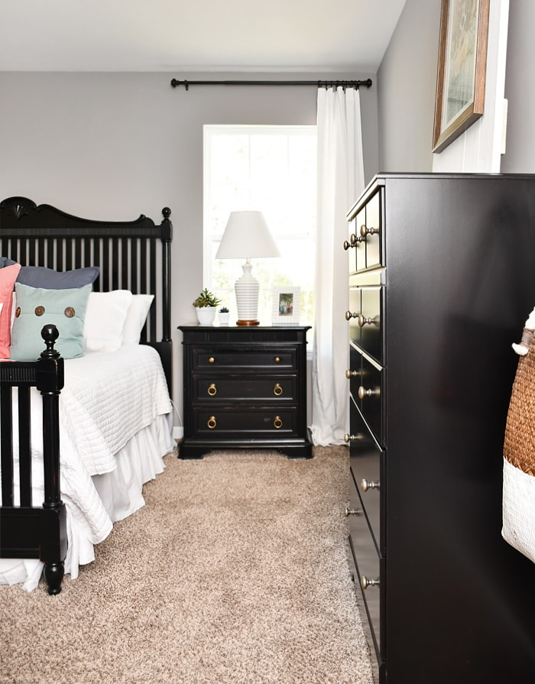  Image credit: (How to Nest for Less)  Light coloured placemats and table runners should be used for contrast when placing dark coloured items on top of dark furniture.  [Image description – Black bed-side table with a white placemat on top of it and a black bedside lamp on the placemat]  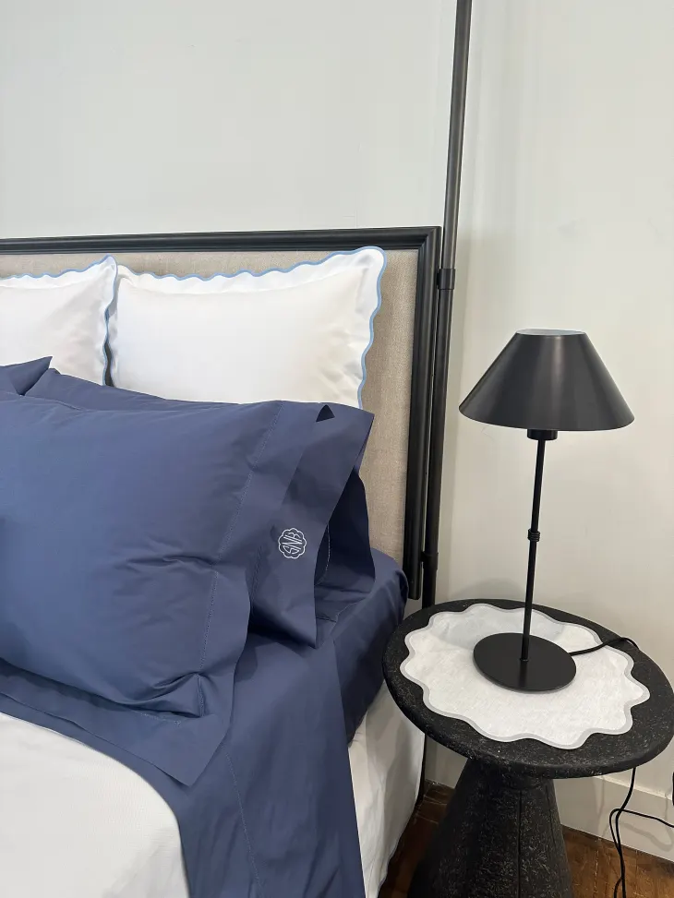  Image credit: (Apartment Therapy) | Having furniture that contrasts with the walls, and flooring makes a room safer and easier to navigate. In the same way, bed linen can be difficult to distinguish if the bed frame is too similar in colour to the linen.  Utilising placemats within the bedroom can be beneficial to create contrast on dark coloured furniture. For example, placing a dark coloured lamp or comb on a dark coloured bed side table would be difficult to discern for some with low vision. Therefore, using lighter coloured place mats may allow for easier identification (Deafblind Information Australia, n.d, Deafblind Ontario Services 2020, p. 51).
Mirrors | Choose mirrors with a coloured edge that contrasts to the wall or background. Alternatively, paint or dark tape can be used to create a contrasting edge.  [Image description – Mirror with a thick black frame leaning against a white wall]  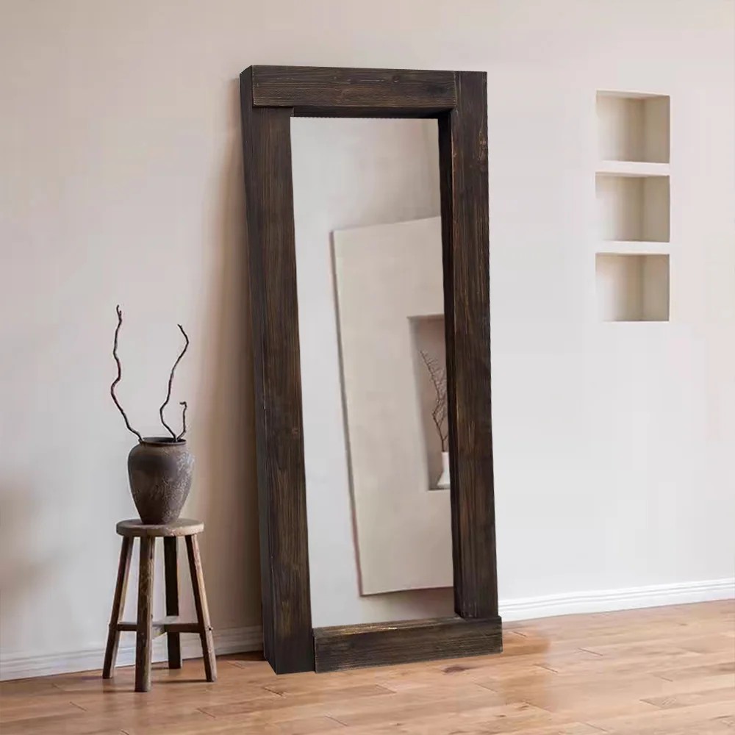  Image credit: (Prime Mirror Australia) | Adding high contrast elements, such as a dark coloured mirror frame against a light-coloured wall may provide easier identification and navigation of the room. Low contrast items, such as a mirror, are harder to detect for people with reduced vision and increase safety risks (Napier-Dovorany, 2026).
Clothing and footwear storage | Have a system for clothing and footwear organisation, such as, organising by colour or hanging items regularly worn together (DBIA).  Keep clothing and shoe storage constant, avoiding sudden changes or re-organisation (Consumer Survey, 2026). | An organised closet supports dressing independence. Keeping items in consistent, clearly defined places allows you to create a reliable mental map of where things are stored, reducing confusion and promoting independence.
Lighting | Install motion activated, under-bed lighting. Many versions exist, varying in cost and installation requirements so ensure that your choice fits your brightness and budgeting requirements.  [Image description – Bed with under-bed lighting]  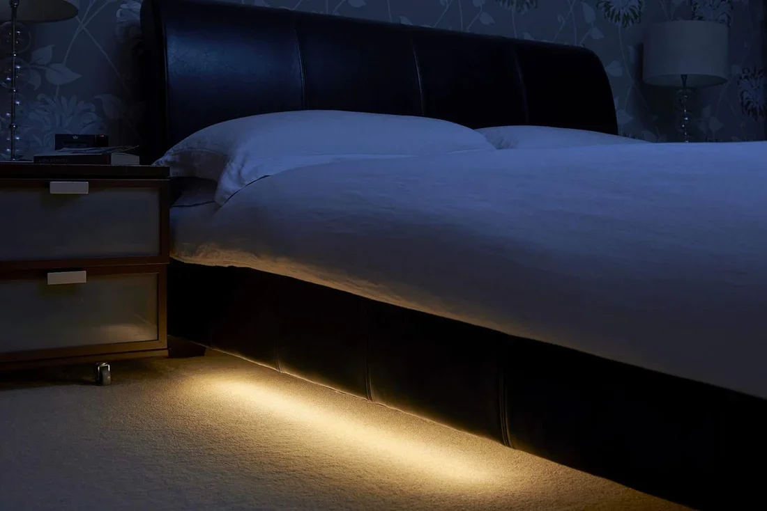Image credit: (Creative.Lighting) | Automatic and predictable lighting helps people orient themselves when getting out of bed. This can then promote night-time safety and independence (Elderly Daily, n.d.).
Clocks | Utilise large print, high contrast clocks for time telling, placed next to the bed for ease of access.  [Image description – White clock with large-print black numbers]  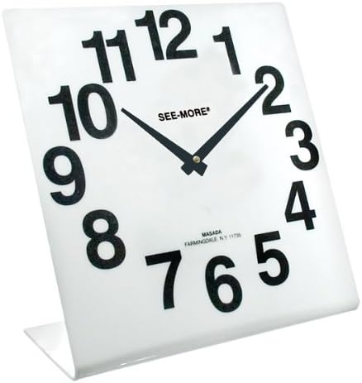  Image Credit: (Riezen)  Tactile markers can be used, such as 3D stick-on numbers or dots, where high contrast and large font is unhelpful for the user. | A large-print, high-contrast analogue clock provides greater readability for people with impaired vision. To support tactile identification, 3D-printed numbers or raised dots can be placed over or beside the printed numbers so the person can feel the time as well as see it.

Modification Level: Assistive Technology/ Equipment
(Products that may support bedroom activities without necessarily changing the structure of the home.)
Assistive technology and equipment should be selected according to the individual’s needs and preferred form of feedback, such as audio, large print, visual or tactile information. The examples provided are not exhaustive, and products and specifications may change over time.
TARGET AREA | WHAT TO CONSIDER | WHY IT HELPS
Vibrating alarms | Connecting systems, such as smoke alarms, security systems and alarm clocks to a bed shaking system that is placed underneath the individual's pillow (Senses Foundation Western Australia, 2013, p. 10)  [Image description – Bed shaking system]  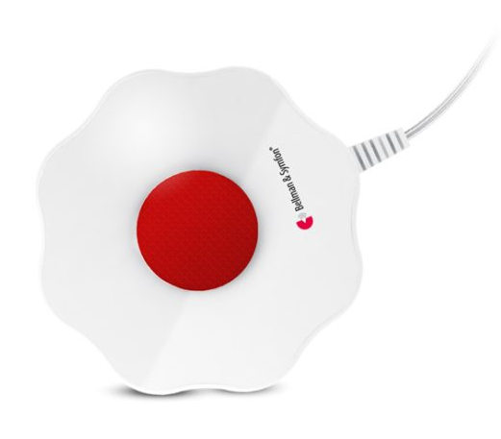Image Credit: (Word of Mouth Technology) | People living with DSI may be unable to use sound-based alarm clocks or security systems. Connecting these systems to a vibrating device provides an accessible alert, ensuring the individual is notified in a way that suits their sensory needs.

Modification Level: Structural / Capital
(Requires plan budget or minor building works)
TARGET AREA | WHAT TO DO | WHY IT HELPS
Accessible Electrical Outlets | Where electrical work is already undertaken, consider locating additional outlets within an accessible reach range and ensuring they can be distinguished from the surrounding surfaces. | The Ontario Guide recommends badroom electrical outlets that contrast with surrounding walls/ counters. The NDIS builder/ designer guide lists additional General Purpose Outlets (GPOs) within an accessible reach range as a possible bedroom modification.(NDIS Home Modification Guidance, p.14)

8.3 Tips When Modifying the Bedroom
- Identify and minimise trip hazards.
- Use high contrast furniture, doors, handles, and bedding to support easier identification.
- Assess lighting and glare to ensure the space is safe and comfortable.
- Utilise storage effectively by organising items in predictable, permanent locations to reduce confusion and promote independence.
Clinical Reasoning Corner - For Clinicians & Support Workers
Do NOT Rely on One Compensatory Sense
A bedroom modification should not automatically replace visual information with sound, or auditory information with visual alert.
For people living with DSI, both senses are reduced, and functional vision or hearing may also change depending on fatigue and environmental conditions. Where possible, consider whether important bedroom information can be accessed in more than one way, including tactile information. (Vision Australia; Consumer Survey)

Shared Spaces
It is important to be mindful of shared spaces within the home and to encourage input from all residents when implementing modifications. For example, a bed shaker may be unsuitable for a bed shared by a couple. Therefore, modifications should consider the needs and preferences of all people living within the home.

Start with the Activity, NOT the Product
For example, difficulty getting into and out of bed could relate to:
- Locating the bed
- Locating the bed linen
- Lighting
- Clutter
- Trip hazards

Different barriers may require different solutions. Hearing Australia recommends linking intervention to meaningful activities and personal goals rather than focusing only on the technology itself. (Hearing Australia).

Hence, instead of asking “what bedroom modifications should this person have?”, clinicians might begin by asking e.g., “What part of your bedtime, overnight or morning routine is currently difficult, unsafe or exhausting?”

Chapter 9 Living Room
Please ensure to read Chapter 4: General Environmental Advice before exploring this section. Chapter 4 covers house-wide principles on lighting, colour contrast, textures, acoustics, and general navigation that form the foundation for a supportive home.
The recommendations below focus on keeping the living room predictable, making television and media easier to access, and supporting communication and family routines.

9.1 Practical Living Room Adaptation Tips
Modification Level: Low-Cost / DIY
(Immediate, budget-friendly changes that can be trialled before larger modifications.)
TARGET AREA | WHAT TO DO | WHY IT HELPS
Furniture & Item Placement | Keep sofas, armchairs, coffee tables, remote controls and other frequently used items in consistent, agreed locations. Encourage family members, visitors and support workers to return things to their designated place after use. | Predictable placement reduces unexpected obstacles and makes it easier to build a reliable mental map of the room. A consumer specifically recommended keeping things in the same place, including in the living room. (Consumer Survey, 2026)
Furniture Contrast | Where residual vision is useful, make major furniture easier to distinguish from the surrounding walls and flooring. If replacing furniture is not practical, contrasting cushions or a clearly visible picture/print behind the sofa may help create a visual cue. | Deafblind Information Australia gives the specific example of a light-coloured lounge blending into light walls and flooring. It suggests contrasting cushions, wall colour or a picture/print as practical ways to make the area easier to identify. (DBIA, 2026; Deafblind Ontario Services 2020, pp. 28, 29)
TV Captions | Turn on closed captions/ subtitles where these are accessible to the person’s residue vision. | Captions provide a visual alternative when television speech is difficult to hear. Hearing Australia specifically recommends enabling subtitles, closed captioning as a simple adjustment, and the Ontario Guide also recommends closed captioning for TV programs and movies. (Deafblind Ontario Services 2020, p. 80; Hearing Australia)
Reduce Noise | When talking with family or visitors, reduce competing sound where possible. For example, pause or turn down the television and switch off unnecessary background noise. | A quieter environment can make communication easier for people using residue hearing. Hearing Australia recommends focusing on one sound source at a time and reducing competing noise such as TVs and fans. (Deafblind Ontario Services 2020, pp. 30, 31; Hearing Australia

Modification Level: Assistive Technology/ Equipment
(Products that may support communication, television access and household organisation without necessarily changing the structure of the home.)
TARGET AREA | WHAT TO DO | WHY IT HELPS
Larger TV Screen & Captions | Where useful for residual vision, consider a larger television screen together with captions or subtitles. Position the screen at a viewing distance that suits the person’s functional vision and field of view. | A larger display may make both the image and captions easier to access, although suitability will depend on the person’s residue vision. (Deafblind Ontario Services 2020, pp. 79, 80)
Direct TV Audio/ Listening Devices | Where the person has useful residual hearing, consider wireless or infrared headphones, a personal listening device, Bluetooth/ direct streaming, or another compatible TV listening system.  [Image description – a portable digital wireless headphone which can connect to a television or other audio devices]    [Image description – an infrared listening system]  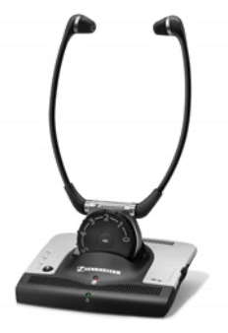  Image credit: (Senses Foundation Western Australia, 2013, p. 14) | The Senses Product Guide states wireless and infrared headphones can improve clarity and amplification when listening to television or other audio. One consumer also described using Bluetooth streaming on hearing aids and a Roger Pen-type transmitter for television and audiobooks. (Consumer Survey, 2026; Senses Foundation Western Australia, 2013, p. 14)
Portable or Neck Loop | For someone whose hearing aids or cochlear implant has an activated Telecoil/ T-switch, consider a portable or neck loop connected to the television or other audio source.  [Image description – an automatic domestic hearing loop amplifier (Univox Autoloop) that can connect TV, stereo or other audio sources to choice of loop system]    Image credit: (Phoenix Hearing Instruments; Senses Foundation Western Australia, 2013, p. 17)  [Image description – a neck loop (Atone Bluetooth Loopset) that can be used with personal listening devices, television, mobile phones and more. Users can wear it around the neck and the loop works in the same way as other loop systems.]  Image credit: (Printacall; Senses Foundation Western Australia, 2013, p. 18) | Loop systems send sound directly to compatible hearing devices/ cochlear implant receiver and can improve clarity by reducing echo and background noise. (DBIA, 2026; Senses Foundation Western Australia, 2013, pp. 15, 17, 18)
Central Household Schedule Screen | Consider a large, accessible digital schedule screen in a shared area where this suits the household. It may display daily routine, appointments, support-worker rosters or reminder for family members. | Paola Murray uses a large central screen to display daily schedules and support-worker rosters. It also alerts her sons when they need to leave the house and helps them know when to assist with tasks such as locating her cane or medication. This is a lived experience example of technology supporting shared household routines. (Paola Murray)
Item-Locating Technology | Consider an electronic item location (e.g. AirTags) for important objects, such as keys or other everyday items. | Paola Murray attaches Apple AirTags to keys and daily items so they can be located if moved or misplaced. (Paola Murray)

Modification Level: Structural / Capital
(Requires plan budget or minor building works)
TARGET AREA | WHAT TO DO | WHY IT HELPS
Fixed/ integrated Listening System | Where clinically appropriate, consider a professionally installed room loop system connected to the television or other audio source | A room loop can transmit sound directly to compatible Telecoil hearing aids or cochlear implants while reducing background noise. (Senses Foundation Western Australia, 2013, pp.15-17)
Window & Glare Control | Where glare significantly affects television viewing or communication, consider installing blinds, window treatments or other glare-control measures that allow natural light to be adjusted. | Too much sunlight can wash out the room and make visual information harder to see. The Ontario Guide recommends adjustable window treatments in living spaces to control natural light. (Deafblind Ontario Services 2020, p. 30)
Accessible Electrical Outlets | Where electrical work is already undertaken, consider providing enough outlets near television, communication and assistive technology areas, and ensuring they can be distinguished from the surrounding surfaces. | The Ontario Guide recommends distributing electrical outlets throughout the living room because this can reduce cables and extension cords across walking routines. (Deafblind Ontario Services 2020, p.15). It is also recommended having electrical outlets that contrast with surrounding walls/ counters (Deafblind Ontario Services 2020, pp, 36-37, 67).

9.2 Tips when Setting Up TV & Media
There is no single television setup that will work for every person living with DSI. Before purchasing new equipment or changing the setup, consider:
- Can the person comfortably see captions or subtitles from their preferred seat?
- Would a larger screen make the television image or captions easier to access?
- Does the person's hearing device support Bluetooth, Telecoil or direct streaming?
- Would headphones or direct streaming make speech clearer without needing to increase the television volume for everyone?
- Can the important remote-control buttons be identified by touch?
- Is glare from windows or lighting making the television screen harder to see?
- Does the setup still allow the person to communicate with family members while watching television?
This was directly emphasised by a consumer contributor:
“Don’t spend money until you know the solution works for you.” (Consumer Survey, 2026)
Clinical Reasoning Corner - For Clinicians & Support Workers
For appliances with controls that need to be identified tactilely, clients may benefit from physically trialling the controls before purchase rather than ordering online immediately.

Do NOT Rely on One Compensatory Sense
Do not assume that replacing sound with visual information will work for everyone. A person with significant vision loss may not be able to read captions reliably, while someone with profound hearing loss may not benefit from additional amplification. Equipment should be selected according to the individual’s combines sensory profile and preferred way of accessing information. (Consumer Survey, 2026; Vision Australia)

Think about the Whole Household
Living room modifications may support more than the individual person living with DSI. Consider how the space is used by partners, children, family members, support workers, and visitors.

Paola Murray’s central schedule screen is one example of a technology supporting shared household routine. See Modification Level: Assistive Technology/ Equipment – central Household Schedule Screen for the lived-experience example. (Paola Murray)

Start with the Activity, NOT the Product
When recommending living room technology, first, identify what the person is trying to do. For example, difficulty watching television may related to:
- Seeing the screen or caption;
- Hearing speech clearly;
- Background noise
- Operating the remote
- Glare on the screen; or
- Communicating with family while the television is on.

Different barriers may require different solutions. Hearing Australia recommends linking intervention to meaningful activities and personal goals rather than focusing only on the technology itself. (Hearing Australia).

Chapter 10 Exterior Space
Please ensure to read Chapter 4: General Environmental Advice and Chapter 5: Safety & Emergency before exploring this section. Those chapters cover house-wide principles on lighting, colour contrast, textures, acoustics, and general navigation that form the foundation for a supportive home. The recommendations below build directly on those principles with targeted strategies for exterior space.

10.1 Introduction
Outdoor areas such as pathways, driveways, gardens, patios, and entrances extend the living environment of the home. Changes in ground surfaces, natural light and weather conditions can make these areas harder to navigate for someone living with Dual Sensory Impairment (DSI).
For some people, a co-occurring balance condition may further increase the risk of a serious fall. Clear pathways, consistent boundaries, suitable contrast and tactile cues may make outdoor areas easier and safer to use.

10.2 Practical Exterior Adaptation Tips
There is no single “right” way to modify an exterior space. These suggestions are examples only. Consider the person’s residual vision and hearing, balance, mobility, familiar routes and preferences before making changes.

Modification Level: Low-Cost / DIY
(Immediate, budget-friendly changes that can be trialled before larger modifications)
TARGET AREA | WHAT TO DO | WHY IT HELPS
Garden Hazard Maintenance | Consider keeping pathways clear of thorny bushes, overhanging tree branches, fallen seed pods, loose garden hoses, and other obstacles. | A clear pathway may reduce unexpected head-level obstacles and tripping hazards along familiar walking routes.  (Deafblind Ontario Services 2020, pp. 20, 63)
Door & Step Identifiers | Where helpful, consider using weather-resistant contrasting paint or non-slip contrasting tape around doorframes and along step edges. | Contrast may make doorways, steps and changes in level easier to identify, particularly when moving between different lighting conditions.  (Deafblind Ontario Services 2020, pp. 20, 77, 78)
Entrance & Patio Contrast | Brightly coloured plant pots or other familiar markers could be placed near entrances or patio edges, provided they do not obstruct the walking path. | A consistent visual marker with colour contrast may help identify an entrance or the edge of an outdoor area.  (Deafblind Ontario Services 2020, pp. 77, 78)

Modification Level: Assistive Technology / Equipment
(Products and devices supporting outdoor safety without structural alterations)
TARGET AREA | WHAT TO DO | WHY IT HELPS
Perimeter Arrival Detection | Where appropriate, consider placing smart motion sensors or cameras along the driveway rather than only at the front door. Check that the notifications are accessible to the person, such as through vibration, sound or an enlarged visual alert. | An earlier notification may give the person more time to identify an approaching visitor or vehicle before they reach the entrance. (Hannah McPierzie)
Obstacle Detectors | Some people may wish to trial a wearable haptic obstacle detector, such as a BuzzClip, during outdoor activities. These devices may be worn on clothing or used alongside a mobility aid. | The device may provide vibrating alerts when it detects certain nearby obstacles. It should be trialled with the individual and should not replace appropriate orientation and mobility support. (Paola Murray)
Driveway Identification Lighting | Consider using a distinctive marker light near the driveway or entrance. The colour and brightness should be chosen with the person to suit their vision and avoid glare. | A distinctive light may help visitors, support workers or drivers identify the correct property, particularly at night. (Paola Murray; Deafblind Ontario Services 2020, p. 77)

Clinical Reasoning Corner - For Clinicians & Support Workers
For appliances with controls that need to be identified tactilely, clients may benefit from physically trialling the controls before purchase rather than ordering online immediately.
Do NOT Rely on One Compensatory Sense
An exterior space modification should not automatically replace visual information with sound, or auditory information with visual alert.
For people living with DSI, both senses are reduced, and functional vision or hearing may also change depending on fatigue and environmental conditions. Where possible, consider whether important exterior space information can be accessed in more than one way, including tactile information. (Consumer Survey, 2026; Vision Australia)

Assess the Route
Think about how the person is going to move through the outdoor space. For example, walking from the front door to the car or from the clothesline to the mailbox. Look for the hazards and then assess their entire journey within that outdoor space.

Outdoor Conditions Change
Weather conditions, lighting, shadows, glare and wetness change quickly in outdoor spaces. Therefore, it is important to take this into consideration when making modification suggestions.

Trial Technology in the Real Environment
Where possible, trial technology in the environment it will be used, as usefulness can be affected by the environment, placement, lighting and connectivity.

Avoid creating NEW Hazards
Anything new to the environment could potentially cause confusion or a trip hazard. So, avoid placing cables and devices on familiar routes.

Chapter 11 Leisure
Please ensure to read Chapter 4: General Environmental Advice before exploring this section. Chapter 4 covers house-wide principles on lighting, colour contrast, textures, acoustics, and general navigation that form the foundation for a supportive home. The recommendations below build directly on those principles with targeted strategies for leisure.

10.1 Introduction
What we choose to do with our spare time — away from work, study and other commitments — is highly individual and personal. We all have different interests and passions, as well as activities that help us unwind after a long day. Many common leisure activities rely heavily on sight and hearing, such as listening to music, watching TV and reading books. These may still be accessible depending on a person's residual hearing and vision, often with certain adjustments. The suggestions below are non-exhaustive but give a sense of the range of leisure possibilities within the DSI community, particularly activities that focus on other senses or require only a small amount of residual hearing or vision.

10.2 Home Modifications
ButtKicker Advance Transducer | 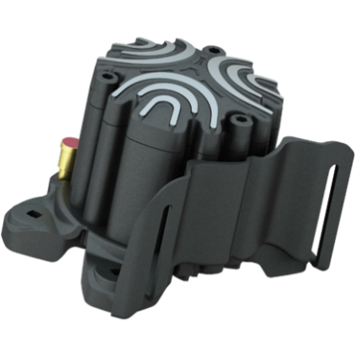  [Image description – ButtKicker Advance Transducer]  Image credit: (Pagnian) ($469 AUD) | Haptic transducers convert low-frequency audio to physical vibration. This transducer can be attached to an armchair or lounge and provide a tactile component to listening to music, watching tv or gaming, therefore allowing sound to be felt by vibration (Pagnian Imports, n.d.)
Raised Garden Bed | 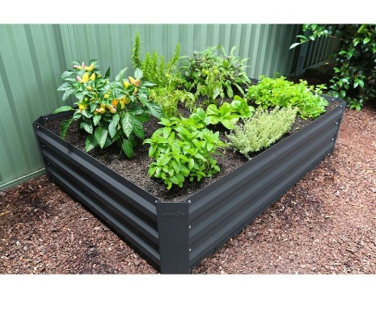  [Image description – grey raised garden bed with herbs and plants growing inside]  Image Credit: (Big W) ($45 AUD) | A raised garden bed filled with plants that offer different smells and textures can provide a sensory experience that does not rely on sight or hearing. Raising the garden bed may also make it easier to locate and access. Plants such as lavender and mint can provide pleasant scents, while plants such as lamb’s ear offer soft and distinctive textures to explore through touch (Consumer Survey).
Sensory Room | [Image description – Sensory room including lounges with different textured blankets, plants and diffuser]    Image Credit: (AI-generated sensory room designed for an adult living with dual sensory impairment) | This suggestion was informed by lived experience perspectives highlighting the value of small, quiet spaces for reducing stress. One individual also described switching off her hearing aids at times to focus on senses beyond sight and hearing. A sensory room could incorporate textured blankets, cushions and preferred scents to create a calming space for rest, disconnection and decompression (Consumer survey)

10.3 Adaptive Equipment
Braille/Large Print Playing Cards | [Image description – Large print playing cards with storage box]  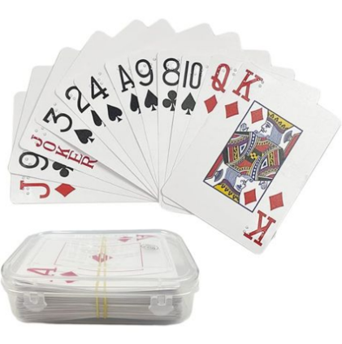  Image credit: (Vision Australia) ($22 AUD) | These cards can assist people who are blind or have vision loss. They contain both large print and braille for greater social inclusion (Vision Australia)
Braille/Large Print Board Games | [Image description – Large print Monopoly with braille markings]  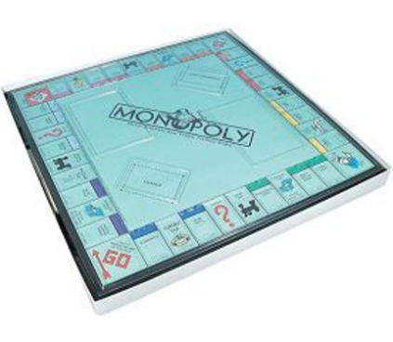  Image credit: (Vision Australia) (Monopoly $330 AUD) | Vision Australia's website has many games that provide greater accessibility and social inclusion. They are designed with both large print and braille. (Vision Australia)
Tactile Rubix Cube | [Image description – Rubik’s cube with different tactile markings to signify different colours]  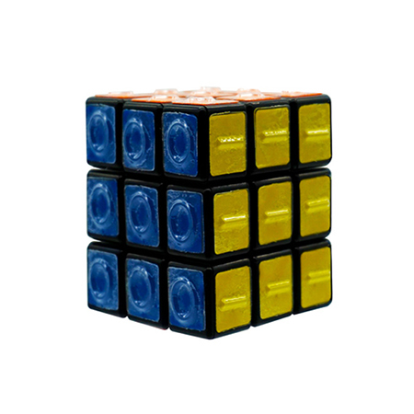Image credit: (Queensland Blind Association Inc.) ($79 AUD) | The classic puzzle game but with additional tactile markings and large print instructions (Queensland Blind Association Inc.).
Tactile Jigsaw Puzzles | 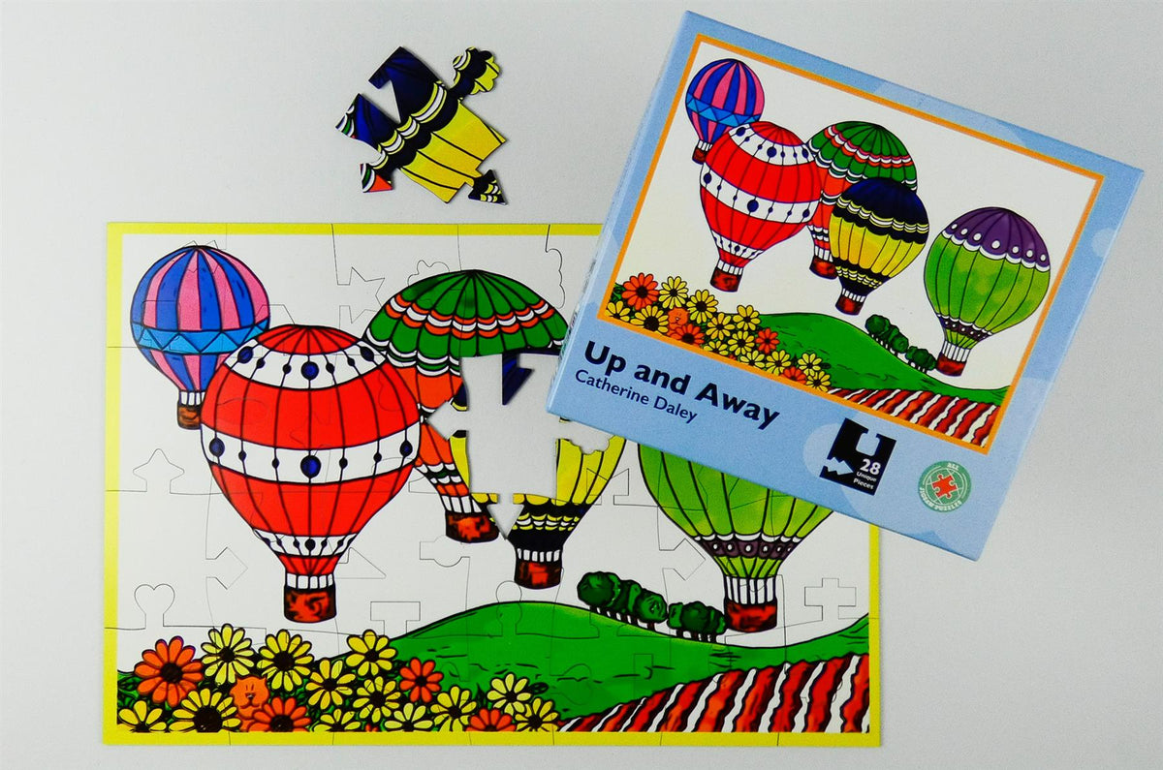  [Image description – Completed tactile jigsaw puzzle with one missing piece]  Image credit: (All Jigsaw Puzzles) ($49 AUD) | Tactile jigsaw puzzles have distinct key shaped pieces with bright, colourful images and borders to assist those with low vision completing the puzzles.
Refreshable Braille Tablet (Orbit Reader 20 plus) | 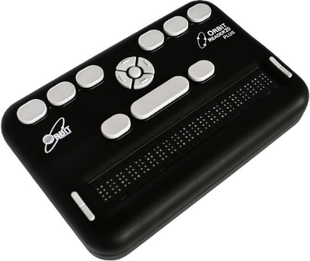  [Image description – The Orbit Reader 20 plus, a refreshable braille tablet]  Image credit: (Pacific Vision Australia) ($2,695 AUD) | Refreshable braille displays read books, take notes and connect to phones/computers via Bluetooth or USB. This model is also pairable with a free Vision Australia library membership with thousands of braille titles (Vision Australia)
Dumbbell Weight Set with Embossed Numbers |   [Image description – black dumbbell weights stacked on a weight rack]  Image credit: (Big W) ($249.95) | Embossed weights allow for tactile identification, reducing the need for visual identification.
Bright Coloured PVC Dumbbell Set | 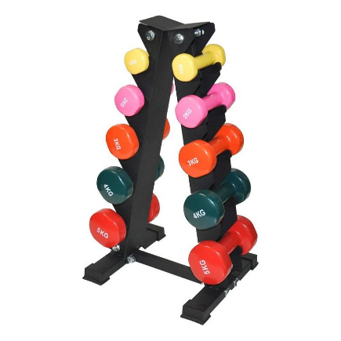  [Image description – Brightly coloured PVC dumbbells, stacked on a weight rack]  Image credit: (Big W) ($149.95) | Bright coloured dumbbells with large print numbers and stored on a dark coloured rack allows for easier visual identification.

10.4 Groups
1) Achilles Australia – Operating across multiple Australian cities, Achilles trains volunteer guide runners to use a tether and short verbal cue system to guide runners with disabilities. Please follow the below link to read more about the group and reach out regarding your individual support needs. Please see the link below for more details.
https://www.achillesaustralia.org.au/
2) Deafblind Information Australia – The online directory can be used to find local deaf/blind social and craft groups. For example, the Hunter Deafblind Hub in NSW participates in activities such as; rock climbing, arts and crafts and community outreach. Please see the links below for more details.
https://www.cdah.org.au/peer-groups-events/hunter-deafblind-drop-in/
https://www.deafblindinformation.org.au/services/directory-of-services/
Clinical Reasoning Corner - For Clinicians & Support Workers
The Importance of Disconnection
Our consumer survey and conversations with people who have lived experience of DSI point to the same theme: people need opportunities to decompress. For one individual, this meant turning off her hearing aids and returning to an activity that had stayed the same before and after her dual sensory loss — sitting with her cats and patting them. Another described sitting in the garden, taking in the smells and feeling the plants. Therefore, have this conversation and make sure they have an easily accessible escape.
Take a Moment in DSI Shoes
Without lived experience of DSI, it's hard to know how it feels to suddenly or gradually lose the ability to do the things that give you purpose and connection. Take a moment: cover your eyes and block your ears. Think of something you really enjoy doing — without those senses, how would you do it? Would it be safe? How would you feel if you couldn't?
Safety Always Comes First
Unfortunately, as much as we want to believe we can help our clients achieve any task, sometimes it just isn't safe. This is where a client-led, conversational approach becomes crucial. Talk with them about what they want to do, discuss the safety and health implications together, and co-design leisure activities that are both safe and fulfilling.

Chapter 12 DSI Community Resources
The Organisations and equipment suppliers listed below are provided as a reference to help individuals living with Dual Sensory Impairment (DSI), family carers, and clinicians find specialist services and assistive technology. We do not formally endorse specific commercial products, and product availability or contact details may change over time. Independent trials and professional consultation with an Occupational Therapist (OT) or Orientation & Mobility (O&M) specialist are recommended prior to purchase.
(Accurate at time of publication)

12.1 Key Deafblind & Support Organisations Mentioned in This Guide
These organisations provide specialist services, allied health support, consumer resources, and advocacy specifically for people with vision loss, hearing loss, and dual sensory loss:

1) Deafblind Information Australia (DBIA)
A national information hub and resource platform specifically dedicated to deafblindness and dual sensory impairment in Australia. It provides practical environmental guides, communication resources, lived-experience stories, and access to deafblind consultants.
- Website: https://www.deafblindinformation.org.au/
- Contact:
  - Deafblind Consultant: info@deafblindinformation.org.au
  - To lodge a request form for a “Ask a deafblind consultant” session: https://www.deafblindinformation.org.au/services/ask-a-deafblind-consultant/

2) Vision Australia (Services & Vision Store)
One of Australia's largest national providers of blindness and low-vision services, supporting people with vision loss and co-occurring hearing challenges to live independently.
- Website: https://www.visionaustralia.org/
- Services Provided: Occupational Therapy home assessments, Orientation & Mobility (O&M) training, Seeing Eye Dogs, access technology support, and peer social networks (e.g. Quality Living Groups).
- Contact:
  - Phone: 1300 847 466
  - Email: info@visionaustralia.org
  - Fax: 1300 847 329
  - International: +612 9334 3200
- Vision Store (Assistive Tech Shop)
to browse and purchase equipment like handheld and desktop electronic magnifiers, talking scales/jugs, liquid level indicators, large-print/tactile clocks and watches, task lamps, bump dots, white mobility canes, and more.
  - Shop Website: https://shop.visionaustralia.org/
  - Contact:
    - Store Email: visionstore@visionaustralia.org
    - Store Orders & Enquiries: 1300 847 466
3) Deafblind Australia (DBA)
The national consumer and advocacy organisation representing people living with deafblindness, focused on human rights, media access, and community empowerment.
- Website: https://deafblind.org.au/
- Contact:
  - Email: info@deafblind.org.au
  - Phone: +61 427 006 890 (SMS or voice)
  - Facebook: https://www.facebook.com/people/Deafblind-Australia/100064659373277/

4) Senses WA
A leading not-for-profit disability organisation in Western Australia offering specialist deafblind and sensory services. Their interdisciplinary team includes Deafblind Consultants, Occupational Therapists, Physiotherapists, Orientation and Mobility (O&M) specialists, and Social Workers.
- Website: https://www.senseswa.com.au/
- Contact:
  - Email: customerservice@senses.org.au
  - Phone: 1300 111 881

5) Deafblind West Australians (DBWA)
A peer-led consumer and advocacy group based in Perth, Western Australia, run by and for individuals living with deafblindness and dual sensory impairment. It offers peer support networks, community education, and guidance on accessible communication and inclusive spaces.
- Website: https://dbwa.org.au/
- Services Provided: Deafblind advocacy, lived-experience peer connection, community events, and consultation on accessible communication and inclusive design.
- Contact:
  - Email: info@dbwa.org.au
  - Facebook: https://www.facebook.com/groups/364764059137

6) Hearing Australia
One of Australia's largest providers of government-funded hearing services, dedicated to delivering comprehensive hearing assessments, hearing device fittings, and ongoing hearing care for over 75 years.
- Website: https://www.hearing.com.au/
- Services Provided: Hearing assessments and devices for eligible adults with complex needs (including DSI) under the Community Service Obligation (CSO) program, assistive listening device advice, and tinnitus support programs.
- Contact:
  - Phone: 134 432
  - Online Contact: https://www.hearing.com.au/get-in-touch/

12.2 Assistive Technology & Equipment Suppliers
These specialist vendors stock alerting devices, listening equipment, magnifying systems, and everyday adaptive tools:

1) Word of Mouth Technology
- Equipment Available:
  - Assistive Listening Devices
  - Hearing Protection
  - Alerting Systems
  - Hearing Augmentation (e.g., looping devices)
- Website: https://wom.com.au/
- Contact:
  - Email: info@wom.com.au
  - Phone:1800 966 266

2) ClearaSound
(Formerly Printacall Communications Technology)
- Equipment Available:
  - Domestic & Commercial Hearing Loops
  - Multi-Sensory Alerting Systems (flashers & bed shakers)
  - Wireless & Infrared TV Listening Systems
  - Telephone Amplifiers & Ringers
- Website: https://clearasound.com.au/
- Contacts:
  - Email: sales@clearasound.com.au
  - Phone: (02) 9481 9750
TTY: (02) 9484 7263

3) Quantum Reading Learning Vision (Quantum RLV)
- Equipment Available:
  - Optical & Illuminated Handheld/Stand Magnifiers
  - Desktop & Portable Electronic Video Magnifiers (CCTVs)
  - Flexible & Glare-Free Task Lighting
  - Reading & Educational Assistive Technology
- Website: https://www.quantumrlv.com.au
- Contact:
  - Email: info@quantumrlv.com.au
  - Phone: 1300 883 853
  - Fax: 02 9875 1646

4) Humanware Australia
- Equipment Available:
  - Refreshable Braille Displays & Tablets
  - Handheld & Portable Video Magnifiers
  - Deafblind Digital Communication Tools
  - Screen Reading & Digital Audio Devices
- Website: https://store.humanware.com/au
- Contact:
  - Email: au.sales@humanware.com
  - Phone: 02 9686 2600

5) Pacific Vision
- Equipment Available:
  - Handheld & Portable Electronic Video Magnifiers
  - Desktop Electronic Video Magnifiers (CCTVs)
  - Computer Screen Magnification & Screen Reading Software
  - Smart Braille Tablet
- Website: https://pacificvisionaus.com.au/
- Contact:
  - Email: office@pacificvisionaus.com.au
  - Phone: 1300 756 849

6) Oricom International
- Equipment Available:
  - Amplified Big-Button Corded & Mobile Phones
  - Jumbo Display Clocks with Vibrating Alert System
  - Visual Flashing Telephone Ring Alerts
- Website: https://oricom.com.au/
- Contact:
  - Phone: (02) 4574 8888

12.3 Accessible Telecommunications & Guide Dog Services

1) National Relay Service (NRS) & Access Hub
- Website: https://www.accesshub.gov.au/about-the-nrs/
Or https://www.accesshub.gov.au/
(Please read Chapter 5 and Appendix for more NRS details)

2) Telstra Disability Equipment Program
- Service: Supplies accessible telecommunications equipment (large-button phones, visual flashing ringers, and TTY units) to eligible Telstra customers with disabilities.
- Website: https://www.telstra.com.au/accessibility-and-disability/accessibility-equipment
- Email: disability@online.telstra.com.au
- Disability Enquiry Hotline (Toll Free): 1800 068 424
- TTY (Free call): 1800 808 981
- Fax: 1800 814 777

3) Guide Dogs
- Website: https://guidedogs.com.au/
- Phone: 1800 484 333

4) Seeing Eye Dogs Australia (SEDA - Vision Australia)
- Website: https://sed.visionaustralia.org/
- Email: info@sed.org.au
- Phone: 1800 443 638

12.4 Government Schemes, Advocacy & Dispute Bodies

1) National Disability Insurance Scheme (NDIS)
- Website: https://www.ndis.gov.au/
- Phone: 1800 800 110

2) My Aged Care (MAC)
- Website: https://www.myagedcare.gov.au/
- Phone: 1800 200 422

3) Older Persons Advocacy Network (OPAN)
- Website: https://opan.org.au
- Phone: 1800 700 600

4) Administrative Review Tribunal (ART)
(Independent review for government and NDIS decisions)
- Website: https://www.art.gov.au/
- Online Service: https://online.aat.gov.au/
- Email: reviews@art.gov.au
- Phone: 1800 228 333

5) Blind Citizens Australia (BCA)
- Website: https://www.bca.org.au/
- Email: bca@bca.org.au
- Phone (Toll Free): 1800 033 660
- Text: 0436 446 780

6) Deaf Australia:
- Website: https://www.deafaustralia.org.au/
- Email: info@deafaustralia.org.au
- Online Service: https://www.deafaustralia.org.au/contact

7) Better Hearing Australia
- Website: https://www.bca.org.au/

References
2026 AITextured. (2026a). Rubber seamless textures. AITextured. https://aitextured.com/textures/rubber/
All Jigsaw Puzzles. (n.d.-a). Jigsaw Puzzles for the Visually Impaired. All Jigsaw Puzzles. Retrieved 2 September 2026, from https://www.alljigsawpuzzles.co.uk/en-au/collections/jigsaw-puzzles-for-the-visually-impaired?srsltid=AfmBOop61lljpbofaV5Nysbcr_uST3NQG2s33atGH_LUSDvfyueWJvEe
Ames Australasia Pty Ltd. (n.d.-b). Premium Laundry Trolley. Hills Home. Retrieved 2 September 2026, from https://hillshome.com.au/products/premium-laundry-trolley
Ask Larsen, F., & Damen, S. (2014). Definitions of deafblindness and congenital deafblindness. Research in Developmental Disabilities, 35(10), 2568–2576. https://doi.org/10.1016/j.ridd.2014.05.029
Baur, M. (2026, June 19). Deafblind diversity – deafblind international DbI. Deafblindinternational.Org. https://deafblindinternational.org/deafblind-diversity/
BIG W. (n.d.-a). 2-4-6-8-10kg Total 60kg 5 Pair Hex Rubber Dumbell Weight Set with Rack. BIG W Market Place. Retrieved https://www.bigw.com.au/product/2-4-6-8-10kg-total-60kg-5-pair-hex-rubber-dumbell-weight-set-with-rack/p/9901068970
BIG W. (n.d.-b). 5 Pairs Pvc Dumbbell Set Weight - 1-2-3-4-5kg - Total 30kg Plus A Rack. BIG W Market Place. Retrieved https://www.bigw.com.au/product/5-pairs-pvc-dumbbell-set-weight-1-2-3-4-5kg-total-30kg-plus-a-rack/p/9902923641
Blundell, D. (2026, May 12). My Mom Puts This Dining Room Staple in Her Bedroom — The Reason Why Is Ingenious. Apartment Therapy. https://www.apartmenttherapy.com/placemat-for-nightstand-2-37550429
Commonwealth of Australia. (2025a). Assessment outcome: Support at Home. Myagedcare.Gov.Au. https://www.myagedcare.gov.au/assessment-outcome-support-at-home
Commonwealth of Australia. (2025b). Assistive technology and home modifications (AT-HM) scheme. Myagedcare.Gov.Au. https://www.myagedcare.gov.au/aged-care-programs/assistive-technology-and-home-modifications-scheme
Commonwealth of Australia. (2025c). How to get assessed | my aged care. Myagedcare.Gov.Au. https://www.myagedcare.gov.au/how-get-assessed
Commonwealth of Australia. (2025d). Preparing for your assessment. Myagedcare.Gov.Au. https://www.myagedcare.gov.au/preparing-your-assessment
Commonwealth of Australia. (2025e). Receiving your assessment outcome. Myagedcare.Gov.Au. https://www.myagedcare.gov.au/receiving-your-assessment-outcome#assessment-outcome-next-steps
Commonwealth of Australia. (2025f). Should I apply? | My aged care. Myagedcare.Gov.Au. https://www.myagedcare.gov.au/should-i-apply
Compliance solutions Canada. (2026b). Smart Accessibility: Tactile-Tech Integration for Buildings. Tactilesolution.Ca. https://www.tactilesolution.ca/blog/integrating-code-compliant-tactile-and-technology-to-enhance-building-accessibility
Deafblind Australia. (2023, June 5). Deafblind communication . Deafblind Australia. https://deafblind.org.au/deafblind-communication/
Deafblind Information Australia. (n.d.-c). Adapting the environment | deafblind information. Deafblindness Support Services. Retrieved 1 September 2026, from https://www.deafblindinformation.org.au/living-with-deafblindness/adapting-the-environment/
DeafBlind Ontario Guide. (2020). Accessibility Guidelines
for Sensory Loss, A simple touch leads to endless possibilities, 3rd Edition.
Dull Men’s Club®. (2026). I’ve been lurking on here for a while and I finally have something appropriately dull to ask... | Facebook. Facebook Groups. Facebook. https://www.facebook.com/groups/thedullclub/posts/3476811399190621/
Dyke, P. (2013, July). A Clear View - Identifying Australians who live with
deafblindness and dual sensory loss. Senses Australia.
E. U. Fabrics Ltd Store. (n.d.). EU Fabrics Long Pile Faux Fur Fabric | Soft, Warm and Fluffy Upholstery Material for Jackets and Clothing | Fur Felt Fabric by the Meter (Brown, Sample 10x10cm). Amazon.Es. Retrieved https://www.amazon.es/Fabrics-sintético-material-tapicería-chaquetas/dp/B0DX1NLWNS
Eliesha Coxall. (2022, October 20). 4 Tips for picking the perfect colour for your bed linen. Canningvale. https://www.canningvale.com/blog/picking-the-perfect-colour-for-your-bed-linen
Franks, L. (2026). Rustic wood frame full length mirror (dark) - FLM27 - clearance. Prime Mirror. https://primemirror.com.au/products/tall-wooden-mirror-in-rustic-industrial-design
Germade, M. (2020, February 6). Sandpaper grit explained. Empire Abrasives. https://www.empireabrasives.com/blog/sandpaper-grit/?srsltid=AfmBOooGS9yDjZpqtyuEWar1JylzqF1FMdzTABk-YXeJLw6tXHjdn9qr
GreenLife. (n.d.-d). Greenlife Rectangular Raised Garden Bed 1200 x 900 x 300mm Charcoal. BIG W. Retrieved https://www.bigw.com.au/product/greenlife-rectangular-raised-garden-bed-1200-x-900-x-300mm-charcoal/p/9902068331
Guangzhou Chubang Hardware Decoration CO. (n.d.). Decorative Wall LED Skirting Light Aluminum Skirting Board Led Skirting Board Kitchen Cabinet Aluminum Profile Light. Alibaba.Com. Retrieved 1 September 2026, from https://www.alibaba.com/product-detail/Decorative-Wall-LED-Skirting-Light-Aluminum_1600683414466.html
Hahne, W. (2024, February 16). 5 Innovative ways to use motion sensor lights in your home. Creative.Lighting. https://creative.lighting/blogs/news/5-innovative-ways-to-use-motion-sensor-lights-in-your-home
Haining Lesun Textile Technology CO. (2020). 235GSM 100% polyester corduroy fabric / SOFA ginger knit corduroy fabric. Haining Lesun Textile Technology CO.,LTD.https://www.micropolyesterfabric.com/sale-12786676-235gsm-100-polyester-corduroy-fabric-sofa-ginger-knit-corduroy-fabric.html
Home modifications guidance for builders and designers. (2020). National Disability Insurance Agency.
howtonestforless. (2017, September 18). Budget master bedroom makeover with SW functional gray. How to Nest for LessTM. https://howtonestforless.com/budget-master-bedroom-makeover/
Independent Living Specialists. (n.d.-e). Long Handled Sponge - Extended reach for daily bathing. Independent Living Specialists. Retrieved 2 September 2026, from https://ilsau.com.au/product/scrubmate-long-handled-sponge/
Manandhar, S., Lukman, A., Dain, S. J., Bridge, C. E., Relf, M., & Boon, M. Y. (2022). Luminance contrast preferences of people with a vision impairment for elements in the built environment. Work, 73(4), 1265–1278. https://doi.org/10.3233/wor-210997
Napier-Dovorany, K., Rietdyk, S., Gruber, A. H., & Hassan, S. E. (2026). Stepping over obstacles: Lead foot clearance decreased with low-contrast obstacles in older adults with and without central vision loss. Gait & Posture, 130, 110296. https://doi.org/10.1016/j.gaitpost.2026.110296
National Disability Insurance Agency. (2026a). Guide to decision reviews | NDIS. Ndis.Gov.Au. https://www.ndis.gov.au/participants/changing-your-plan/decision-reviews/guide-decision-reviews
National Disability Insurance Agency. (2026b). Guide to providing home modifications | NDIS. Ndis.Gov.Au. https://www.ndis.gov.au/providers/home-and-living-providers/home-modifications/guide-providing-home-modifications
National Disability Insurance Agency. (2026c). How to provide a home modification assessment | NDIS. Ndis.Gov.Au. https://www.ndis.gov.au/providers/home-and-living-providers/home-modifications/how-provide-home-modification-assessment
National Disability Insurance Agency. (2026d). What is a home modification assessor | NDIS.Ndis.Gov.Au. https://www.ndis.gov.au/participants/home-and-living/modifying-your-home/what-home-modification-assessor
National Disability Insurance Agency. (2026e). What is an NDIA planner | NDIS. Ndis.Gov.Au. https://www.ndis.gov.au/participants/creating-plan/understanding-plan-meeting/what-ndia-planner
National Disability Insurance Agency. (2026f). What is an NDIS plan | NDIS. Ndis.Gov.Au. https://www.ndis.gov.au/participants/creating-plan/creating-your-first-plan/what-ndis-plan#what-an-ndis-plan-is
National Relay Service. (n.d.-f). Using the National Relay Service (NRS). Access Hub. Retrieved https://www.accesshub.gov.au/sites/default/files/documents/using-the-national-relay-service-nrs.pdf
Nordic Leadership Forum on Deablindness. (2024). Nordic Definition on Deafblindness. Nordic Welfare Centre.
ORBIT RESEARCH. (n.d.). Orbit Reader 20 Plus. Pacific Vision Australia Pty Ltd. Pacific Vision Australia . Retrieved https://pacificvisionaus.com.au/product/orbit-reader-20-plus/
Pagnian. (n.d.-g). ButtKicker advance transducer. Pagnian Imports. Retrieved 2 September 2026, from https://pagnianimports.com.au/collections/buttkicker-brand/products/buttkicker-advance-transducer
Queensland Blind Association. (2016, August 29). Rubix Cube With Tactile Markings. Queensland Blind Association. https://qldblind.org.au/shop/games-and-leisure/games-puzzles-mind-teasers-games-and-leisure/rubix-cube-with-tactile-markings/
Reizen. (2026c). Amazon.Com: Reizen giant view clock- white face : Home & kitchen. Amazon.Com. https://www.amazon.com/Reizen-Giant-View-Clock-White/dp/B00JU1AF14
Royal College of Speech & Language Therapists . (2021, August). Deafblindness (multi-sensory impairment) clinical information. Rcslt. https://www.rcslt.org/speech-and-language-therapy/clinical-information/deafblindness/
Schneider, J., Gopinath, B., McMahon, C., Teber, E., Leeder, S. R., Wang, J. J., & Mitchell, P. (2012). Prevalence and 5-Year incidence of dual sensory impairment in an older Australian population. Annals of Epidemiology, 22(4), 295–301. https://doi.org/10.1016/j.annepidem.2012.02.004
Schneider, J. M., Gopinath, B., McMahon, C. M., Leeder, S. R., Mitchell, P., & Wang, J. J. (2011). Dual sensory impairment in older age. Journal of Aging and Health, 23(8), 1309–1324. https://doi.org/10.1177/0898264311408418
Senses Foundation Western Australia. (2013). Equipment and devices for people who have dual sensory loss.
SIMCOCK, P. (2016). Ageing with a unique impairment: A systematically conducted review of older deafblind people’s experiences. Ageing and Society, 37(8), 1703–1742. https://doi.org/10.1017/s0144686x16000520
SK Kutubuddin. (2025, April 8). Hearing and vision support at home for seniors. ElderlyDaily. https://elderlydaily.com/caregiver-guides/hearing-and-vision-support-at-home
Vision Store. (n.d.-a). Braille and large print playing cards. Visionaustralia.Org. Retrieved 2 September 2026, from https://shop.visionaustralia.org/braille-and-large-print-playing-cards.html?srsltid=AfmBOoqZvG8ZhhzPZ1EFncI8_C4q-FF-Oe2ZVDyfB763Q3rVmC83t2w9
Vision Store. (n.d.-b). Monopoly Board Game - Braille and Large Print. Visionaustralia.Org. Retrieved 2 September 2026, from https://shop.visionaustralia.org/monopoly-board-game-braille-and-large-print.html
Vision Store. (2026a). Auditory and vibrating liquid level indicator. Visionaustralia.Org. https://shop.visionaustralia.org/auditory-and-vibrating-liquid-level-indicator.html?srsltid=AfmBOor5fT3IMyScYylagI4J1Fr6lt63wy2P9NhSRoBmrCvgwHZQ3g7N
Vision Store. (2026b). Explore 12 - with stand. Visionaustralia.Org. https://shop.visionaustralia.org/explore-12-with-stand.html
Vision Store. (2026c). Uccello Kettle - black and white. Visionaustralia.Org. https://shop.visionaustralia.org/uccello-kettle-black-and-white.html
Who is Deafblind? (2024, September 9). Comprehensive ICF Core Set for Deafblindness Project. https://whoisdeafblind.org
Watharow, Annmaree, and Moira Dunsmore. Dual Sensory Impairment and the Older Person : An Invisible Epidemic?, Lived Places Publishing, 2024. ProQuest Ebook Central, https://ebookcentral.proquest.com/lib/usyd/detail.action?docID=31134346.
Wittich, W., Southall, K., Sikora, L., Watanabe, D. H., & Gagné, J.-P. (2013). What’s in a name: Dual sensory impairment or deafblindness? British Journal of Visual Impairment, 31(3), 198–207. https://doi.org/10.1177/0264619613490519
Wittorff, M., Prain, M., & Wills, A. (n.d.). Ending the isolation for older adults with combined vision and hearing impairment. In Deafblind Information Australia. Senses Australia .Retrieved https://www.deafblindinformation.org.au/wp-content/uploads/2021/01/SEN5964_Ending_the_Isolation_Resource_A4_WEB-Spreads_V3.pdf
Word of Mouth Technology. (n.d.-h). Bellman Visit Bed Shaker. Retrieved https://wom.com.au/product/be1270/
World Federation of the Deafblind. (2018). At risk of exclusion from CRPD and SDGs implementation: Inequality and persons with deafblindness initial global report on situation and rights of persons with deafblindness. https://www.wfdb.eu/wp-content/uploads/2019/06/WFDB_complete_Final.pdf
World Health Organization. (2025, October 1). Ageing and health. World Health Organization. https://www.who.int/news-room/fact-sheets/detail/ageing-and-health

Appendix 1
National Relay Service
